The following document is supplemental to ACRP WebResource 16: Playbook for Developing a Culture of Innovation at Airports (ACRP Project 01-47, “A Guide to Developing a Culture of Innovation at Airports”). The full WebResource can be found at https://crp.trb.org/acrpwebresource16/.

The Airport Cooperative Research Program (ACRP) is sponsored by the Federal Aviation Administration. ACRP is administered by the Transportation Research Board (TRB), part of the National Academies of Sciences, Engineering, and Medicine. Any opinions and conclusions expressed or implied in resulting research products are those of the individuals and organizations who performed the research and are not necessarily those of TRB; the National Academies of Sciences, Engineering, and Medicine; or ACRP sponsors.

Developing a Culture of Innovation
WebResource Companion Worksheet

Welcome to the companion worksheet for ACRP WebResource 16: Playbook for Developing a Culture of Innovation at Airports. This worksheet provides you with a place to answer questions and take notes to help spur you on toward implementing the ideas presented in the WebResource.

This worksheet presents the check-in and check-out questions based on your perspective as a manager and prompts you to provide answers that apply to your organization, business function, and/or your team, as well as yourself individually.

Part 1: Understand (read it here)

Part 1 Check-In
Before reading Part 1, consider and answer the following questions:

- How would you describe the culture of the team you manage today? Underline each that apply. Further, does it differ from that of your entire business function? The organization as a whole?

- Appreciative  - Biased  - Boring  - Casual  - Collaborative  - Connected  - Creative  - Curious  - Decisive  - Demanding | - Disengaged  - Diverse  - Empathetic  - Engaging  - Flexible  - Fun  - Happy  - Hostile  - Inclusive  - Innovative | - Micromanaged  - Motivating  - Nimble  - Nurturing  - Outdated  - Progressive  - Relaxed  - Respectful  - Rewarding  - Safe | - Siloed  - Stagnant  - Stressful  - Supportive  - Toxic  - Transparent  - Trusting  - Unaccountable  - Unsupportive  - Welcoming
Others? Describe here:

- Do you think your team has a culture of innovation? Why or why not? (Or maybe another way to think about it: what things do you see that point to or stand in contrast to a culture of innovation?)
Describe here:

- Do you think you have a mindset of innovation? Why or why not? What things do you do (or wish you could do) that contributes to a mindset of innovation?
Describe here:

Personal Notes

Chapter 1 (read it here)
Insert notes here…

Chapter 2 (read it here)
Insert notes here…

Chapter 3 (read it here)
Insert notes here…

Part 1 Check-Out
After reading Part 1: Understand, consider and answer the following questions:

- Has your opinion changed regarding whether your team has a culture of innovation? If so, is your culture more or less like the description of a culture of innovation? Also consider the impact of the broader organizational culture and whether you are in alignment.
Describe here:

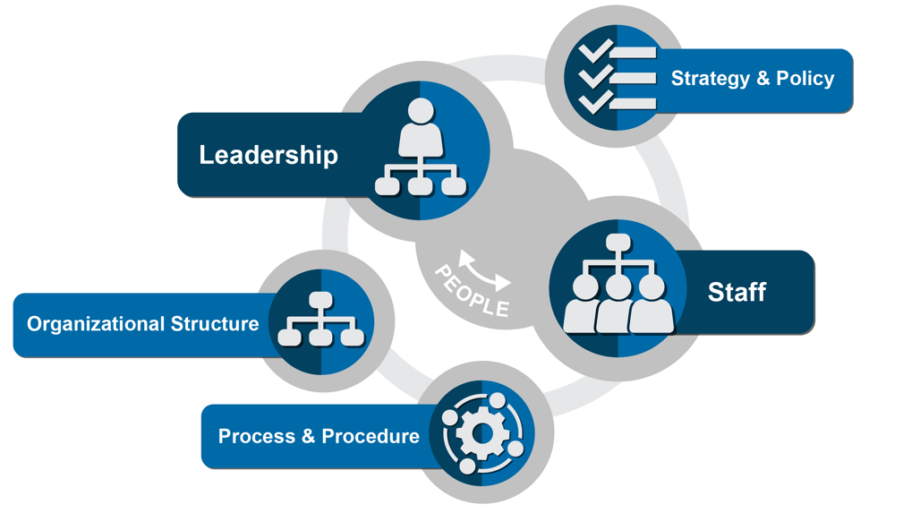
- Describe the extent to which your organizational elements are already aligned to support innovation within your team. Also consider your business function, and even your organization as a whole; to what extent is this broader set of elements properly aligned?
Leadership: Insert here…

Staff: Insert here…

Strategy and Policy: Insert here…

Organizational Structure: Insert here…

Process and Procedure: Insert here…

- Consider other teams within your business function. Are they aligned to support innovation? Think of initiatives and new ideas you have pursued. Did other teams or business functions support or block your progress? Your ideas here could be very beneficial to your business function leader and executive leaders. Where your team’s business function is named, take some extra time to consider its current state.
Business Functions | Aligned?
Corporate Management (CEO/C-Suite)
Legal
Administration
Human Resources
Procurement
Property Management
Finance
Public Affairs
Air Service/Marketing
Information Technology
Operations/Maintenance
Planning / Engineering
Security/Safety
Other business function…
Other business function…
Other business function…
Other business function…
Other business function…

- Consider your airport’s industry partners, to the extent you interact with them; are they aligned to support innovation? Think in the context of the reach of your team and initiatives you are seeking to implement.
Aviation Partner | Aligned?
Airlines
Government Agencies (TSA, CBP, FAA)
Concessionaires
Ground Transportation
FBOs
Other Airports
Passengers
Public Affairs
Other partner…
Other partner…

- Consider yourself and those around you in your team. Which persona descriptions fit these individuals? Also consider the organization as a whole and whether there are individuals in your team that would be of great benefit to a broader culture of innovation program.
Persona | People
Catalyst
Enabler
Accelerator
Sustainer
Challenger
Inhibitor
Destroyer

Part 2: Develop (read it here)

Part 2 Check-In
- Does the team you manage already carry out innovation in their daily tasks? If so, jot down a few of those that come to mind. Who on your staff is typically taking the lead on these initiatives?
Insert answer here…

- What are some of the ways you and your team celebrate achievements in your department? Do you believe team members feel like they are positively contributing to the betterment of their department? If not, what’s missing?
Insert answer here…

- Do you believe your organization would be supportive of you and your team trying new things in pursuit of innovation? If so, are you lacking anything in being able to pursue innovation?
Insert answer here…

Personal Notes

Chapter 4 (read it here)
Insert notes here…

Chapter 5 (read it here)
Insert notes here…

Part 2 Check-Out
- What opportunities exist for you as a manager to help lead innovation with your team members? Does the cultivation cycle help you visualize elements that your team is already doing? If so, name at least one item per element.
Insert answer here…

- What are the most important Plays to you and your department? Which of the organizational elements will be most challenging to you and your team?
Insert answer here…

- If you have developed a personalized playbook for your team, consider developing a plan of action identifying who will be involved, what will happen, when will it occur, why it will need to happen, and how will you accomplish it.
Insert answer here…

- What challenges in the matrix provided at the end of Chapter 4 resonated with you about your department? Continue into Chapter 7 for additional correlations to Plays and supplemental resources that will help you deal with these challenges.
Insert answer here…

Part 3: Sustain (read it here)

Part 3 Check-In
- Were you able to deploy some of your Plays with your department? Take some notes about their effectiveness or the challenges you experienced; the next few chapters will provide additional ideas and resources to help you refine your Plays.
Insert answer here…

- Did new barriers or challenges emerge within your business function once you deployed a Play? Identify which organizational element(s) were most challenging.
Insert answer here…

- As you implemented new Plays, did new persona traits emerge? How did these personas impact the Play?
Insert answer here…

Personal Notes

Chapter 6 (read it here)
Insert notes here…

Chapter 7 (read it here)
Insert notes here…

Chapter 8 (read it here)
Insert notes here…

Part 3 Check-Out

Now that you have completed Part 3, take a moment to consider how you will implement what you have learned.
- Has your organization identified a team that will maintain accountability for making progress toward the desired culture change? If not, champion this among your fellow leaders, and track it as something to resolve going forward.
Insert answer here…

- Has your organization selected Plays and used the playbook worksheet to start tracking their deployment? Or within your team or business function, have you identified Plays to deploy? If not, what is holding you back? Track this as something to resolve going forward.
Insert answer here…

- Have you identified opportunities to put in place sustainability processes and tools from Chapters 6-8? If not, what is holding you back? Track this as something to resolve going forward.
Insert answer here…

- Have you shared this WebResource will your colleagues? If not, do so now! They will probably key in on things you did not. This will make a great opportunity to come together, share ideas, and be the spark to help your team, business function, or organization move one step closer to a culture of innovation.

