The following document is supplemental to ACRP WebResource 16: Playbook for Developing a Culture of Innovation at Airports (ACRP Project 01-47, “A Guide to Developing a Culture of Innovation at Airports”). The full WebResource can be found at https://crp.trb.org/acrpwebresource16/.

The Airport Cooperative Research Program (ACRP) is sponsored by the Federal Aviation Administration. ACRP is administered by the Transportation Research Board (TRB), part of the National Academies of Sciences, Engineering, and Medicine. Any opinions and conclusions expressed or implied in resulting research products are those of the individuals and organizations who performed the research and are not necessarily those of TRB; the National Academies of Sciences, Engineering, and Medicine; or ACRP sponsors.

Developing a Culture of Innovation
WebResource Companion Worksheet

Welcome to the companion worksheet for ACRP WebResource 16: Playbook for Developing a Culture of Innovation at Airports. This worksheet provides you with a place to answer questions and take notes to help spur you on toward implementing the ideas presented in the WebResource.

This worksheet presents the check-in and check-out questions based on your perspective as an individual and prompts you to provide answers that apply to your organization, business function, and/or your team, as well as yourself individually.

Part 1: Understand (read it here)

Part 1 Check-In
Before reading Part 1, consider and answer the following questions:

- How would you describe the culture of the team you are part of? Underline each that apply. Further, does it differ from that of the organization as a whole?

- Appreciative  - Biased  - Boring  - Casual  - Collaborative  - Connected  - Creative  - Curious  - Decisive  - Demanding | - Disengaged  - Diverse  - Empathetic  - Engaging  - Flexible  - Fun  - Happy  - Hostile  - Inclusive  - Innovative | - Micromanaged  - Motivating  - Nimble  - Nurturing  - Outdated  - Progressive  - Relaxed  - Respectful  - Rewarding  - Safe | - Siloed  - Stagnant  - Stressful  - Supportive  - Toxic  - Transparent  - Trusting  - Unaccountable  - Unsupportive  - Welcoming
Others? Describe here:

- Do you think your team has a culture of innovation? Why or why not? What about your organization?
Describe here:

- Do you think you have a mindset of innovation? Why or why not? What things do you do (or wish you could do) that contributes to a mindset of innovation?
Describe here:

Personal Notes

Chapter 1 (read it here)
Insert notes here…

Chapter 2 (read it here)
Insert notes here…

Chapter 3 (read it here)
Insert notes here…

Part 1 Check-Out
After reading Part 1: Understand, consider and answer the following questions:

- Has your opinion changed regarding whether your team has a culture of innovation? If so, is your culture more or less like the description of a culture of innovation? Also consider the impact of the broader organizational culture and whether you are in alignment.
Describe here:

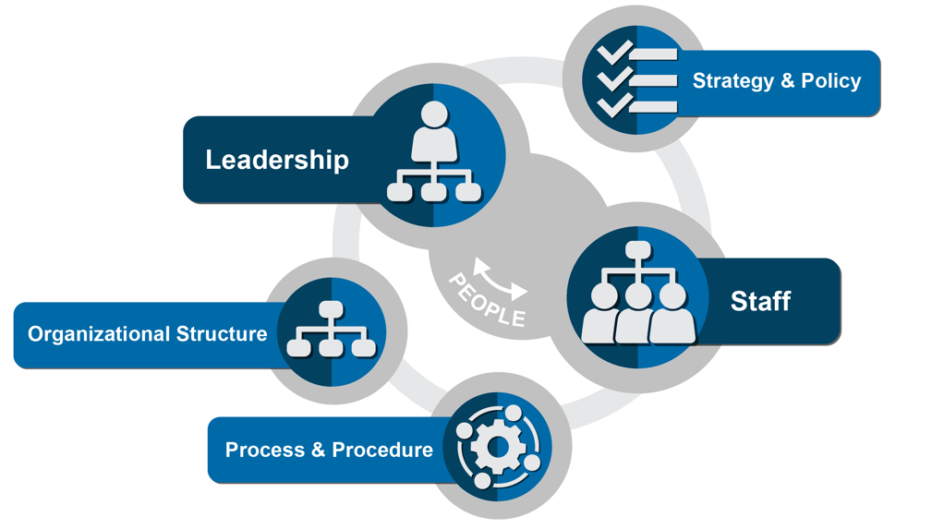
- Describe the extent to which your organizational elements are already aligned to support innovation within your team. Also consider your business function, and even your organization as a whole; to what extent is this broader set of elements properly aligned?
Leadership: Insert here…

Staff: Insert here…

Strategy and Policy: Insert here…

Organizational Structure: Insert here…

Process and Procedure: Insert here…

- Consider others within your team, as well as other business functions. Are they aligned to support innovation? Think of initiatives and new ideas you have pursued. Do others support or block your progress? Where your team’s business function is named, take some extra time to consider its current state.
Business Functions | Aligned?
Corporate Management (CEO/C-Suite)
Legal
Administration
Human Resources
Procurement
Property Management
Finance
Public Affairs
Air Service/Marketing
Information Technology
Operations/Maintenance
Planning / Engineering
Security/Safety
Other business function…
Other business function…
Other business function…
Other business function…
Other business function…

- Consider your airport’s industry partners, to the extent you interact with them; are they aligned to support innovation? Think in the context of the reach of your team and initiatives you are seeking to implement. Your ideas here could be very beneficial to your manager and other leaders.
Aviation Partner | Aligned?
Airlines
Government Agencies (TSA, CBP, FAA)
Concessionaires
Ground Transportation
FBOs
Other Airports
Passengers
Public Affairs
Other partner…
Other partner…

- Consider yourself and those around you in your team. Which persona descriptions fit these individuals? Also consider the organization as a whole; would you make a good participant or ambassador of a broader culture of innovation program?
Persona | People
Catalyst
Enabler
Accelerator
Sustainer
Challenger
Inhibitor
Destroyer

Part 2: Develop (read it here)

Part 2 Check-In
- What issues or challenges are you experiencing in your everyday tasks? Is there a specific item you and your team could consider an innovative solution? If so, what would you need from management or above to move in a direction of innovation?
Insert answer here…

- Do you believe your organization would be supportive of you and your team trying new things in pursuit of innovation? If so, are you lacking anything in being able to pursue innovation?
Insert answer here…

- What persona trait do you align with from Chapter 2? What about your co-workers?
Insert answer here…

Personal Notes

Chapter 4 (read it here)
Insert notes here…

Chapter 5 (read it here)
Insert notes here…

Part 2 Check-Out
- How has the cultivation cycle in Chapter 4 changed your view about innovation relative to your department or even your own contributions? Are you already innovating? If so, write down some examples. Do you encourage your team to celebrate achievements? If so, what makes you and your team feel special when you tackle a hard project?
Insert answer here…

- Did you identify a role for yourself developing a culture of innovation in your department? How about in your business function? Or in your organization as a whole? You can use the playbook worksheet to select which Plays you are going to personally implement.
Insert answer here…

- What challenges in the matrix provided at the end of Chapter 4 resonated with you about your department? Continue into Chapter 7 for additional correlations to Plays and supplemental resources that will help you deal with these challenges.
Insert answer here…

Part 3: Sustain (read it here)

Part 3 Check-In
- For the Plays you selected in Part 2, were you able to work with your team to deploy any of them? Maybe your deployment was with yourself, or between you and your manager.
Insert answer here…

- Did you gain any insights from the Plays and how effective they were or could be with your team? The next few chapters will provide additional ideas and resources to help you refine your Plays.
Insert answer here…

- Did new barriers or challenges emerge within your business function once you deployed a Play? Identify which organizational element(s) were most challenging in implementing your Plays.
Insert answer here…

Personal Notes

Chapter 6 (read it here)
Insert notes here…

Chapter 7 (read it here)
Insert notes here…

Chapter 8 (read it here)
Insert notes here…

Part 3 Check-Out

Now that you have completed Part 3, take a moment to consider how you will implement what you have learned.
- Has your organization identified a team that will maintain accountability for making progress toward the desired culture change? If so, consider volunteering to be part of this team. If not, recommend that your leaders take a look at this WebResource.
Insert answer here…

- Has your organization selected Plays and used the playbook worksheet to start tracking their deployment? Or within your team or business function, have you identified Plays to deploy? If not, what is holding you back? Track this as something to resolve going forward.
Insert answer here…

- Have you shared this WebResource will your colleagues? If not, do so now! They will probably key in on things you did not. This will make a great opportunity to come together, share ideas, and be the spark to help your team, business function, or organization move one step closer to a culture of innovation.

