The following document is supplemental to ACRP WebResource 16: Playbook for Developing a Culture of Innovation at Airports (ACRP Project 01-47, “A Guide to Developing a Culture of Innovation at Airports”). The full WebResource can be found at https://crp.trb.org/acrpwebresource16/.

The Airport Cooperative Research Program (ACRP) is sponsored by the Federal Aviation Administration. ACRP is administered by the Transportation Research Board (TRB), part of the National Academies of Sciences, Engineering, and Medicine. Any opinions and conclusions expressed or implied in resulting research products are those of the individuals and organizations who performed the research and are not necessarily those of TRB; the National Academies of Sciences, Engineering, and Medicine; or ACRP sponsors.

Developing a Culture of Innovation
WebResource Companion Worksheet

Welcome to the companion worksheet for ACRP WebResource 16: Playbook for Developing a Culture of Innovation at Airports. This worksheet provides you with a place to answer questions and take notes to help spur you on toward implementing the ideas presented in the WebResource.

This worksheet presents the check-in and check-out questions based on your perspective as a business function leader and prompts you to provide answers that apply to your organization, business function, and/or your team, as well as yourself individually.

Part 1: Understand (read it here)

Part 1 Check-In
Before reading Part 1, consider and answer the following questions:

- How would you describe the culture of your business function today? Underline each that apply. Further, does it differ from that of the organization as a whole?

- Appreciative  - Biased  - Boring  - Casual  - Collaborative  - Connected  - Creative  - Curious  - Decisive  - Demanding | - Disengaged  - Diverse  - Empathetic  - Engaging  - Flexible  - Fun  - Happy  - Hostile  - Inclusive  - Innovative | - Micromanaged  - Motivating  - Nimble  - Nurturing  - Outdated  - Progressive  - Relaxed  - Respectful  - Rewarding  - Safe | - Siloed  - Stagnant  - Stressful  - Supportive  - Toxic  - Transparent  - Trusting  - Unaccountable  - Unsupportive  - Welcoming
Others? Describe here:

- Do you think your business function has a culture of innovation? Why or why not? (Or maybe another way to think about it: what things do you see that point to or stand in contrast to a culture of innovation?)
Describe here:

- Do you think you have a mindset of innovation? Why or why not? What things do you do (or wish you could do) that contributes to a mindset of innovation?
Describe here:

Personal Notes

Chapter 1 (read it here)
Insert notes here…

Chapter 2 (read it here)
Insert notes here…

Chapter 3 (read it here)
Insert notes here…

Part 1 Check-Out
After reading Part 1: Understand, consider and answer the following questions:

- Has your opinion changed regarding whether your business function has a culture of innovation? If so, is your culture more or less like the description of a culture of innovation? Also consider the impact of the broader organizational culture and whether you are in alignment.
Describe here:

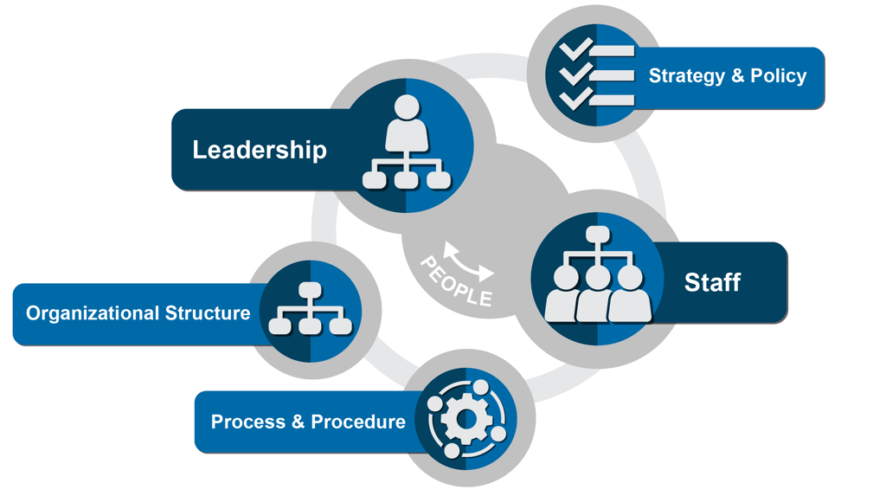
- Describe the extent to which your organizational elements are already aligned to support innovation within your business function. Also consider your organization as a whole; to what extent is this broader set of elements properly aligned?
Leadership: Insert here…

Staff: Insert here…

Strategy and Policy: Insert here…

Organizational Structure: Insert here…

Process and Procedure: Insert here…

- Consider other business functions at your airport. Are they aligned to support innovation? Think of initiatives and new ideas you have pursued. Did other functions support or block your progress? Your ideas here could be very beneficial to your executive leadership team. Where your team’s business function is named, take some extra time to consider its current state.
Business Functions | Aligned?
Corporate Management (CEO/C-Suite)
Legal
Administration
Human Resources
Procurement
Property Management
Finance
Public Affairs
Air Service/Marketing
Information Technology
Operations/Maintenance
Planning / Engineering
Security/Safety
Other business function…
Other business function…
Other business function…
Other business function…
Other business function…

- Consider your airport’s industry partners; are they aligned to support innovation? Think in the context of the reach of your business function and initiatives you are seeking to implement.
Aviation Partner | Aligned?
Airlines
Government Agencies (TSA, CBP, FAA)
Concessionaires
Ground Transportation
FBOs
Other Airports
Passengers
Public Affairs
Other partner…
Other partner…

- Consider yourself and those around you in your business function. Which persona descriptions fit these individuals? Also consider the organization as a whole and whether there are individuals in your business function that would be of great benefit to a broader culture of innovation program.
Persona | People
Catalyst
Enabler
Accelerator
Sustainer
Challenger
Inhibitor
Destroyer

Part 2: Develop (read it here)

Part 2 Check-In
- When you think about your business function, rank the following statements from 1-5 with 1 being “less likely” and 5 being “absolutely.”
Statements | 1 | 2 | 3 | 4 | 5
Innovation activities are happening
You see staff trying to innovate
You celebrate results from innovation
You have a formal innovation team
- Does your business function have a mindset of innovation? Rank from 1-5 with 1 being “less likely” and 5 being “absolutely,” relative to each of these mindset of innovation concepts.
Statements | 1 | 2 | 3 | 4 | 5
Open to change
Consider experimenting
Resist fear of failure
Learn from setbacks
Desire to collaborate
Seek feedback
Inspired by other’s success
Accountable
Go back to each of these items with a score of 3 or below and list at least one item you can do to improve the score.

Personal Notes

Chapter 4 (read it here)
Insert notes here…

Chapter 5 (read it here)
Insert notes here…

Part 2 Check-Out
- After selecting Plays from Chapter 5 for your business function, how will you track and manage deploying them across your business function? Have you included opportunities to involve other airport partners in this endeavor?
Insert answer here…

- Do you have any specific team members in mind that would form a culture of innovation team to track and manage the deployment of your Plays? If not, revisit the personas in Chapter 2 to gain insight into the positive traits that would benefit your implementation plan, as well as guard against those negative traits discussed
Insert answer here…

- Seeing the cultivation cycle in Chapter 4, can you name at least one way in which your business function accomplishes the elements shown in the cycle?
Insert answer here…

- What challenges in the matrix provided at the end of Chapter 4 resonated with you about your business function? Continue into Chapter 7 for additional correlations to Plays and supplemental resources that will help you deal with these challenges.
Insert answer here…

Part 3: Sustain (read it here)

Part 3 Check-In
- Have you tried some of your Plays with your business function? Take some notes about their effectiveness or the challenges you experienced; the next few chapters will provide additional ideas and resources to help you refine your Plays
Insert answer here…

- Did new barriers or challenges emerge within your business function once you deployed a Play? Identify which organizational element(s) were most challenging
Insert answer here…

- As you implemented new Plays, did new persona traits emerge? How did these personas impact the Play?
Insert answer here…

Personal Notes

Chapter 6 (read it here)
Insert notes here…

Chapter 7 (read it here)
Insert notes here…

Chapter 8 (read it here)
Insert notes here…

Part 3 Check-Out

Now that you have completed Part 3, take a moment to consider how you will implement what you have learned.
- Has your organization identified a team that will maintain accountability for making progress toward the desired culture change? If not, champion this among your fellow leaders, and track it as something to resolve going forward.
Insert answer here…

- Has your organization selected Plays and used the playbook worksheet to start tracking their deployment? Or within your business function, have you identified Plays to deploy? If not, what is holding you back? Track this as something to resolve going forward.
Insert answer here…

- Have you identified opportunities to put in place sustainability processes and tools from Chapters 6-8? If not, what is holding you back? Track this as something to resolve going forward.
Insert answer here…

- Have you shared this WebResource will your colleagues? If not, do so now! They will probably key in on things you did not. This will make a great opportunity to come together, share ideas, and be the spark to help your team, business function, or organization move one step closer to a culture of innovation.

