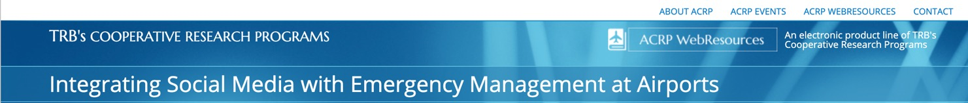

Federal and Airline Newsroom Links
This sample checklist was compiled as part of the research for ACRP WebResource 8 and is meant to be modified according to what best fits your program.

Federal Media/Newsroom Links
FAA | https://www.faa.gov/news/contact_information/
FBI - Offices | https://www.fbi.gov/contact-us/field-offices
TSA | https://www.tsa.gov/news/press
CBP | https://www.cbp.gov/newsroom/press
CDC | https://www.cdc.gov/media/subtopic/contact.htm
NTSB | https://www.ntsb.gov/news/pages/media_resources.aspx
NOAA | https://oceanservice.noaa.gov/newsroom/
USDA | https://www.usda.gov/media
FWS - Offices | https://www.fws.gov/offices/
USCG | https://www.news.uscg.mil/News_Region/

Airline Newsroom Links
Aero México | https://aeromexico.com/en-us/about-us/press-room
Air Canada Airlines | https://aircanada.mediaroom.com/
Air France - KLM | https://corporate.airfrance.com/en/press
Alaska Airlines | https://newsroom.alaskaair.com/
American Airlines | http://news.aa.com/home/default.aspx
Delta Air Lines | https://news.delta.com/
Detroit Metro Airport | https://www.metroairport.com/business/media-center
Emirates | https://www.emirates.com/media-centre/
EVA Air | https://www.evaair.com/en-global/about-eva-air/news/news-releases/#
Frontier Airlines | https://news.flyfrontier.com/
Hawaiian Airlines | https://newsroom.hawaiianairlines.com/
JetBlue | http://bluemedia.investproductions.com/media-room
Lufthansa | https://www.lufthansagroup.com/en/press.html
Qatar | https://www.qatarairways.com/en-us/media-newsroom.html
Southwest | https://www.swamedia.com/pages/contacts
Spirit Airlines | https://www.spirit.com/Contact.aspx
Sun Country Airlines | https://www.suncountry.com/About/News.html
United Airlines | https://hub.united.com/search/?q=contact&searchfor=newsroom

