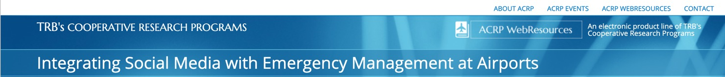

EOC/JIC Activation Checklist
This sample checklist was compiled from airports as part of the ACRP research and is meant for you to modify for what best fits your crisis communications plan. The Responsibility column has been left blank since each airport’s reporting structure is unique. The checklist is designed to allow for a single duplex printed sheet that may be laminated as a quick reference (you may need to adjust the font and table properties to keep it a single sheet).

Initial Activation - Crisis Communications Team
Done  (✓) | Actions | Responsibility
 | Put the [Public Affairs] team on standby
 | Activate the Crisis Communications Plan
 | Contact the Crisis Communications Team. [Establish meeting location and time]
 | Crisis Communications Team assembled and briefed
 | Assign Crisis Communications Team roles
 | Designate team members to log all actions/decisions/communications efforts
 | Designate incident command center spokesperson
 | Contact Airport Support Team (IT, Admin., etc.)
 | Activate the Dark Site (Crisis Website)
 | Review available information surrounding crisis event
 | Designate official spokesperson and alternate
 | Initiate contact with designated key stakeholders as appropriate
 | Draft initial/holding statement for media
 | Determine first formal briefing press time
 | Set up media perimeter with public safety coordination
 | Designate staff member to draft terminal messaging
 | Designate staff member to draft hospital messaging

Once Activated – Other Crisis Communications Team Duties
Done  (√) | Actions | Responsibility
 | Contact appropriate departments to gain more information about the incident. (Airlines, EOC Mgr., Duty Manager)
 | Contact appropriate partners or departments about Friends and Relative Center (usually set up by airlines).
 | Immediately release holding statements to [media agencies] in regards to incident
 | Disseminate information to airport employees
 | Establish call logging of incoming calls and all media inquiries to facilitate updates
 | Create an email list for press releases, starting with base list and adding requesters as they reach out
 | Update social media posts as crisis progresses via Twitter, Facebook and other appropriate means
 | Begin media monitoring/recording including broadcast and social media
Hold initial press conference Distribute press release and media kit (if applicable)
Location:
 | Distribute press releases and media kits (if applicable) to media email contact list
 | Update social media sites as necessary for public and stakeholder information or as requested by the IC for public safety
 | Inform media of procedures and guidelines when viewing/reporting on the scene. Escort media to crisis site.
 | Hold crisis team update meeting hourly, or as needed

