Snow and Ice Control Plan

(Insert your Airport Name)

Table of Contents

**Phase #1 Pre- and Post Winter Season Topics Page**

**Chapter 1. Pre-Season Actions**

* 1. Airport Preparation…………………………………………………………………………………

Airport Management Meetings…………………………..……………………………………………………….………………...

Personnel Training……………………………………………….……………………….……….

Equipment Preparation…………………………………………………..……….……………….

* 1. Snow and Ice Control Committee (SICC) Meetings……………….…………………………..

**Chapter 2. Post Event/Season Actions**

* 1. Post Event…………………………………………………………………………………………..
  2. Post Season………………………………………………………………………………….……..

**Phase #2 Winter Storm Actions and Procedures**

**Chapter 3. Snow Removal Action Criteria**

* 1. Activating Snow Removal Personnel……………………………………………….……………

Weather Forecasting……………………………………………………………………………….

Chain of Command………………………………………………………………………………...

Triggers for Initiating Snow Removal Operations……………………………………………….

* 1. Personnel Responsible…………………………………………………………………………….
  2. Snow Control Center (SCC)……………………………………………………………………………….
  3. Airfield Clearing Priorities………………………………………………………………………….

Priority 1……………………………………………………………………………………………..

Priority 2……………………………………………………………………………………………..

Priority 3……………………………………………………………………………………………..

* 1. Airfield Clearance Times…………………………………………………………………………..
  2. Snow Equipment List………………………………………………………………………………
  3. Storage of Snow and Ice Control Equipment……………………………………………………
  4. Definitions…………………………………………………………………………………………...

**Chapter 4. Snow Clearing Operations and Ice Prevention**

* 1. Snow Clearing Principles………………………………………………………………………….

Ramp and Terminal………………………………………………………………………………..

Runway and Taxiways…………………………………………………………...………………..

Snowbanks………………………………………………………………………………………….

NAVAIDS……………………………………………………………………………………………

* 1. Controlling Snow Drifts…………………………………………………………………………….
  2. Snow Disposal……………………………………………………………………………………...
  3. Methods for Ice Control and Removal–Chemicals…………………………………………….
  4. Sand…………………………………………………………………………………………………
  5. Surface Incident/Runway Incursion Mitigation Procedures……………………………………

Radio Communication……………………………………………………………………………..

Failed Radio Communication……………………………………………………………………..

Low Visibility and Whiteout Conditions…………………………………………………………..

Driver Fatigue……………………………………………………………………………………….

**Chapter 5. Surface Assessment and Reporting**

* 1. Conducting Surface Assessments……………………………………………………………….
  2. Applying the Runway Condition Assessment Matrix (RCAM)………………………………..

Determining Runway Conditions…………………………………………………………………

Downgrade Assessment Criteria ………………………………………………………………..

Upgrade Assessment Criteria Based on Friction Assessments………………………………

* 1. Runway Friction Surveys, Equipment, and Procedures………………………………………..

Conditions acceptable to use Decelerometers or Continuous Friction Measuring Equipment to conduct runway friction surveys on frozen contaminated surfaces…………..

When to Conduct…………………………………………………………………………………...

How to Conduct…………………………………………………………………………………….

Calibration…………………………………………………………………………………………..

* 1. Taxiway, Apron, and Holding Bay Assessments……………………………………………….
  2. Surface Condition Reporting………………………………………………………………………
  3. Reportable Contaminants without Performance Data………………………………………….
  4. Slippery When Wet Runway………………………………………………………………………
  5. Requirements for Closures…………………………………………………………………….....
  6. Continuous Monitoring and Deteriorating Conditions…………………………………………..
  7. Surface Conditions Not Being Monitored/Reported…………………..………………………..

Appendices

Insert

Phase #1

Pre- and Post-Winter Season Topics**Chapter 1. Pre-Season Actions**

**1.1 Airport Preparation**

# a) Airport Management Meetings

# The (titles) will typically initiate a meeting the month of (month) timeframe to discuss equipment and material inventory, repair needs, staffing, budget, training, previous years issue’s, and any other topics associate with snow and ice control and its plan.

**b) Personnel Training**

All (title or department) personnel receive annual, recurrent snow removal training. All training for airport personnel is conducted by (state whom). Training records are maintained by (title). (State what training is provided).

* + 1. (Title i.e. Operations and describe training received)
    2. (Title i.e. Maintenance and describe training received)

**c) Equipment Preparation**

The airports (type of friction tester) will be calibrated, updated and certified (timeframe recommended by manufacturer i.e. annually) (when i.e. during summer if applicable).

(Timeline i.e. 30 or 60 days) prior to snow season (title, department or company) will inspect and prepare each piece of snow removal equipment. Required fluids, replacement parts, and snow removal equipment components will be inventoried and stockpiled.

**1.2 Snow and Ice Control Committee (SICC) Meetings.**

Does the airport have a SICC? Provide who is on the committee.

The Airport has developed a Snow and Ice Control Committee (SICC) to provide feedback and make recommendations to snow and ice removal operations and Snow and Ice Control Plan (SICP) updates at (Airport Name). The SICC is chaired by (title) and includes (list departments or titles from the airport), Federal Aviation Administration (Air Traffic and/or Technical Operations), and (list tenants, i.e. air carriers, FBO, flight school).

If applicable:

Tenants and airport users not able to participate in the SICC are provided minutes and kept apprised of all changes and provided the opportunity to comment.

During the month of (state when) the Airport will begin notifying tenants and airport users to review and provide comments to be discussed at the season kick-off meeting (state when).

The following topics should be discussed in the SICC:

* Airport Clearing Operations Discussion Topics
  + Areas Designated as Priority I area, any new airfield infrastructure
  + Clearing operations and follow-up airfield assessments
  + Potentials for pilot or vehicular runway incursions or incidents
  + Staff requirements and qualifications (training)
  + Update training program
  + Streamline decision making process
  + Response time to keep runways, taxiways and ramp areas operational
  + Communication, terminology, frequencies, and procedures
  + Monitoring and updating of runway surface conditions
  + Issuance of NOTAMS and dissemination to ensure timely notification
  + Equipment inventory
  + Status of procurement contracts, including storage of materials
  + Validation of deicer certification letters from vendors (if applicable)
  + Procedures for storm water runoff mitigation
  + Snow hauling/disposing, snow dumps
  + New runoff requirements for containment or collection
  + Changes to contract service for clearing ramps
* Air Carrier Ground Deicing/anti-icing programs
  + Assessing all air carriers deicing programs by reviewing airport surface flow strategies; reviewing ground time and takeoff clearances after deicing; analyzing and adjusting airplane deicing plans
  + Maximizing efficiency of operations during icing conditions by identifying locations for airplane deicing; planning taxi routes to minimize ground times; developing rates for deiced departures; allocating departure slots; determination airport deicing crew needs; verifying communications.
* Any requirements for containment/collection of deicing/anti-icing.

**Chapter 2. Post-Event/Season Actions**

* 1. **Post Event.**

After each snow event, airport management will/may host a meeting and invite (Air Traffic if applicable) to discuss any issues that have arisen from the event.

All members of the SICC will be encouraged to provide feedback to airport management before, during or following each snow event. After a significant event or a challenging operation, a separate SICC meeting will be held.

If applicable:

During the snow season, winter operations is an agenda item at (tenant meetings, station manager meeting, etc.), which is held (state frequency, i.e. monthly).

* 1. **Post Season.**

After each snow season a SICC meeting will be held, typically in (state month) to review the snow season issues and recommendations for changes. The same topics as pre-season should be reviewed.

Provide actions for each of your department or sections post season, i.e. Maintenance-inspect and repair equipment, Operations – calibrate friction tester, airport management – update SICP.

Phase #2

Winter Storm Actions and Procedures

**Chapter 3. Snow Removal Action Criteria**

**3.1 Activating Snow Removal Personnel.**

Describe overall staffing and procedures you have in place. If your airport has several sections/departments with responsibilities during snow removal operations provide explanation of responsibilities for each section.

**a)** **Weather Forecasting**

* Who is responsible to monitor the current and/or forecast weather conditions? How often?
* What sources are used for weather forecasts?
* Does your airport have surface sensors?

**b) Chain of Command**

* Who is responsible to monitor the airfield and when, how often?
* Is the airfield physically inspected? By whom?
* Who is responsible to initiate a Snow Alert Callout?
* Specify Procedures for Callout and Notification of Personnel
* Hold over or call in of personnel?

**c) Triggers for Initiating Snow Removal Operations**

Snow removal operations will begin when contaminants begin accumulating on pavement surfaces. Explain when and how these operations will begin (if applicable). Describe how these triggers were developed.

| **Precipitation** | **Depth in Inches** |
| --- | --- |
| Slush | ? |
| Wet Snow | ? |
| Dry Snow | ? |
| Ice or Freezing Rain | ? |

* 1. **Personnel Responsible.**

Describe each section (i.e. Maintenance, Operations, and Management) and the responsibilities under the SICP.

* 1. **Snow Control Center (SSC).**

If applicable, describe where, when and who operates the SCC (i.e. snow desk or command vehicle).

At a minimum, the SCC will perform the following functions:

* Managing snow clearing operations.
* Serving as the prime source for initiating FICONS, Closures, Openings, etc.
* Informing ATCT, Air Carriers, Air Taxis, and other users of airport conditions.
* Issuing NOTAMs.

What additional functions does the SCC perform at your airport?

**3.4 Airfield Clearing Priorities.**

Describe how the priorities are determined. A color coded map may be included but should not substitute text.

**a) Priority 1**

List areas to be cleared which are the most critical portions of the aircraft movement area and supporting facilities. This would normally include primary runways with associated turnoffs, access taxiways leading to the terminal, the terminal and cargo aprons, ARFF stations and designated emergency response roads, gates, and NAVAIDs**.** The entire airport would not be a Priority 1.

**b) Priority 2**

List areas to be cleared in Priority 2, which are areas of less importance than Priority 1. These areas would include crosswind/secondary runways and associated taxiways, remaining aircraft movement areas, commercial ramp areas.

**c) Priority 3**

At some airports areas not essential to flight operations or not used on a daily basis would be Priority 3. Some airports might only have Priority 1 and 2 and not Priority 3.

**3.5 Airfield Clearance Times.**

Discuss your airfield clearance times. This should not be limited to runways it needs to include required associate taxiways.

State which table below you comply with and delete the other table.

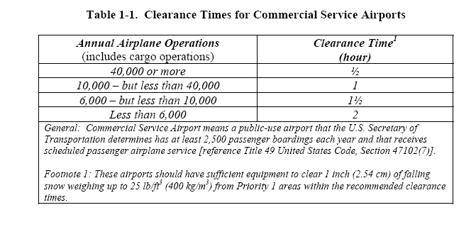

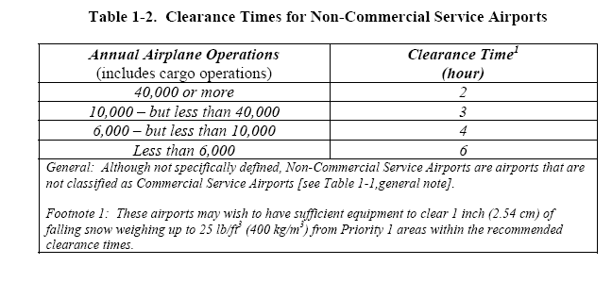

* 1. **Snow Equipment List.**

This can be referenced as an exhibit but provide year, make, model of each piece of snow equipment. Some airports may use primary are secondary equipment.

List Equipment

**3.7 Storage of Snow and Ice Control Equipment.**

Describe where equipment is stored and maintained, inside, inside heated or outside.

**3.8** **Definitions.**

Airside Urea.

(Otherwise known as “Carbamide”) The approved specifications are SAE AMS 1431, Compound, Solid Runway and Taxiway Deicing/Anti-Icing, and MIL SPEC DOD-U-10866, Technical Urea. Agricultural grade urea that meets any of these specifications, called airside urea, is acceptable.

Approved Chemical.

A chemical, either solid or liquid, that meets a generic SAE or MIL specification.

Ash.

A grayish-white to black solid residue of combustion normally originating from pulverized particulate matter ejected by volcanic eruption.

Compacted Snow.

Snow that has been compressed and consolidated into a solid form that resists further compression such that an airplane will remain on its surface without displacing any of it. If a chunk of compressed snow can be picked up by hand, it will hold together or can be broken into smaller chunks rather that falling away as individual snow particles.

Note: A layer of compacted snow over ice must be reported as compacted snow only.

Example: When operating on the surface, significant rutting or compaction will not occur. Compacted snow may include a mixture of snow and embedded ice; if it is more ice than compacted snow, then it should be reported as either ice or wet ice, as applicable.

Contaminant.

A deposit such as frost, any snow, slush, ice, or water on an aerodrome pavement where the effects could be detrimental to the friction characteristics of the pavement surface.

Contaminated Runway.

For purposes of generating a runway condition code and airplane performance, a runway is considered contaminated when more than 25 percent of the runway surface area (within the reported length and the width being used) is covered by frost, ice, and any depth of snow, slush, or water.

When runway contaminants exist, but overall coverage is 25 percent or less, the contaminants will still be reported. However, a runway condition code will not be generated.

While mud, ash, sand, oil, and rubber are reportable contaminants, there is no associated airplane performance data available and no depth or Runway Condition Code will be reported.

Exception: Rubber is not subject to the 25 percent rule, and will be reported as Slippery When Wet when the pavement evaluation/friction deterioration indicates the averaged Mu value on the wet pavement surface is below the Minimum Friction Level classification specified in Table 3-2 of FAA Advisory Circular 150/5320-12.

Dry (Pavement).

Describes a surface that is neither wet nor contaminated.

Dry Runway.

A runway is dry when it is neither wet, nor contaminated. For purposes of condition reporting and airplane performance, a runway can be considered dry when no more than 25 percent of the runway surface area within the reported length and the width being used is covered by:

Visible moisture or dampness, or

Frost, slush, snow (any type), or ice.

A FICON NOTAM must not be originated for the sole purpose of reporting a dry runway. A dry surface must be reported only when there is need to report conditions on the remainder of the surface.

Dry Snow.

Snow that has insufficient free water to cause it to stick together. This generally occurs at temperatures well below 32° F (0° C). If when making a snowball, it falls apart, the snow is considered dry.

Eutectic Temperature/Composition.

A deicing chemical melts ice by lowering the freezing point. The extent of this freezing point depression depends on the chemical and water in the system. The limit of freezing point depression, equivalent to the lowest temperature that the chemical will melt ice, occurs with a specific amount of chemical. This temperature is called the eutectic temperature, and the amount of chemical is the eutectic composition. Collectively, they are referred to as the eutectic point.

FICON (Field Condition Report).

A Notice to Airmen (NOTAM) generated to reflect Runway Condition Codes, vehicle braking action, and pavement surface conditions on runways, taxiways, and aprons.

Fluid Deicer/Anti-Icers. The approved specification is SAE AMS 1435, Fluid, Generic Deicing/Anti-icing, Runways and Taxiways.

Frost.

Frost consists of ice crystals formed from airborne moisture that condenses on a surface whose temperature is below freezing. Frost differs from ice in that the frost crystals grow independently and therefore have a more granular texture.

Note: Heavy frost that has noticeable depth may have friction qualities similar to ice and downgrading the runway condition code accordingly should be considered. If driving a vehicle over the frost does not result in tire tracks down to bare pavement, the frost should be considered to have sufficient depth to consider a downgrade of the runway condition code.

Generic Solids. The approved specification is SAE AMS 1431, Compound, Solid Runway and Taxiway Deicing/Anti-Icing.

Ice.

The solid form of frozen water to include ice that is textured (i.e., rough or scarified ice).

A layer of ice over compacted snow must be reported as ice only.

Layered Contaminant.

A contaminant consisting of two overlapping contaminants. The list of layered contaminants has been identified in the RCAM and include:

* Dry Snow over Compacted Snow
* Wet Snow over Compacted Snow
* Slush over Ice
* Water over Compacted Snow
* Dry Snow over Ice
* Wet Snow over Ice

Mud.

Wet, sticky, soft earth material.

Multiple Contaminants.

A combination of contaminants (as identified in the RCAM) observed on paved surfaces. When reporting multiple contaminants, only the two most prevalent / hazardous contaminants are reported. When reporting on runways, up to two contaminant types may be reported for each runway third. The reported contaminants may consist of a single and layered contaminant, two single contaminants, or two layered contaminants. The reporting of “multiple contaminants” represent contaminants which are located adjacent to each other, not to be confused with a “layered contaminant” which is overlapping. For example:

* Single contaminant and Layered contaminant.

‘Wet’ and ‘Wet Snow over Compacted Snow’

* Single contaminant and Single contaminant.

‘Wet Snow’ and ‘Slush’

* Layered contaminant and Layered contaminant.

‘Dry Snow over Compacted Snow’ and ‘Dry Snow over Ice’

Oil.

A viscous liquid, derived from petroleum or synthetic material, especially for use as a fuel or lubricant.

Runway (Primary and Secondary).

Primary.

Runway(s) being actively used or expected to be used under the existing or anticipated adverse meteorological conditions, where the majority of the takeoff and landing operations will take place.

Secondary.

Runway(s) that supports a primary runway and is less operationally critical. Takeoff and landing operations on such a runway are generally less frequent than on a primary runway. Snow removal operations on these secondary runways should not occur until Priority 1 surfaces are satisfactorily cleared and serviceable.

Runway Condition Assessment Matrix (RCAM).

The tool by which an airport operator will assess a runway surface when contaminants are present.

Runway Condition Code (RwyCC).

Runway Condition Codes describe runway conditions based on defined contaminants for each runway third. Use of RwyCCs harmonizes with ICAO Annex 14, providing a standardized “shorthand” format (Eg: 4/3/2) for reporting. RwyCC (which replaced Mu values) are used by pilots to determine landing performance calculations.

Sand.

A sedimentary material, finer than a granule and coarser than silt.

Slush.

Snow that has water content exceeding a freely drained condition such that it takes on fluid properties (e.g., flowing and splashing). Water will drain from slush when a handful is picked up. This type of water-saturated snow will be displaced with a splatter by a heel and toe slap-down motion against the ground.

Slush over Ice.

See individual definitions for each contaminant.

Slippery When Wet Runway.

A wet runway where the surface friction characteristics would indicate diminished braking action as compared to a normal wet runway.

Slippery When Wet is only reported when a pavement maintenance evaluation indicates the averaged Mu value on the wet pavement surface is below the Minimum Friction Level classification specified in Table 3-2 of FAA Advisory Circular 150/5320-12. Some contributing factors that can create this condition include: Rubber buildup, groove failures/wear, pavement macro/micro textures.

Water.

The liquid state of water. For purposes of condition reporting and airplane performance, water is greater than 1/8-inch (3mm) in depth.

Wet Runway.

A runway is wet when it is neither dry nor contaminated. For purposes of condition reporting and airplane performance, a runway can be considered wet when more than 25 percent of the runway surface area within the reported length and the width being used is covered by any visible dampness or water that is 1/8-inch or less in depth.

Wet Ice.

Ice that is melting, or ice with a layer of water (any depth) on top.

Wet Snow.

Snow that has grains coated with liquid water, which bonds the mass together, but that has no excess water in the pore spaces. A well-compacted, solid snowball can be made, but water will not squeeze out.

**Chapter 4. Snow Clearing Operations and Ice Prevention**

* 1. **Snow Clearing Principals.**

1. **Ramp and Terminal**

Describe snow clearing objective for the ramp and terminal and who is responsible? (Does your airport contract any portions or areas out?)

* Address procedures to:
* Ensure signs are clear of snow
* Stockpiles of snow issues:
* Height Limitations-Clearance
* Obstruct View of Pilots
* Heavy Snow-Hauling/Melting?

1. **Runway and Taxiways**

Describe equipment and procedures used at your airport. Describe local factors that contribute to these decisions. Designate the minimum acceptable clearing for runway at your airport (is it full width). Document the typical technique(s) used at your airport.

Types of formation of snow equipment (V-formation, close wing formation)

High Speed Turn Offs

1. **Snowbanks**

Snow Bank Height Profiles – See Figure 4-1. Which Design Group applies to your airport?

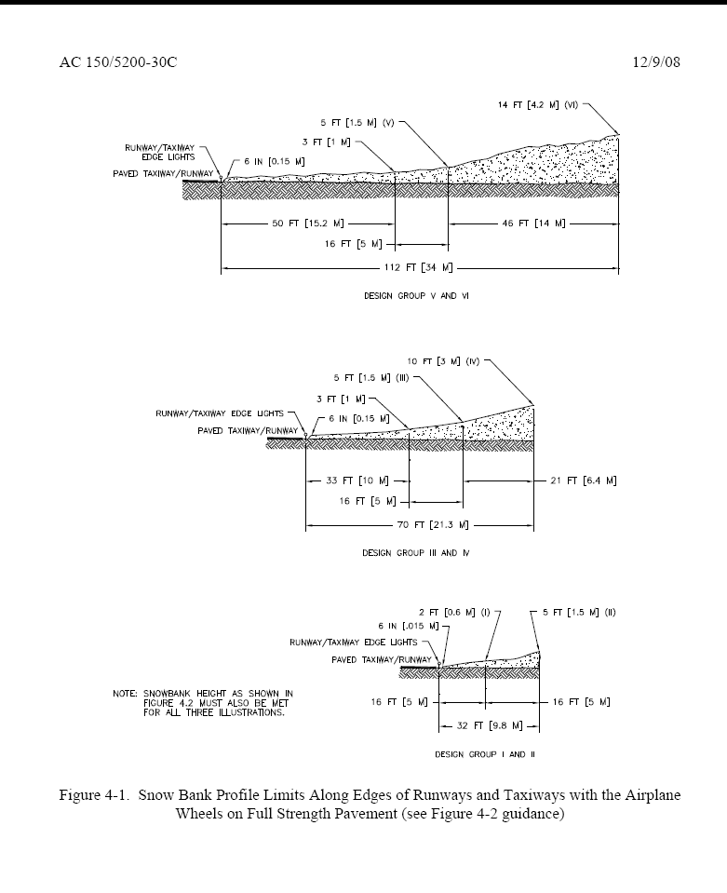

1. **NAVAIDs**

Address triggers to clear each glide slope critical areas and PAPI/VASI and who is responsible. Include maps describing critical areas.

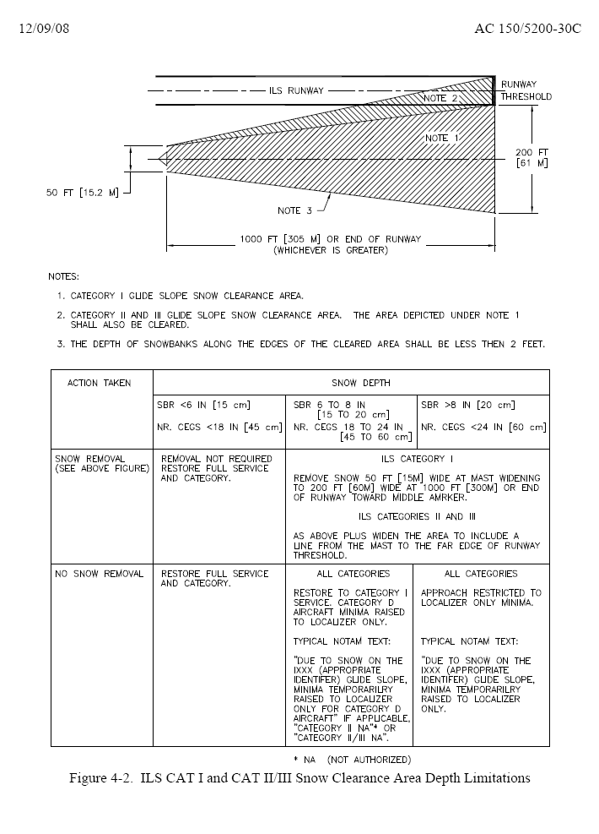

* 1. **Controlling Snow Drifts.**

Describe methods used at your airport (i.e. snow fences, snow trenches)

**4.3 Snow Disposal.**

Describe how and where large quantities of snow are disposed of.

**4.4** **Methods for Ice Control and Removal–Chemicals.**

Describe if anti-icer or de-icer products are used, which ones, and how they are applied.

**4.5 Sand (for the purposes of treating a winter surface).**

Describe if sand is used, how and when it is applied and if it is chemically treated or heated. State if your sand meets FAA gradient standards and which table below.

If a Modification of Standards exists, please indicate.

Table 4-2. Standard Gradation for Sand from Advisory Circular 150/5200-30D, Airport Field Condition Assessments and Winter Operations Safety. The A C is available on www.faa.gov.

Table 4-3. Expanded Sand Gradation Standard from Advisory Circular 150/5200-30D, Airport Field Condition Assessments and Winter Operations Safety. The A C is available on www.faa.gov.

* 1. **Surface Incident/Runway Incursion Mitigation Procedures.**

Do you review past surface incidents at your airport that have occurred during snow removal operations? Do you discuss how additional vehicles and time on the airfield might lead to a surface incident? What preventative measures have you put in place at your airport to prevent such an occurrence during winter operations.

Vehicles will be marked and lighted in accordance with AC 150/2510-5, Painting, Marking and Lighting of Vehicles Used on an Airport.

**a) Radio Communication**

How does radio communication work at your airport during Snow Operations? Provide description of your operation, i.e. ground control frequencies, scanner for approach and ground control, CTAF, or be in the direct control of vehicles equipment). Does one person monitor all communication and take the lead on communicating? Are equipment operators provided headsets?

**b) Failed Radio Communication**

What procedures do you have in place if radio communication fails between the snow team and or the Air Traffic Control Tower (if applicable)?

**c) Low Visibility and Whiteout Conditions**

Describe what specific procedures you have put in place to follow if visibility suddenly drops or a whiteout conditions exist.

d) **Driver Fatigue**

Do you have limits on time on equipment or shift? What do you to do for operator fatigue?

**Chapter 5.Surface Assessment and Reporting**

**Conducting Surface Assessments:**

(State the department, title or individuals) will remain aware and monitor all paved surface conditions in order to plan and carry out appropriate maintenance actions in accordance with the Snow and Ice Control plan. The airport strives to maintain a ‘no worse than wet’ surface condition.

The airport operator in complying with Part 139.339, at a minimum, will utilize the NOTAM system for collection, dissemination and logs of airport information to air carriers, and other airport users.

Describe which NOTAM System is used to report conditions.

(NOTAM Manager/ENII/Phone)

**5.1 Conducting Surface Assessments.**

Describe how your airport conducts assessments of runway, taxiway, apron, and holding bay conditions to ensure that they are accurate and timely.

* How often are assessments performed and who is responsible?
* What resources are used by the airport to assist in conducting assessments (IE: Vehicles, Sensors, Pilot Reports, CFME/Decelerometers, etc.)

**5.2 Applying the Runway Condition Assessment Matrix (RCAM).**

1. **Determining Runway Conditions**

Describe how the airport will determine the type of contaminant present on surfaces from the approved contaminant list. Insert the Runway Condition

Assessment Matrix (RCAM)

Step 1: Runway Condition Code (RwyCC) Applicability:

If 25 percent or less of the overall runway length and width or cleared width is covered with contaminants, RwyCCs must not be applied, or reported. The airport operator in this case, will simply report the contaminant percentage, type and depth for each third of the runway, to include any associated treatments or improvements.

Or

If the overall runway length and width coverage or cleared width is greater than 25 percent, RwyCCs must be assigned, and reported, informing airplane operators of the contaminant present, and associated codes for each third of the runway. (The reported codes, will serve as a trigger for all airplane operators to conduct a takeoff and/or landing performance assessment).

Step 2: Apply Assessment Criteria

Based on the contaminants observed, the associated RwyCC from the RCAM for each third of the runway will be assigned.

Step 3: Validating Runway Condition Codes

If the observations by the airport operator determine that RwyCCs assigned accurately reflect the runway conditions and performance, no further action is necessary, and the RwyCCs generated may be disseminated.

1. **Downgrade Assessment Criteria**

When observations indicate a more slippery condition than generated by the RCAM, the airport operator may downgrade the RwyCC(s). When applicable, the downgrade of RwyCCs may be based on friction (µ) readings, vehicle control or pilot reported braking action or temperature.

NOTE: Temperatures near and above freezing (e.g., at negative 26.6° F (-3° C) and warmer) may cause contaminants to behave more slippery than indicated by the runway condition code given in the RCAM. At these temperatures, airport operators should exercise a heightened awareness of airfield conditions, and should downgrade the RwyCC if appropriate.

1. **Upgrade Assessment Criteria Based on Friction Assessments.**

RwyCCs of 0 or 1 may only be upgraded when the following requirements are met.

1. All observations, judgment, and vehicle braking action support the higher RwyCC, and
2. Mu values of 40 or greater are obtained for the affected third(s) of the runway by a calibrated friction measuring device that is operated within allowable parameters.
3. This ability to raise the reported RwyCC to no higher than a code 3 can only be applied to those runway conditions listed under code 0 and 1 in the RCAM. (See footnote 2 on the RCAM.)
4. The airport operator must also continually monitor the runway surface as long as the higher code is in effect to ensure that the runway surface condition does not deteriorate below the assigned code.
   1. The extent of monitoring must consider all variables that may affect the runway surface condition, including any precipitation conditions, changing temperatures, effects of wind, frequency of runway use, and type of aircraft using the runway.
   2. If sand or other approved runway 'treatments are used to satisfy the requirements for issuing the higher runway condition code, the monitoring program must confirm continued effectiveness of the treatment.
   3. **Runway Friction Surveys, Equipment, and Procedures.**

What type of equipment (decelerometer or continuous friction measuring equipment) does the airport utilizes. If no friction equipment exists at your airport, please state.

1. **Conditions Acceptable to Use Decelerometers or Continuous Friction Measuring Equipment to Conduct Runway Friction Surveys on Frozen Contaminated Surfaces.**

The data obtained from such runway friction surveys are only considered to be reliable when the surface is contaminated under any of the following conditions.

* Ice or wet ice.
* Compacted snow at any depth.
* Dry snow 1 inch or less.
* Wet snow or slush 1/8 inch or less.

1. **When to Conduct**

Friction assessments should be conducted if any of the following occurs:

* When the central portion of the runway, centered longitudinally along the runway centerline, is contaminated 500 feet or more.
* After any type of snow removal operations or chemical application (including sanding)
* Immediately following any aircraft incident or accident on the runway.
* Describe any additional triggers you have locally.

1. **How to Conduct**

Describe procedures in how you conduct a friction test and address:

* lateral location from centerline (provide distance based on narrow or wide body aircraft)
* direction (same direction as arrival aircraft)
* friction tests is completed in one pass
* runway zones, touchdown, midpoint and rollout zones

1. **Calibration**

Describe how friction equipment is calibrated and who is responsible to ensure that it is.

**5.4 Taxiway, Apron, and Holding Bay Assessments.**

Assessments to these surfaces will occur when contaminants are present, and whenever a contaminant is present on the surface. Assessments will occur anytime the pavement is worse than wet. Surfaces will be monitored on a regular, continual basis.

Describe additional ‘specific’ procedures for conducting assessments on these areas:

**5.5 Surface Condition Reporting.**

Personnel responsible for implementing the SICP will carefully monitor changing airfield conditions and disseminate information about those conditions via the NOTAM System in a timely manner to airport users.

**Runway:** Runway condition reports will occur when contaminants are present on a runway surface via the Federal NOTAM System. Condition Reports and RwyCCs will be updated as necessary whenever conditions change, such as a contaminant type, depth, percentage or treatment/width change.

**Taxiway, Apron or Holding Bay:** Taxiway, Apron or Holding bay condition reports will occur when contaminants are present on these surfaces via the Federal NOTAM System. NOTAMS will be updated as necessary whenever conditions change, such as a contaminant type, depth, percentage or treatment/width change.

Describe additional ‘specific’ procedures for reporting:

* Triggers for a runway condition report to be updated or changed (time/changing weather conditions)?
* Triggers for a taxiway, apron or holding bay condition report to be updated or changed (time/changing weather conditions)?
* When the cleared runway width is less than full width, and if you have uncleared runway edges with a different condition from cleared width on runway.

Any time a change to the surface conditions occurs which could be any of the following:

* active snow event
* plowing/brooming/deicing/sanding
* rapidly rising or falling temperatures
* rapidly changing conditions

Describe how your airport assesses runway conditions to ensure that they are accurate and timely?

* How often and who is responsible?
* How this information is communicated to the user of your airport and who is responsible to communicate this information?
* What NOTAM systems are used to convey this information (should be included in you SICP).

The term ‘DRY’ is used to describe a surface that is neither wet nor contaminated. While a FICON NOTAM is not generated for the sole purpose of reporting a dry runway, a dry surface will be reported when there is need to report conditions on the remainder of the surface. (For example: snow is present on the first two thirds of the runway.)

**5.6 Reportable Contaminants without Performance Data.**

If present, unable to be removed, and posing no hazard, mud will be reported with a measured depth. Ash, oil, sand, and rubber contaminants will be reported without a measured depth. These contaminants will not generate a RwyCC.

**5.7 Slippery When Wet Runway.**

For runways where a friction survey (for the purposes of pavement maintenance) indicates the averaged Mu value at 40 mph on the wet pavement surface failed to meet the minimum friction level classification specified in AC 150/5320-12, the airport will report via the NOTAM system a RwyCC of ‘3’ for the entire runway (by thirds: 3/3/3) when the runway is wet.

A runway condition description of ‘Slippery When Wet’ will be used for this condition.

If it is determined by the airport that a downgrade is necessary, the downgrade will be made to all three runway thirds match (i.e. 3/3/3, 2/2/2, 1/1/1).

The NOTAM will be cancelled when the minimum runway friction level classification has been met or exceeded.

**5.8 Requirements for Closures.**

Runways receiving a NIL braking (either pilot reported or by assessment by the airport) are unsafe for aircraft operations and will be closed immediately when this unsafe condition exists.

Describe what procedures and Letters of Agreement (include LOA’s) that your airport has in place to immediately cease all aircraft operations, and close runway(s) when a NIL braking action is received, or when a NIL assessment is made.

When previous PIREPs have indicated GOOD or MEDIUM braking action, two consecutive POOR PIREPS should be taken as evidence that surface conditions may be deteriorating. If the airport operator has not already instituted its continuous monitoring procedures, an assessment should occur before the next operation. If the airport operator is already continuously monitoring runway conditions, this assessment should occur as soon as air traffic volume allows.

The airport will maintain available airport surfaces in a safe operating condition at all times and provide prompt notifications when areas normally available are less than satisfactorily cleared for safe operations. If a surface (runway, taxiway, apron, lane or holding bay) becomes unsafe due to a NIL (by braking action or assessment) or otherwise unsafe hazard or condition, the surface will be closed until the condition no longer exists and is safe.

It is recommended that airports develop additional triggers for runway, taxiway, apron, and holding bay closures (i.e., Maximum slush, wet, dry snow depths, ice, freezing rain, and a minimum RwyCC level). These tables may be derived from auditing a variety of the most common airplane operations at your airport.

**5.9 Continuous Monitoring** **and Deteriorating Conditions.**

Under deteriorating conditions, the airport will take all reasonable steps using available equipment and materials that are appropriate for the condition to improve the braking action. If braking action cannot be improved, and the surface is not NIL, the airport will continually monitor the runways, taxiways, aprons and holding bays to ensure braking does not become NIL.

**Including but not limited to:**

* Frozen or freezing precipitation.
* Falling air or pavement temperatures that may cause a wet runway to freeze.
* Rising air or pavement temperatures that may cause frozen contaminants to melt.
* Removal of abrasives previously applied to the runway due to wind or airplane effects.
* Frozen contaminants blown onto the runway by wind.

Expand upon additional continuous monitoring procedures that are put in place and what deteriorating braking action, weather, and surface conditions triggers continuous monitoring. What constitutes continuously monitoring a runway at your airport (details)?

**5.10 Surface Conditions Not Being Monitored/Reported**

If conditions at your airport are not being monitored/reported at certain times, provide details.

(See FAA Advisory Circular 150/5200-28, current version, for NOTAM format guidance.)