Terminal Curb Requirements

The Terminal Curb Requirements spreadsheet model is a peak demand–driven process that estimates the curb frontage requirement and utilization based on current use and allocation. The model is set up in the same manner as the other spreadsheet models, with links back to the Table of Contents and User’s Guide, and uses color-coded cells for consistency as seen in Figure 1.

Figure 1
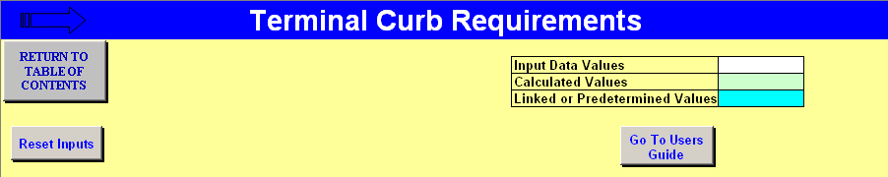

Figure 2 shows the Curb Requirements model and illustrates the basic flow that yields the outputs of required curb frontage from the peak 15 minutes of demand and the comparison to existing curbfront length with the percentage utilized.

Figure 2
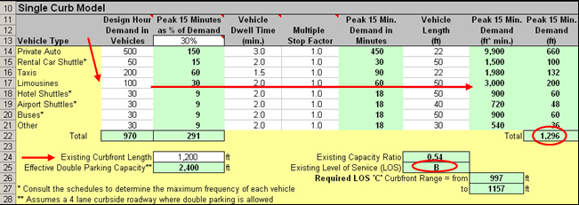

The Curb Requirements model uses passenger survey data to find the modal split on passenger traffic to and from the airport. The split percentages are used with the design hour passenger volume to generate demand for autos, taxis, and limousines. Shuttle and bus schedules should be consulted to determine the peak frequency. The peak 15 minutes of the design hour can be determined through a design day analysis or by observations with the use of design day factors. The peak 15-minute percentage is applied as well as the dwell times, vehicle lengths, and multiple stop factors. These inputs will generate the associated frontage demand for each vehicle type and the total curb frontage. By adding a double parked factor to the existing curbfront length, the utilization percentage is determined and the analysis of curb frontage adequacy can take place.

