Security Screening

The Security Screening model is designed to provide a view of the passenger experience in the queue in relation to wait times and queue area. The user defines the processing rates and number of lanes, and inputs the existing or desired screening lane dimensions and queue dimensions. Figure 1 is a screenshot of the model. The cells are color coded in the same manner as the other models in the spreadsheet. The user makes the inputs into the white cells and can perform a sensitivity analysis of the screening process by adjusting the inputs and observing the changes to the wait times and passenger space values.

Figure 1
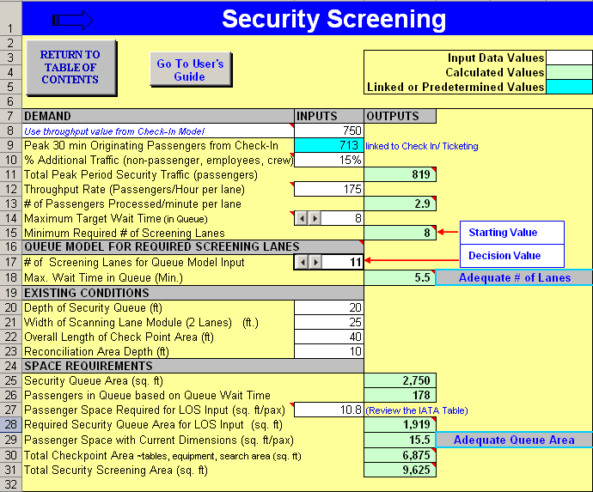

Additional information about the inputs or calculations in the user cells is provided by way of cell comments that will pop up when the user’s cursor is placed over the cell.

The Demand portion of the Security Screening model is broken out in Figure 2, where the user determines the percentage of additional traffic at the airport in question, the throughput in passengers per hour per lane, and the desired maximum waiting time. These inputs will provide a starting point for the required number of screening lanes. The linked mini-queue model uses a normal peaked distribution which allows for lags and surges in the flow to estimate a required number of screening lanes that is more likely to achieve the desired max waiting time.

Figure 2
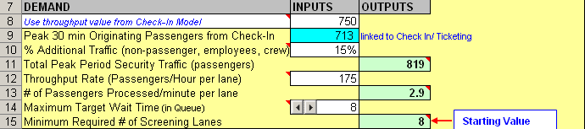

In the next section of the model, the user selects and inputs the current configuration and dimensions of the security screening and queuing area. Figure 3 is taken from the model and shows how the user can adjust the number of screening lanes being used in the mini-queue model to see the impact on the max waiting time in the queue. The preliminary calculation for the number of required screening lanes in Row 15 was determined by optimizing the process potential, and thus the real number of screening lanes must be greater with time lost during periods of flow that are below the capability of the process.

Figure 3
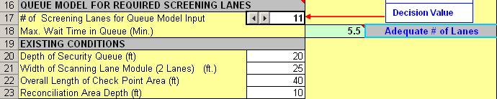

The last section of the model (as represented in Figure 4) looks at the queuing area and determines the passenger space within the queue. A pop-up International Air Transport Association (IATA) Table (Figure 5) is included for the user to adjust the level of service and see the required changes to either the number of screening lanes or the dimension of the queue. By making adjustments and performing a sensitivity analysis, the user can better understand how to use the space and configuration available to provide their passengers with the level of service that is desired. Other spaces like Total Checkpoint Area and Total Security Screening Area are also calculated for future comparison of space per passenger values with other airports.

Figure 4
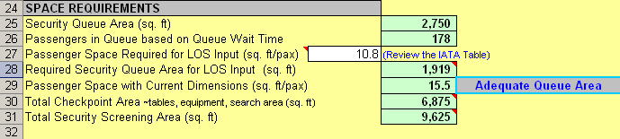

Figure 5
IATA Table - Comment Pop Up
