Holdrooms

The factors that determine the total seating/standing lounge area of the holdroom are used in the Holdroom model, where the user sets the level of service conditions and determines the suggested holdroom size. The Holdroom model is organized like the other spreadsheet models with the same color coding of user cells and links back to the Table of Contents and to the User’s Guide as seen in Figure 1.

Figure 1
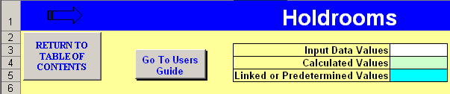

The Holdroom model shown in Figure 2 requires that the user input aircraft and load factor information and, by using the level of service guidance in the cell comments, select the percentages and criteria that will determine the holdroom areas. By adjusting the factors that increase or decrease the suggested holdroom area, the user can observe the effects of the impact that properly account for the amenities, utilization, and sharing factors can have.

Figure 2
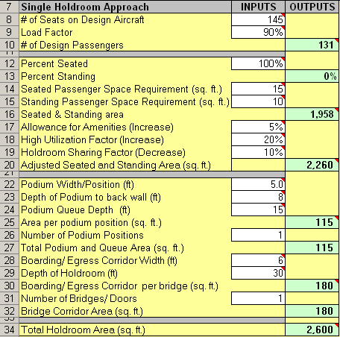
Figure 3 shows that the High Utilization Factor will increase the suggested holdroom size as does the Allowance for Amenities factor. When gates have a high turnover rate, it is likely to have passengers from several flights waiting in the holdroom at about the same time. These cases are unique and only certain airports will have a need to apply this factor. If this is not an obvious case, this number should be entered as 0%, but in instances where the turnover is unusually high, such as with many of Southwest Airlines’ markets, this factor could be between 10% and 30%. A general allowance, in the range of 5%, for amenities should be included where relevant.

Figure 3
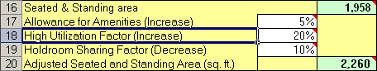

When the user has entered all the required data and adjusted the model until the settings match the airport holdroom in question, the final area can be compared to a table of typical holdroom areas used by many terminal planners. See Figure 4.

Figure 4
