Gate Demand Requirements

The Gate Demand model is set up like the other spreadsheet models, with links back to the Table of Contents and the User’s Guide, and uses color-coded cells for consistency. See Figure 1. The two methods of determining gate demand without a Design Day Flight Schedule are used in the model as outlined in the Guide. The results of each method can be averaged to reach a more conservative projection of gate requirements.

Figure 1
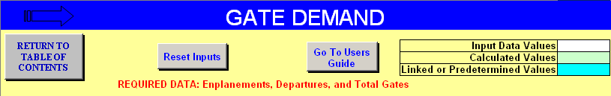

The first approach, as shown in Figure 2, uses the current ratio of annual passengers per gate, adjusted for forecast changes in fleet mix and annual load factors. This methodology assumes that the pattern of gate utilization will remain relatively stable over the forecast period. The changes in passengers per gate would be due to changes in enplanements per departure (due to fleet seating capacity and/or passenger load factors), as opposed to increasing (or decreasing) numbers of departures per gate.

Figure 2
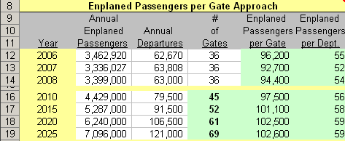

In the model example in Figure 2, the ratio of enplanements/gate for each forecast year is calculated by multiplying the current (2008 in this example) factor by the percentage increase in enplanements/departure. For example, enplanements per departure increases from 54 in 2008 (actual) to 56 in 2010 (forecast), thus the factor would increase from 94,400 enplanements/gate (2008 data when 36 gates were in use) to 97,500 for 2010, and 102,600 enplanements/gate by the end of the forecast period without any further increase in the number of daily departures per gate.

Future gate requirements are then estimated by dividing annual forecast passengers by the estimated passengers per gate factor for that forecast period. For example, in 2010, 4,429,000 enplanements divided by 97,500 enplanements/gate results in a demand for 45 gates. This approach results in a forecast demand for 69 gates by the end of the forecast period.

For the Departures per Gate Approach from the model (example shown in Figure 3), the ratio of annual departures/gate for each forecast year is calculated by multiplying the current (2008) factor by the percentage change in assumed daily departures/gate. In this example, it was assumed that average daily gate utilization would increase from 5.0 departures/gate in 2008, to 5.2 departures/gate by 2010, and gradually increase to 6.5 departures/gate by 2025. Thus, the annual gate utilization factor would increase from 1,750 annual departures/gate (2008) to 1,820 by 2010.

Figure 3
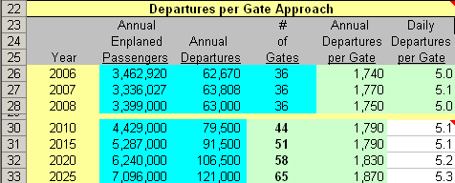

Future gate requirements are estimated by dividing annual forecast departures by the estimated departures per gate factor for that forecast period. For example, in 2010, 79,500 departures divided by 1,820 departures/gate results in a demand for 44 gates.

The model converges the results from the two methods as an average to compare the future gate requirements as a range. The planner will then need to compare the values within the range and sensitively determine the most reasonable and likely outcome. See Figure 4.

Figure 4
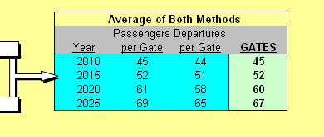
Once the gate requirements have been determined the other ground requirements can be further quantified by relating the future design day flight schedule to available gates. If the flight schedule suggests more aircraft than available gates or for early morning high turnover gates due to airline schedules, then additional aircraft parking will be required.

The model includes a Gate Equivalencies Table (Figure 5) to serve as a gate inventory during the gate demand process, showing current available or leased gates. This inventory is useful to other model segments where the Equivalent Aircraft (EQA) or Narrowbody Equivalent Gate (NBEG) values may be needed as factors that help determine other processing rate factors or space requirements. The user only needs to input the existing number of gates in use for each design group, and the total and equivalent values will be calculated. The calculated values are the cumulative sum product of the gate share and the index values.

Figure 5
