Federal Inspection Services (FIS)/
Customs and Border Patrol (CBP)

The FIS/CBP model is designed to estimate the queue requirements and passenger delay time for primary processing, the baggage claim requirements, and the time the claim unit will be in use. In addition, an example model has been added to show the effects of arrival time variation on primary processing. This model will function in the same manner as the other spreadsheet models with links to the Table of Contents and the User’s Guide, and the use of color-coded cells for consistency as seen in Figure 1.

Figure 1
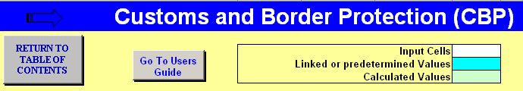

The first section in this model is a random flight arrival time example that adjusts a group of five flights by as much as 15 minutes early or late and runs a mini-queue model on each of ten iterations to determine (1) a range and average for the maximum number of queued passengers and (2) the minimum, maximum, and average wait times in the primary processing queue. This model is separate from the preliminary data used later in this section and acts as a stand-alone example (See Figure 2) with a dedicated randomizing queue model. From this example, the user can see the influence and possible effects that arrival variability can have on primary processing, which would then have an impact on the use of baggage claim. The user can enter their own flight arrival times and aircraft seating capacities to test various flight arrival scenarios. In addition, the model allows the user to vary aircraft passenger load factor, the number of primary process booths, and the rate at which passengers disembark (unload) from the aircraft.

The user can add five flights in the one-hour example window of 16:00 to 16:59, or less if s/he so desires. The queue model assigned to this bank of flights randomly adjusts the arrival time by up to 15 minutes early or late for each of the input flights. With the load factor and unload rate entered, the queue model will determine when and how fast the passengers disembark from the flights and proceed to primary processing. The last function of the queue model uses the number of staffed processing booths and the processing rates that the user entered to estimate the average and maximum wait times likely to be experienced by the passengers. This is useful in studying the effects of possible understaffing by CBP. The maximum number of passengers in the queue is also estimated and can be used to determine the size of the queue needed. A chart showing the passengers arriving at primary processing and how many passengers are in the queue based on the original schedule, and one of the random variations is illustrated in Figure 3. Each time the randomizer button is clicked a different random variation is generated and the chart will depict a new scenario.

Figure 2 Random Flight Arrival Time Example
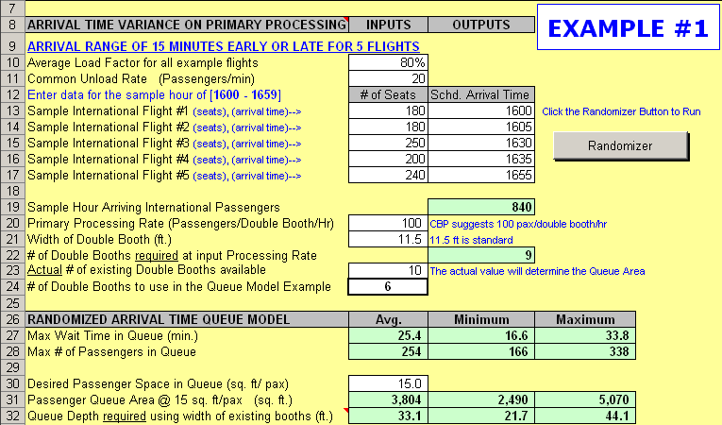

Figure 3 Random Flights and Initial Flights Queuing Chart Example
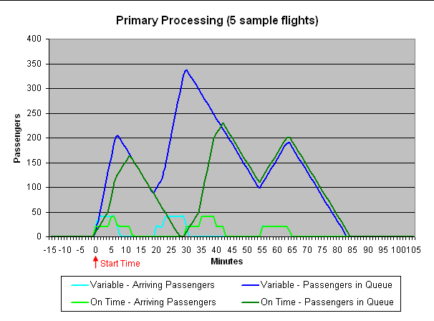
The example in Figure 2 gives a range of wait times that may be experienced by passengers in a scenario similar to the five-flight example period. The maximum wait time based on ten iterations or runs in the queue model yielded a range of 17 to 34 minutes, and a maximum required queue depth of 44 feet. The minimum queue depth at any U.S. airport with international service is required to be at least 50 feet (75 feet normally); so, under the input conditions in this example, the existing queue depth is satisfactory.

The next section in this model allows the user to look at a single sample international flight arrival and run a queue model to estimate wait times and queue size requirements. The demand in this case will be the estimated seat configuration of a likely international flight of a desired aircraft. The user can specify the number of double booths to be used in passenger processing and at what rate. One hundred passengers per hour per double booth is the CBP standard and should be used unless there is better local data that supports using a different known processing rate. This value can also be varied to do a sensitivity check on the overall process.

Among the many CBP facility requirements is the number of double processing counters and the minimum passenger queue depth and width for the primary processing. This spreadsheet model allows the user to evaluate a CBP-recommended passenger flow rate and counter count, or model user-selected values. Figure 4 shows the input section where the user makes these decisions.

Figure 4 Single Arrival Example for Primary Processing
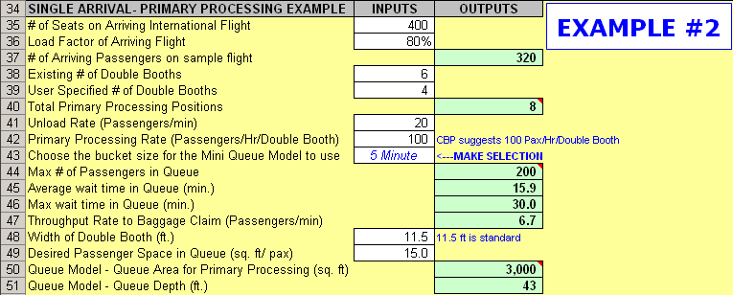

The process in the single arrival example will follow the same methods used in the multi-flight example except, there is no random variability. The user enters the number of seats, load factor, and unload rate to determine the demand on primary processing. By next entering the number of double booths and processing rate, the queue model will estimate the maximum wait time and maximum number of passengers in the queue. To see the effects that bucket size has on a queue model example, the user can select either a one-minute or five-minute bucket size to observe minor variances. As in the first example with multiple flights, the output from the queue model will also estimate the required queue depth based on the existing number of double booths and desired level of service (LOS) area for the passengers. In Example #2 shown in Figure 4, the user’s entries have determined that, if 15 square feet per passenger is the desired LOS area per passenger, then the queue depth would need to be at least 43 feet .

Following the primary processing step, the passengers move to baggage claim to retrieve their checked bags. Because of the potential for delays during primary processing, checked bags often are at the claim unit before the passengers arrive. In Figure 5, the next section in the model uses a probability bag matching model to estimate the time a claim unit will be in use and how much linear frontage will be required for a specific demand load. The user must input average or specific information in relation to passengers and bags as well as the likely bag delivery (dump) rate and delays. From these inputs the included bag matching model will estimate the desired outputs and generate a graph to show a possible flow pattern for the passengers and bags. The key outputs are also highlighted on the graph in Figure 6.

Figure 5 Passengers and Baggage at Claim Model
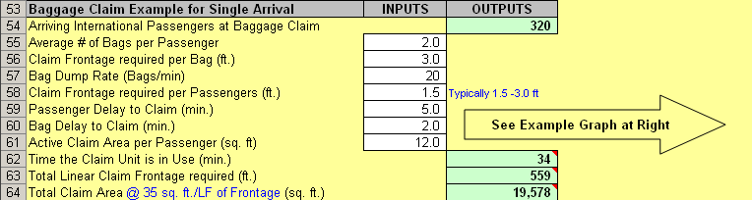

Figure 6 Passengers and Baggage at Claim Chart
