Design Hour Determination

The Design Hour Determination model focuses on departing seats, which can easily be converted to departing passengers with the use of a known average load factor. The model sets up the determination of the peak hour in such a way that most segments of interest can be determined at the same time (i.e., Domestic/International, Air Carrier/Regional, Arriving/Departing).

The Design Hour Determination model is driven by actual data from passenger traffic to systematically calculate the planning factors that could be used later, in the absence of a design day schedule, to estimate peak hour activity. The model’s structure is such that it takes the user through each required step with simple instructions and directions for when to go to the next step. A blue instruction box is used in each tab of the spreadsheet with corresponding step numbers highlighting the area requiring an action. The user will still need to gather the necessary data for each step but the process should be simple to follow by just doing the actions in the right order.

Figure 1 shows the tab structure for the Design Hour Determination model. The user has command buttons in each tab that, when clicked, will jump to the next tab in the right order or the user can just click on the worksheet tabs at the bottom of the screen and follow them in order from 1 to 7.

Figure 1

Figure 2
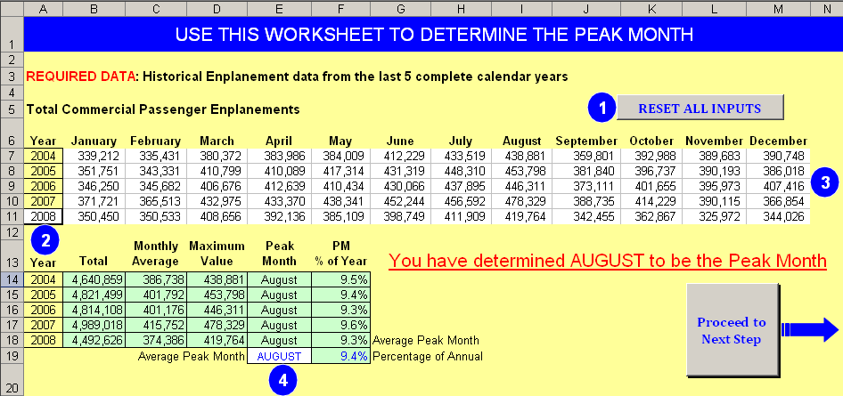

Figure 2 is a screen print of the first tab of the Design Hour Determination spreadsheet. The user gathers monthly enplanement data and enters it into the input cells, and the normal peak month is determined. The spreadsheet functions can be seen in the light green calculated cells to observe the processes that are being used. The process is not difficult and the spreadsheet is doing some of the work automatically for the user. Figure 3 shows the set of instructions.

Figure 3
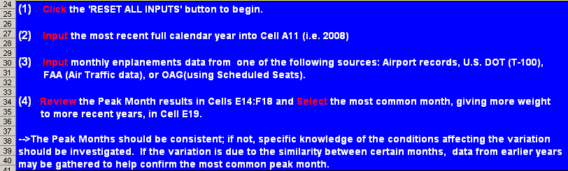

The peak month daily schedule of departures and arrivals is then gathered and is entered into the input cells on Tab 2 (Figure 4) which helps determine an average weekday during the peak month. The user must determine the actual day of the week that day one of the peak month falls on and select that day from a drop down list in cell B9. All of the steps for Tab 2 are again listed in the blue instruction box and the action areas are highlighted with corresponding numbers. The user can adjust the percent variation in step 4 to isolate those weekdays that are within a certain range to limit the options in choosing an average weekday.

Figure 4
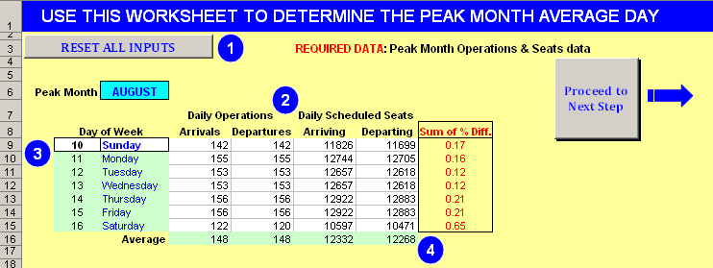

After determining an average weekday (normally a Wednesday or Thursday) that most closely resembles the peak month average, a complete schedule of arriving and departing seats for the average day during the peak month is needed for the next step which will generate 10-minute buckets that will be used to create rolling hours throughout the day. The actual peak rolling hour is then determined automatically and traffic charts are generated on Tab 6 with the corresponding data to better describe the chart activity. The complete schedule can be acquired from recent airport data, T-100 data, or from the Official Airline Guide (OAG). The OAG data will be actual seats flown or scheduled seats to be flown if the peak month average day is very near in the future.

Tabs 3 and 4 are set up to be simple for the user to input the airport or OAG data into the input blocks starting at Row 11 in Column A. Copy and paste the schedule data, as is, into these columns and then update the pivot table if there are international markets that need to be identified. The determination of international and domestic markets was not automated so that in the cases of preclearance efforts, those markets could be treated as each individual airport sees fit. If no markets are selected as international, then there will be no peak hour international segment identified. The instructions for these tabs stress the need for the time of departure or arrival to be in the 24-hour format. This is normally the default time setting, but if not, it will need to be adjusted for the model to work properly.

In Tabs 3 and 4, there is a section that is titled Designation Table for Domestic/International; this section is a built-in pivot table. The section will become populated with a summary of each destination or origin market when the Update Pivot Table tab is clicked. This was added so that when the international and domestic segments were truly desired, the user would only have to select each international market once instead of going through what may be a lengthy list and checking for multiple listings. Figure 5 shows step 5, the location of the pivot table and where the D or I will be selected from a drop down list, and Figure 6 shows the populated table from when step 3 is completed. Figure 6 also shows the included instructions for Tabs 3 and 4.

Figure 5
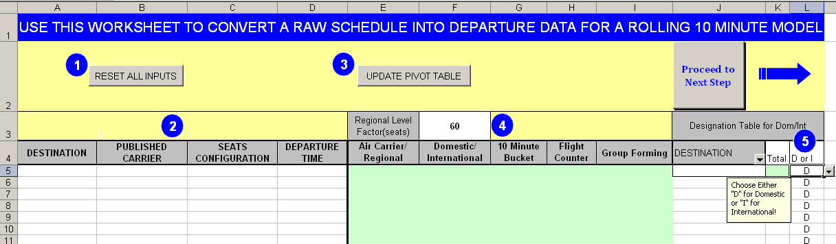

Figure 6
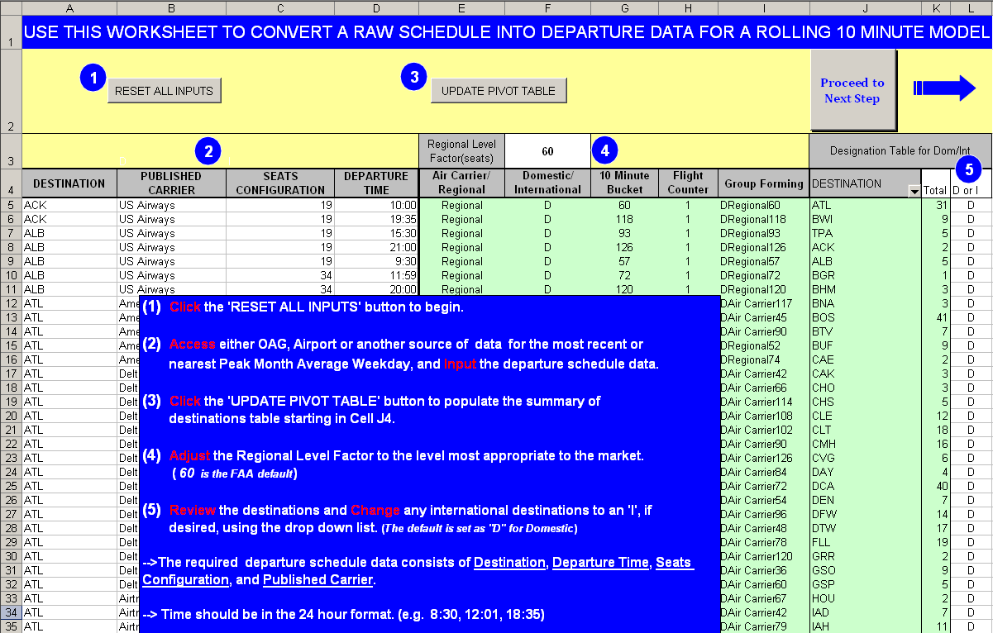

Certain airport markets may have a unique mix of regional aircraft, and the appropriate designation, as either air carrier or regional, may not always follow the FAA guidelines, which use 60 seats as the threshold between air carrier or regional. Cell F3 uses 60 seats as the default, which resets when all the inputs are reset, but allows the user to choose the level that best fits the mix of local aircraft and how that mix is interpreted. By adjusting the Regional Level Factor as pointed out in Figure 7, the user can control which aircraft will be considered regional and air carrier.

Figure 7
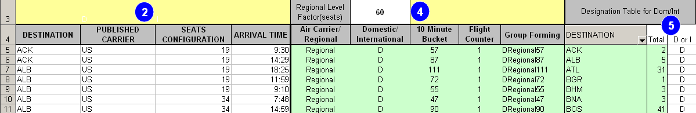

The arrival and departure data that is entered into Tabs 3 and 4 will automatically be organized into 10-minute buckets and rolling hours on Tab 5, which is basically an organized summary sheet that displays the peak hour for arriving, departing, and total seats. With specific knowledge of the operations at local airports, the determined peak hours should be within the expected range based on personal experience of the user as shown in Figure 8.
Figure 8
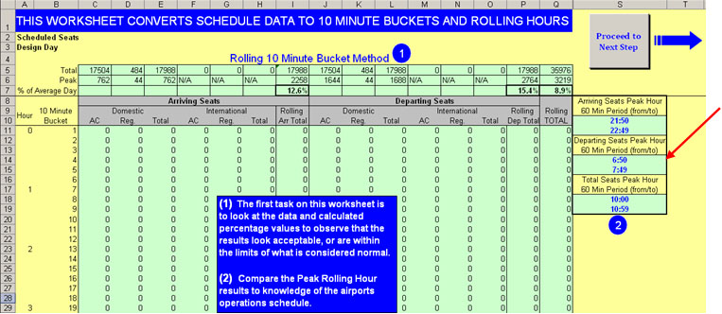

The model highlights the peak bucket and rolling hour period in each section with yellow and red markings. In addition, the percentage of the average day that the peak hour represents is also calculated within this tab and will be displayed on Tab 7-Design Hour Forecast. The percentage of average daily values are displayed in Row 7 and will also be used for determining design hour seats in Tab 7.

Determining the rolling peak hour seats from a flight schedule can be done using a spreadsheet analysis as done in the Peak Hour model on Tab 6 and shown in Figure 9. As shown, the peak hour (design hour) usually does not occur in a clock hour, but across two clock hours.

Figure 9
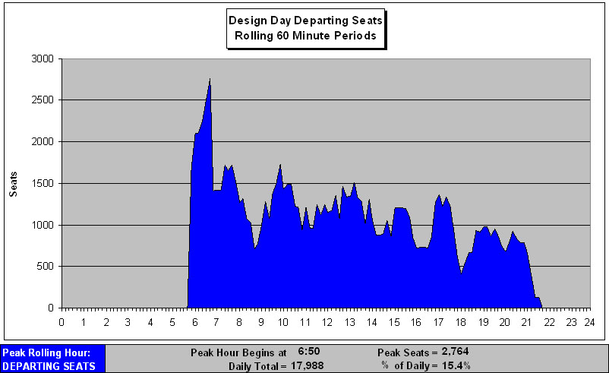
The final tab in the Design Hour Determination Model allows the user to see the calculated planning factors for peak month, average day and design hour and the effect that these factors can have on the peak hours used in future planning levels. Knowledge of these average values for planning factors and understanding their impact can allow the user to make valid use of them in the absence of a design day schedule. The planning factors from the design hour exercise are boxed in red on Figure 10, which is a screen print from Tab 7.

Figure 10
