Circulation

The spreadsheet model was developed to estimate the circulation dimensions using the Narrowbody Equivalent Gate (NBEG) approach. This model will function in the same manner as the other spreadsheet models with links to the Table of Contents and the User’s Guide, and the use of color-coded cells for consistency as seen in Figure 1.

Figure 1
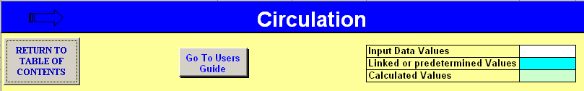

The NBEG approach that is used in the model bases the necessary frontage of a concourse on the equivalent overall wingspan of the design aircraft that could optimize the use of all the available gates on that single concourse. The user is requested to select the input options that best describe the existing or desired concourse conditions to estimate the suggested corridor width that, when multiplied by the concourse length and utilization factor, will determine the circulation area.

There are a number of different circulation areas that can be addressed. The single concourse estimate is used in the model to show the basic approach, and this approach can then be adapted to other areas of circulation which are more dependent on local design and use. Federal Inspection Services (FIS) sterile corridors should be sized for single directional flow.

The model has three basic functions: determine the suggested circulation corridor width, determine the NBEG of the concourse to estimate frontage and overall length, and then calculate and compare the circulation area. Figure 2 is a screen print of the model where the comparison of width and area showed that the existing conditions are “Less than Suggested” based on the inputs to the model.

On line 8 of the model as seen in Figure 2, the user is asked to input a percentage factor for concourses that support an airline hub. The comment for this input suggests a small 5% to 10% range that will add to the suggested corridor width. In most cases this factor can be left at 0%. But, in cases at the largest and busiest airports, the sheer volume of passengers that may enplane or deplane during the peak periods, or the major cross-flows that may occur during the peak transfer times at large hubs, may require more than the normally suggested corridor width.

Figure 2
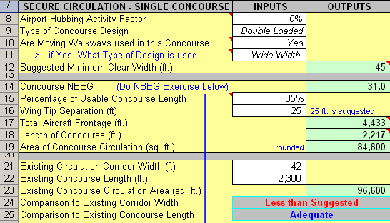

Figure 3
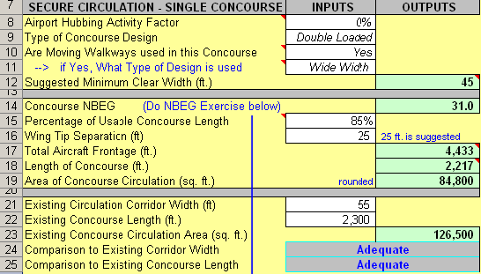

The model asks the user to select inputs that describe the concourse in question. On line 10 the input is whether or not moving walkways are used. If the user selects Yes from the drop down list, the next input on line 11 must be either Narrow Width or Wide Width. If the dash is selected, a Choice Error message will appear to prompt a correction. Conversely, if No is selected from the list on line 10 and then Narrow Width or Wide Width is selected on line 11, the Choice Error message will also appear until the dash is selected, as seen in Figure 4.

Figure 4

The model prompts the user to do a gate exercise to determine the equivalent concourse NBEG. The user only needs to jump down to line 33 and input the number of gates that exist on the concourse of the specific design aircraft classes. The equivalent NBEG will be calculated in cell E42 which is linked back to cell C14 as seen in Figures 5 and 6.

Figure 5
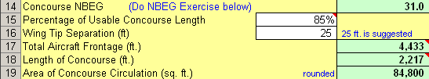

Figure 6
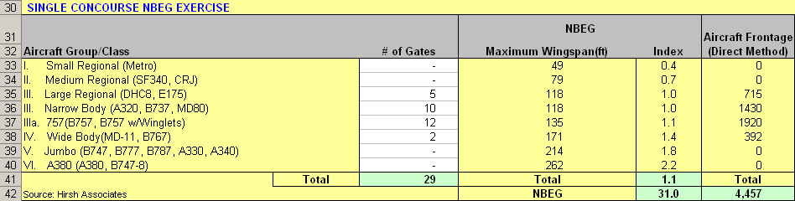

The last inputs that the user needs to make in the model are on lines 15 and 16. A usage percentage is requested to describe the allocation of the end space on the concourse. If the concourse circulation runs to the end of the concourse, with no space used for holdrooms or amenities, then this percentage should be 100%. Depending on how the end space is used and how much area is taken away from circulation for holdrooms, the usage percentage may be as low as 80%. An assessment of the concourse gate allocation and loading structure will help determine what percentage to use. Typically 85% is a good starting point for linear pier concourse design.

The default widths used for double moving walkways are 12 feet and 15 feet in the standard or wide format, which allows for an additional 1-foot buffer between the two walkways.

