Check-in/Ticketing

The Check-in model is formatted like all of the other models and uses a color-coded cell system to keep the spreadsheet clean and easy to use while avoiding confusion.

The Check-in/Ticketing model incorporates the staffed counter positions, kiosk positions, and curbside positions, but does not address self-tagging stations because they are relatively uncommon and minimally used. Use the toggle buttons as seen in Figure 1, to auto scroll the screen to work on one area at a time.

Figure 1
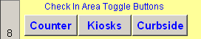

In most of the input cells, there will be a small red triangle in the upper right signifying that a comment has been attached to give more explanation to the input requirements, and/or more information on the general ranges. Some input cells and their title lines are conditionally formatted to alert the user to the possibility of an input error. The user can either keep the entered value, if it is truly correct, or make a change to fall within the expected range, and the highlighted areas will return to the normal appearance. See Figure 2.

Figure 2
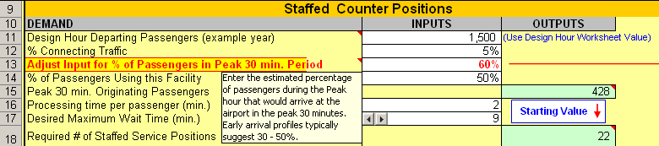

The Design Hour Determination model should have been completed before doing this step or an estimated peak hour value will need to be used. If an estimate is used, just enter the value into cell C11 in the Staffed Counter section and this will break the link to the Peak Hour exercise and the other dependant cells will use this value as well.

Work on one section at a time and when all of the inputs have been entered, check over the sections again to see if there are any errors or alerts. When all the inputs have been made, the user can make adjustments to the queue model inputs for the Staffed Counters and Kiosks to achieve the desired wait times and passenger queue spacing. Figures 3, 4, and 5 show the way common inputs are linked.

Figure 3
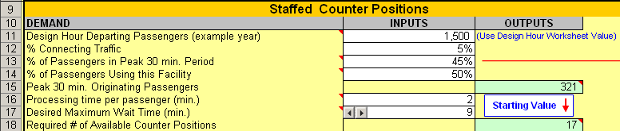

Figure 4
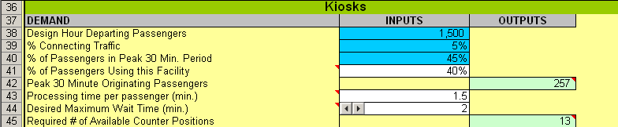

Figure 5
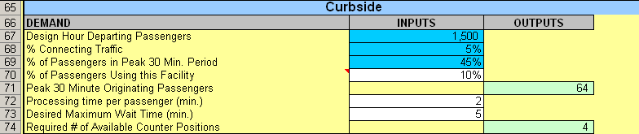

Figure 6 illustrates the use of suggestion boxes for the user to use to achieve the desired results for wait times and passenger spacing by adjusting the queue model’s # of Staffed Service Positions.

Figure 6

The Check-in model is designed to approach the issue of determining the required number of positions from a single airline or common-use perspective. The models’ approach can then be adjusted for additional airlines and the results of each airline can later be summed.

In order to get the basic understanding of a queuing model without having to create a full-scale design day queuing model, a mini-queue model has been created to show the delay process at check-in during the peak 30-minute period during a peak period of the design day. This 30-minute slice of the design day can be used more generically to show the position requirements based on processing times and desired maximum wait periods. The mini-queue model uses an adjusted normal distribution curve around the center of the peak 30 minutes, with the average flow rates during the peak hour as the leading and trailing arrival rates, to establish a stand-alone delay model. Peak hour enplanements can be converted to the peak 30 minutes by prior knowledge of the average percentage of flow observed in the peak 30 minutes during the peak hour. Figure 7 gives the overall process of a queue model, and Figure 8 is the mini-queue model being used to determine the flow conditions for the Airport Ticket Office (ATO) check-in area.

Figure 7
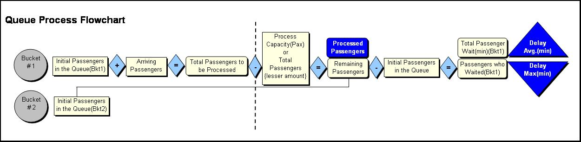

Figure 8
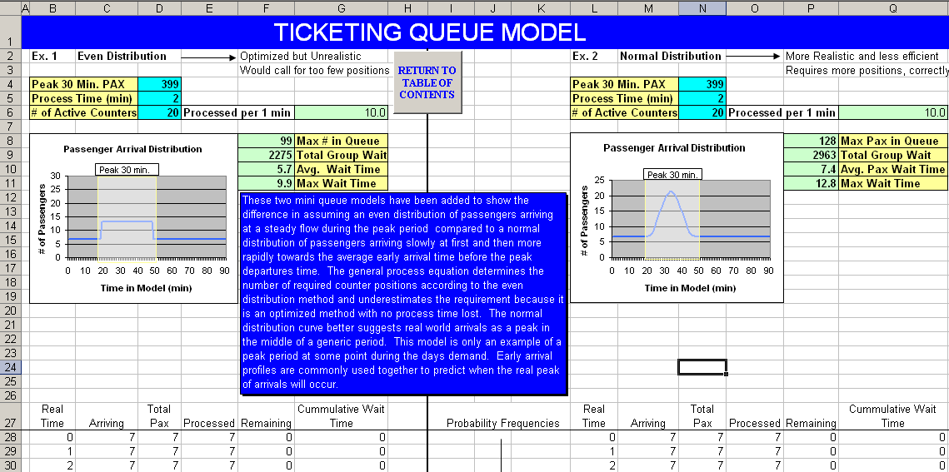

The approach that is used in the spreadsheet model allows the user to determine the peak hour origin and destination (O&D) passengers departing during the peak 30 minutes, which will be in the previously listed range of the peak hour that occurs during the peak 30 minutes. That number is split into the three main areas of check-in by profile data gathered through surveys, and then the 30-minute model is run for each area and the totals are summed by airline or by the airport as a common-use facility.

The top of the model is a dashboard of current settings and status for the inputs and conditions that the user is entering. In Figure 9 the dashboard shows the status summary as well as some ratios such as check-in positions per equivalent aircraft (EQA) that can be compared to other similar airports.

Figure 9
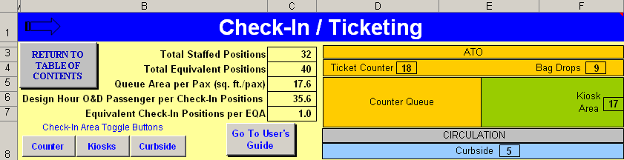

The standard staffed counters check-in queue is normally the major source of check-in delay, but with more travelers using self check-in options, the queue for using the kiosks may be the queue to focus on. Both Staffed Counter and Kiosk portions of the Check-in/Ticketing model have mini-queue models that measure the passengers in the queue and the maximum wait times based on the passenger and position inputs. The model will help determine the current level of service (LOS) conditions and, by adjusting the position inputs for the mini-queue models, the user will see the time and space effects from position allocation.

The Check-in model displays the results to both ratios in the dashboard as peak 30-minute passengers per position and check-in positions per EQA. These results can also be a measure for comparison to a benchmark level or another airport.

Figure 10
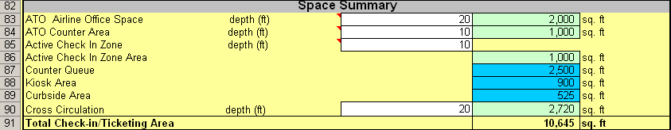

A Space Summary (Figure 10) is provided at the bottom of the spreadsheet model and will appear with the Curbside functional group. The dimensions that have been observed as normal or acceptable are described in the following section and, although they are a good measure of what should work and be sufficient, careful observations of each individual airport are necessary to make adjustments on the use and allocation of space in the terminal.

The ratio approach can combine conventional staffed positions and kiosks as Equivalent Check-in Positions (ECP). Each airline’s ECP is the number of conventional positions in use, plus the number of kiosks. The current ratio of Design Hour Enplaned Passengers per ECP is determined and then either held constant for the forecast years or changed based on the existing LOS. The ratio of staffed position to kiosks can then be varied depending on the current utilization of kiosks at the airport, and the trends in kiosk use identified.

The Check-in model displays the results of both ratios in the dashboard (Figure 9) as Design Hour O&D Passengers per Check-in Position and Equivalent Check-in Positions per EQA. These results can also be a measure for comparison to a benchmark level or another airport. The ratio approaches are incorporated on a separate tab, which can be accessed by the command button as seen in Figure 11. The Ratio Approach Examples button is located just beneath the Staffed Counter Positions section in the Check-in model.

FIGURE 11 Ratio Approach Command Button
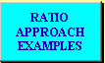

The Design Hour Originating Passengers per ECP method is shown in Figure 12. An advantage of using a Design Hour to ECP ratio is that it requires less detailed data than the 30-minute service model. The disadvantage can be that it assumes a continuation of existing staffing assumptions and the approximate number of airlines.

FIGURE 12 Ratio Method Approach using Design Hour Passengers
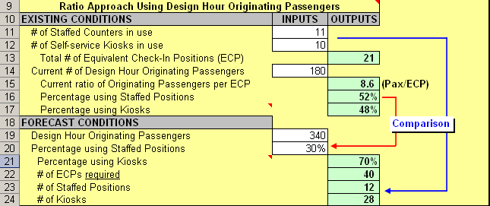

Another variation on this approach is to use a ratio of gate capacity (described by EQA) to ECP as shown in Figure 13. This may be appropriate when the airport is expecting new airlines and larger increases in gates vs. growth in design hour passengers due to load factors and/or aircraft size growth within an aircraft group.

FIGURE 13 Ratio Method Approach using EQA
