Checked Baggage Screening

The spreadsheet model for Baggage Screening is set up in the same manner as the other models where there is a link back to the Table of Contents and the User’s Guide and all the cells are color coded for consistency, as seen in Figure 1.

Figure 1
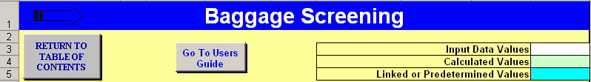

Airports of varying sizes and traffic levels will require different screening systems. The model lets the user decide which type of system to analyze and prompts the user for all the inputs needed to generate requirement estimations.

The spreadsheet model allows for preliminary estimates of the major equipment necessary for Electronic Detection Systems (EDS) programming and follows the standard three-level Transportation Security Administration (TSA) protocols for checked baggage inspection systems (CBIS).

The first step in the model is to determine bag load, which is driven by the peak hour check-in passengers. Lines 9 and 10 in the model request information about the passenger profile in relation to bag checking preferences. This data, along with surge factor provided by TSA, provides the system demand that will drive the estimates for equipment and space. The demand segment is titled Design Hour Bag Load in the model as illustrated in Figure 2.

Figure 2
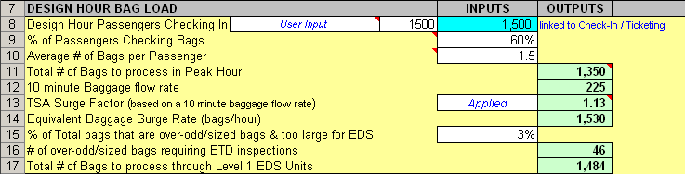

The model calculates the TSA surge factor automatically and the user can choose to apply or not to apply the factor by making the selection in cell F13. In order to segment the model inputs for the next section, the estimated percentage of over/odd-sized bags needs to be input. This setup assumes that most systems will be EDS for Level 1; for smaller airports with only Electronic Trace Detection (ETD) systems, those selections are made in the next section.

Similar to this example, the next section in the model follows this procedure and estimates the equipment quantities for either ETD or EDS, or both. The user selects the existing or desired system setup and inputs the estimated process rates from record, or using TSA suggestions and the first and last outputs in the part of the model are the number of EDS and ETD units required. See Figure 3.

Figure 3
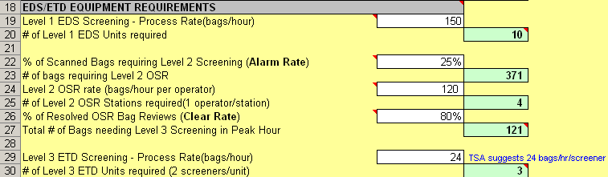

After determining an estimate for unit quantities, the last section of the model, as shown in Figure 4, simply calculates the space necessary in the lobby or back-of-wall screening area for the units and personnel to operate and function efficiently.

Figure 4
