BAGGAGE MAKE-UP

Figure 1 is a screen print from the model showing the linked Equivalent Aircraft (EQA) cell and the four required input cells for the first method and only one required input cell for the alternative ratio method. The user will first determine the baggage make-up area by going through the first method and then will do a simple ratio method check for comparison.

Figure 1
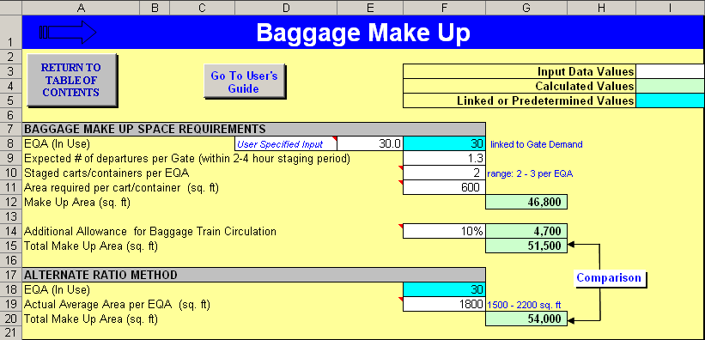

The Baggage Make-up model estimates the necessary area requirement based on the total EQA of gates in use, the number of average departures in the make-up period, and the likely number of staged carts required per EQA. The EQA value will be linked to the Gate Demand model, but the user will first need to estimate the expected number of departures per gate during the make-up period. The make-up period for domestic flights is typically around two hours but may be up to four hours for an international flight. The average make-up period will depend on the type of service provided at the airport and the mix of markets that are served. The estimated value to be entered should reflect the number of departures per gate that will require baggage staging for those flights during the make-up period.

Once the period and expected departure rate are determined, the user will need to choose how many carts are likely to be staged for each EQA. The range is pretty small at two to three carts per EQA. The range correlates to an EQA value of 145 seats, which would require two carts at 75 seats/cart, or three carts at 50 seats/cart. When looking at the baggage checking preferences, the average number of bags checked per person may be found in a recent passenger survey or the type of traveler (business versus leisure) may help in choosing what part of the range is more appropriate.

In a heavy business market where checked baggage is light, one cart may accommodate the baggage for up to 75 passengers, whereas in a heavy leisure or international market, one cart may only accommodate around 50 passengers.

Figure 2
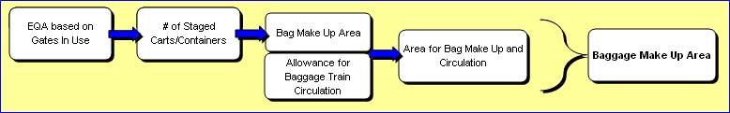

Figure 2 shows the overall method used to determine the Baggage Make-up area. The area per EQA is determined by doing the next step in the model, which is to input a value for the area required per cart. For an airline with exclusive use of a make-up area, 600 square feet per cart is generally acceptable. This value is estimated from the footprint area of the cart itself, the room needed to maneuver and stage baggage, and the room needed for the cart to be loaded. The final step is to add a percentage factor that allows for circulation in the make-up area, and the baggage make-up area is then calculated by multiplying all of the inputs together.

The alternative ratio method uses a general rule-of-thumb approach based on the average make-up area in relation to each EQA. Generally 1,500 to 2,200 square feet is the range when comparing the overall make-up area to the EQA value of in-use gates at most airports that have been studied. The user can divide the make-up area determined in the first method by the EQA value to see the related value. By using actual current space allocations or physical dimensions, the user can see what the current ratio is at a specific airport, which is also a good measure for comparison to the results from the first method.

