Baggage Claim

The Baggage Claim model takes the user through two standard approaches to properly size claim units and total frontage. The spreadsheet model is arranged in the same manner as the other model segments, with color-coded cells and links to both the Table of Contents for the whole spreadsheet model and the User’s Guide as seen in Figure 1.

Figure 1
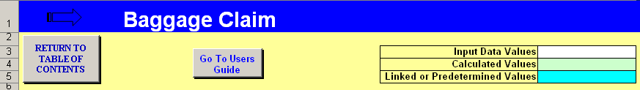

The Baggage Claim model first uses the total demand to estimate the total required claim frontage. To make this estimate, the user must determine and input the percentage of peak 20-minute passengers and the percentage of terminating passengers; in addition the user will need passenger survey data to make the final inputs for passenger and baggage relationships. The cell comments will help to make a general or default decision when specific data can not be found. Figure 2 shows the section of the model that calculates the overall frontage demand based on the peak period of terminating passengers. This number can then be compared to the existing frontage and first hand observations of the level of use and adequacy in the baggage claim area.

Figure 2
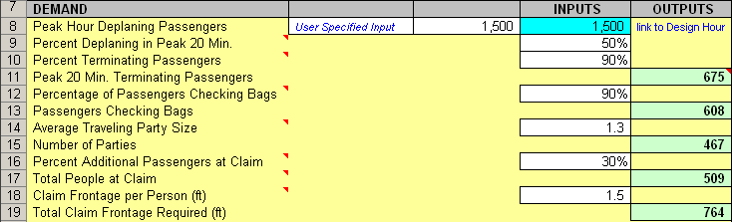

The total claim frontage value will also be useful to the planner when determining how many, and what size, individual claim units will need to be available for the current mix of design hour aircraft.

The spreadsheet model estimates this by calculating the number of traveling parties, taking one member to actively claim bags, and then adding in a percentage for the additional passengers who may accompany the active claimer at the claim unit. These factors would be based on passenger survey data (party size) and observations.

The same basic approach is used to estimate the total amount of claim frontage for a design hour peak period. This substitutes the design hour deplaning passengers and the percentage of arrivals in the peak 20 minutes (domestic) for the aircraft seat and load factor assumptions of an individual flight. See Figure 3. Once the total frontage is estimated, the size and number of claim units should be determined based on the expected number of flights and aircraft sizes during the peak hour(s), and airport operating policies regarding exclusive or preferential use of claim units.

Figure 3
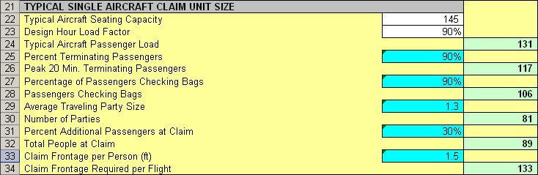

Figure 4
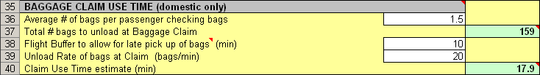

As shown in the example in Figure 4, narrowbody domestic flights typically occupy a claim unit for 20 minutes or less, which results in the typical approach of sizing domestic baggage claim for a peak 20-minute period. Widebody flights can occupy a claim unit for significantly longer periods, which is why units sized for large aircraft typically are configured with two feed conveyors.

