Opening and Running Database

- Double-click on MS Access database file
- If the “Security Warning” bar (see image below) appears, click on the “Options…” button and proceed to step 3. (Note: in Office 2003, the security warning will appear in a dialog box.)

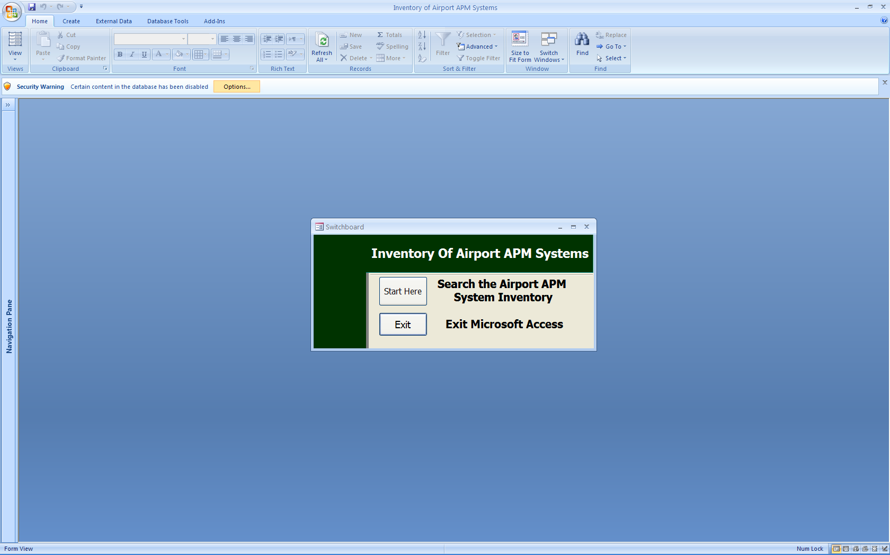

- In the “Security Alert” window click on the “Enable this content” dialog button (see image below).

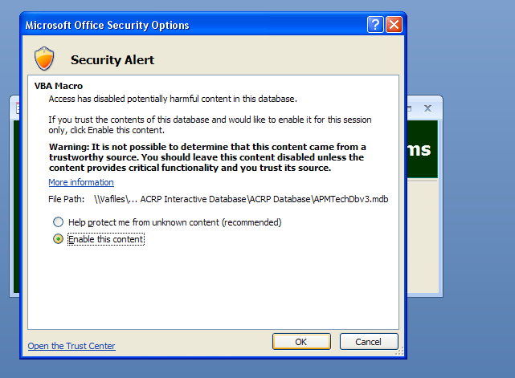

- Hit the “OK” button

- Click on the “Start Here” button to begin searching the Airport APM System (see image below).

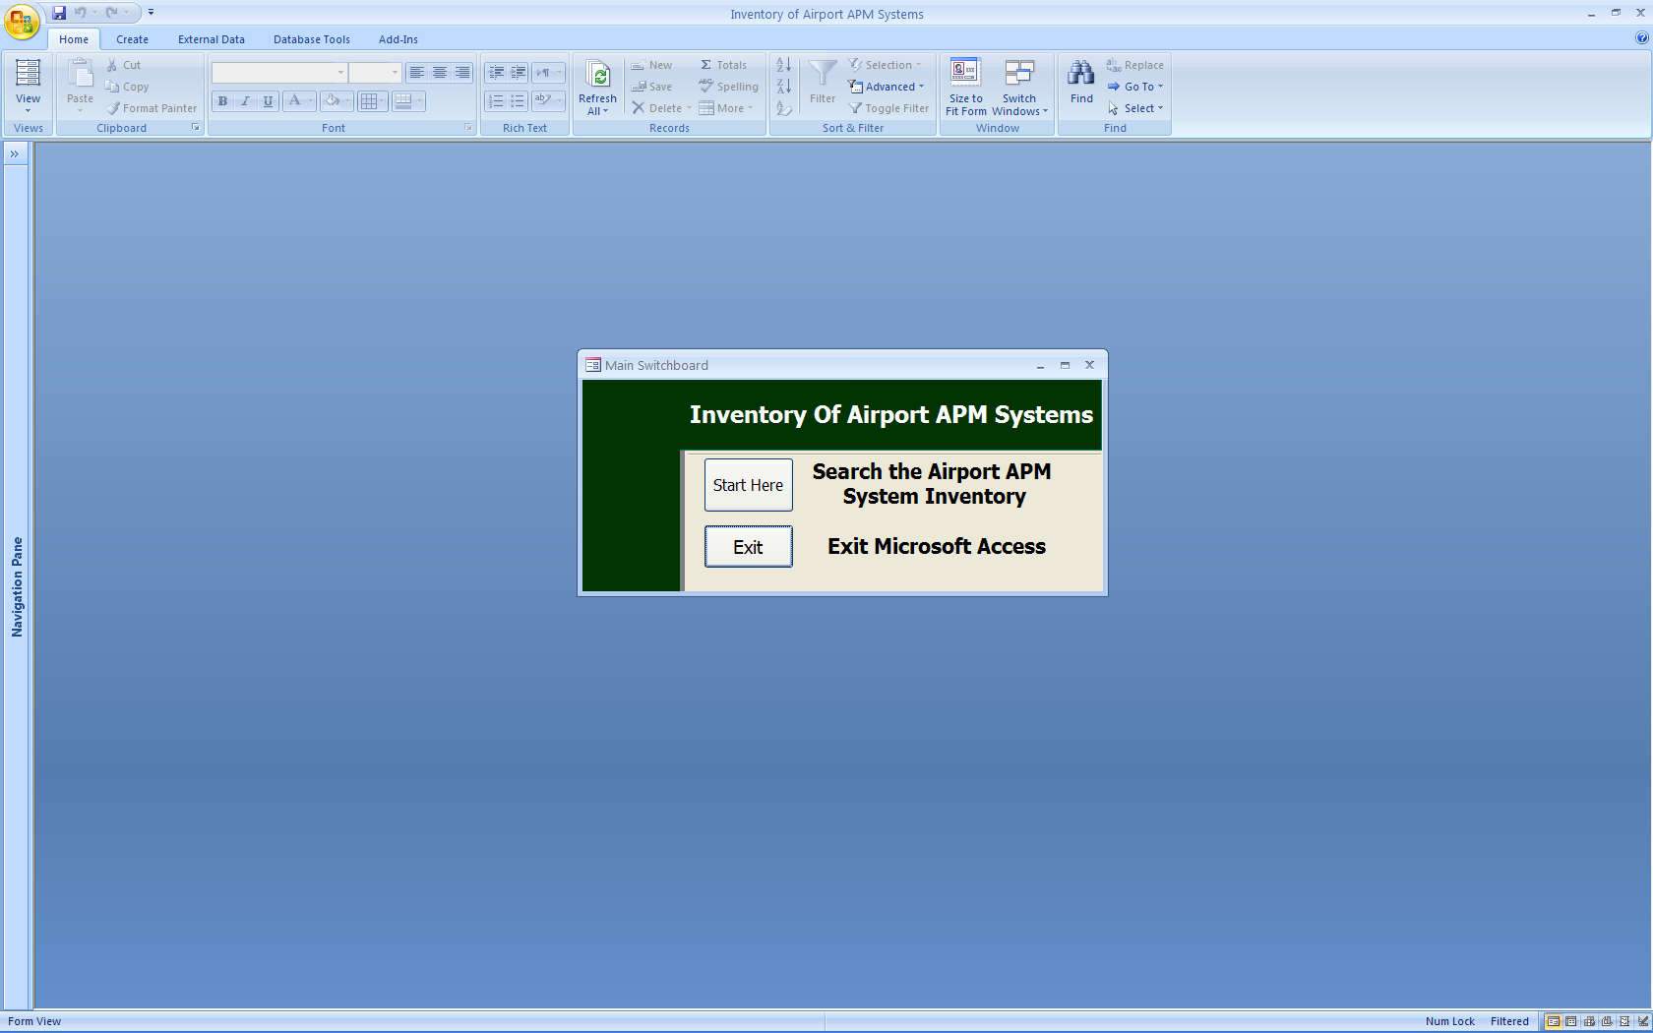

Searching the Database:
To do a search, use the following sample instructions

Sample Search: Search for all APMs with a guideway length of between 0.5 miles and 1.5 miles
- In the “Guideway Length (mi)” field with the entry box labeled “Min:” enter “0.5” and with the entry box labeled “To Max:” enter “1.5”
- Hit the “Search” button

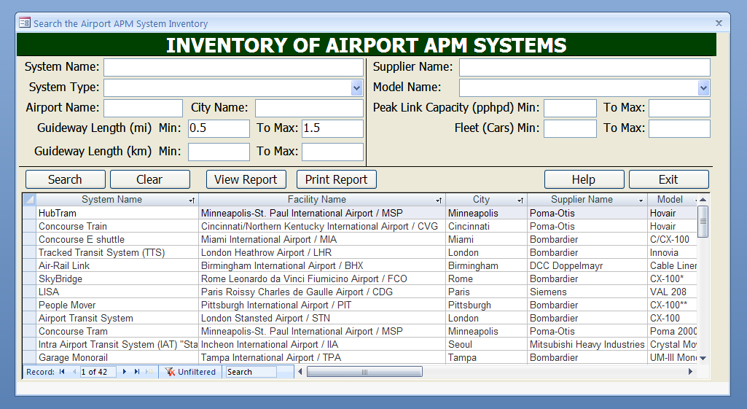

Here, users will see a list of multiple systems all within the given guideway length range. However, to examine the full documentation of a particular system, users will have to enter more specific data relating to that system (e.g., System Name, City Name, or Airport Name) in addition to the already-defined length range. Only when there is one row left showing the system of interest can the user then click on “View Report” to further examine it. So in the above example, if the user wants to see the specifications for Detroit’s Express Tram APM, do the following:

- In the “City Name” entry box type in a city of preference (Detroit for this example) while keeping the 0.5 and 1.5 values in the “Guideway Length (mi)” field.

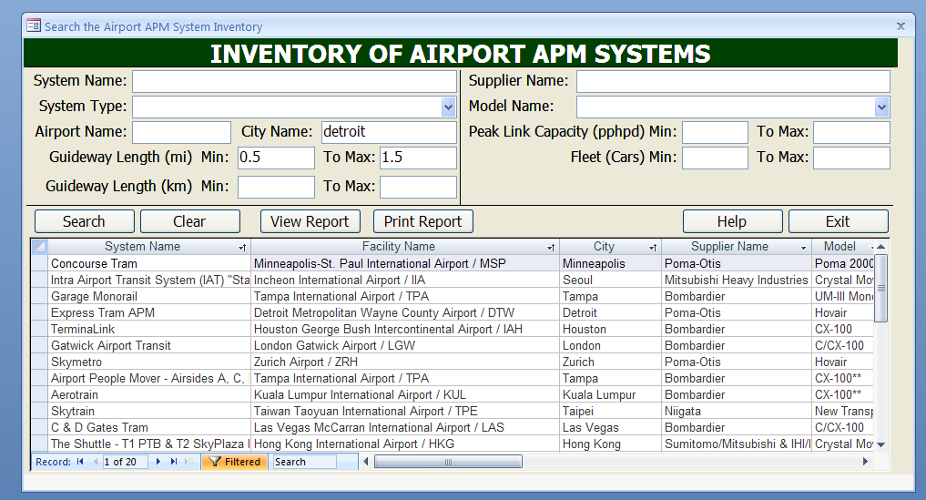

- Hit the “Search” button

User should now see that Detroit’s Express Tram APM is the only system showing in the spreadsheet.

- Click the “View Report” button to see specifications for the Detroit system

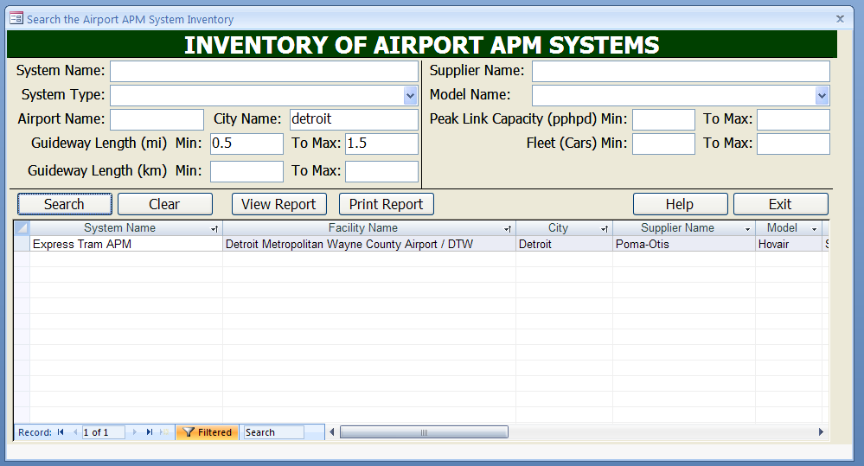

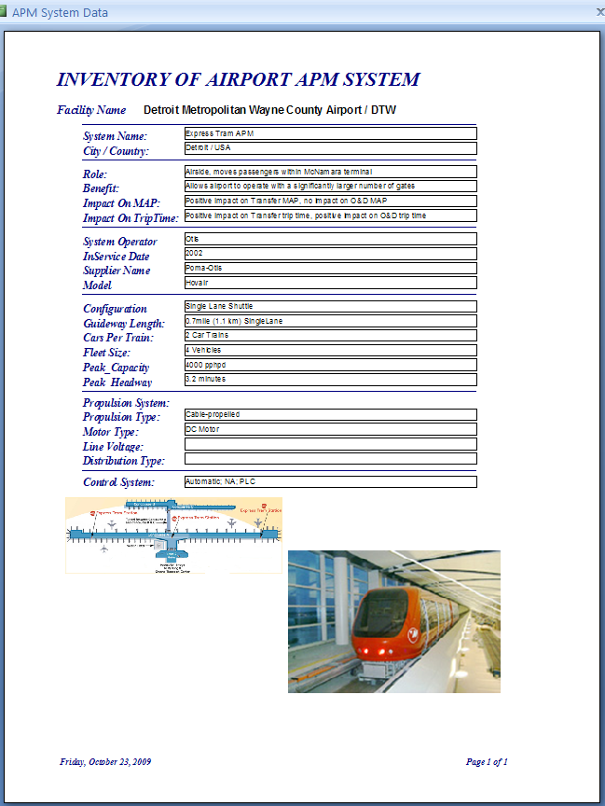

- To return to the full list of APMs within the guideway range defined above, remove the City Name (Detroit in this example) from the search field entry box and hit the search button

