The following document is supplemental to ACRP WebResource 16: Playbook for Developing a Culture of Innovation at Airports (ACRP Project 01-47, “A Guide to Developing a Culture of Innovation at Airports”). The full WebResource can be found at https://crp.trb.org/acrpwebresource16/.

The Airport Cooperative Research Program (ACRP) is sponsored by the Federal Aviation Administration. ACRP is administered by the Transportation Research Board (TRB), part of the National Academies of Sciences, Engineering, and Medicine. Any opinions and conclusions expressed or implied in resulting research products are those of the individuals and organizations who performed the research and are not necessarily those of TRB; the National Academies of Sciences, Engineering, and Medicine; or ACRP sponsors.

Developing a Culture of Innovation at [Insert Your Airport Name]
Personalized Playbook Worksheet

Welcome to the personalized playbook worksheet for ACRP WebResource 16: Playbook for Developing a Culture of Innovation at Airports. The tables below are a place to list out which Plays your organization will implement within the 5 organizational elements listed below. It is also a place for you to manage the status and drive progress as you roll out each Play in your pursuit of a culture of innovation.
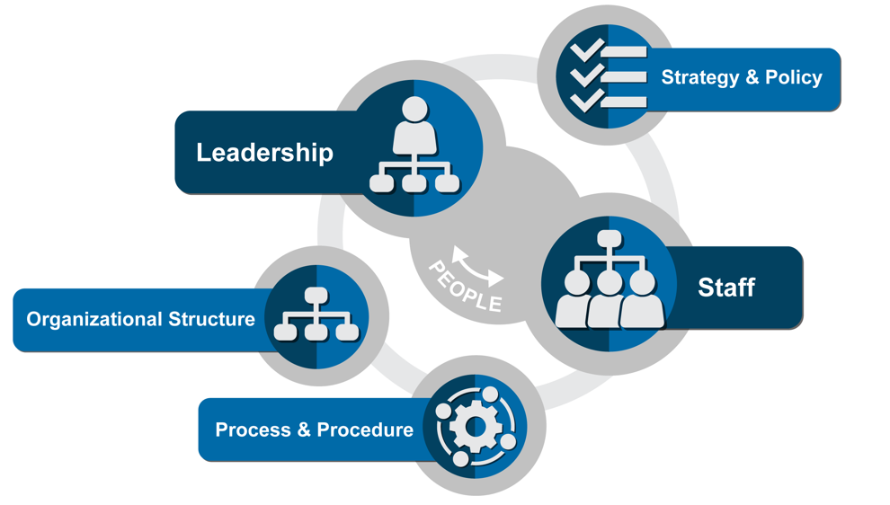

Example play:

Play | Description | Champion | Status | Next Actions
Play 6. Develop an innovation mindset | Develop a new vernacular to avoid the stigma associated with “failure”. | Jane Smith, Airport Operations Team Leader | Working with team to develop a list of words associated with “failure” that team members can and cannot use (e.g., trial or experiment vs. mistake) | Jane needs to roll out new language ideas at next team meeting for discussion and refinement.

Leadership Plays
Review this section in the WebResource and list out below which Plays you will seek to implement.

Play | Description | Champion | Status | Next Actions
Add more rows to the table as needed

Staff Plays
Review this section in the WebResource and list out below which Plays you will seek to implement.

Play | Description | Champion | Status | Next Actions
Add more rows to the table as needed

Strategy and Policy Plays
Review this section in the WebResource and list out below which Plays you will seek to implement.

Play | Description | Champion | Status | Next Actions
Add more rows to the table as needed

Organizational Structure Plays
Review this section in the WebResource and list out below which Plays you will seek to implement.

Play | Description | Champion | Status | Next Actions
Add more rows to the table as needed

Process and Procedure Plays
Review this section in the WebResource and list out below which Plays you will seek to implement.

Play | Description | Champion | Status | Next Actions
Add more rows to the table as needed

