

Project 08-03

Construction Safety and Phasing Plans

**Contractor Training Guide**

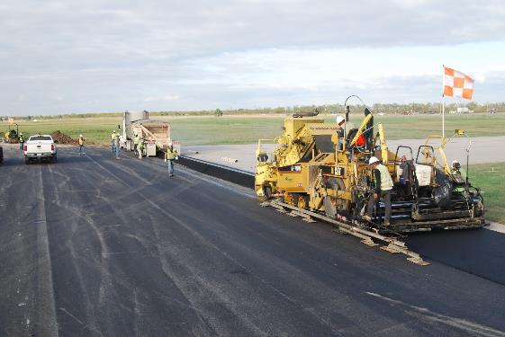

**Last Revised November 2020**

Table of Contents

Table of Contents 2

1.0 Overview and Purpose 4

2.0 Use of Contractor Training Guide (CTG) 5

2.1 External Resources 6

3.0 CTG Integration with Regulatory Training Requirements 7

4.0 Acronyms and Terminology 8

4.1 Acronyms and Terminology – External Resources 10

5.0 SPCD Development 10

5.1 Structure of the SPCD 11

5.2 SPCD Development and Review Process 13

6.0 Contractor Best Practices 15

7.0 Airfield Familiarization and Operational Patterns 17

7.1 Airfield Familiarization and Operational Patterns – Training Topics 17

7.2 Airfield Familiarization and Operational Patterns – Training Aids and Practices 18

8.0 Protected Airport Surfaces 20

8.1 Runway Safety Areas 20

8.2 Taxiway Safety Areas 21

8.3 Object Free Areas 22

8.4 Obstacle Free Zones 23

8.5 14 CFR Part 77 – Civil Imaginary Surfaces 23

8.6 Protected Surfaces Summary – Best Practices 23

8.7 Airport Protected Surfaces – External Resources 24

9.0 Airfield Marking, Signage, and Lighting 25

9.1 Airfield Markings 25

9.2 Airfield Signage 27

9.3 Airfield Lighting 28

9.4 Airfield Marking, Signage, and Lighting – Best Practices 29

9.5 Airfield Marking, Signage, and Lighting – External Resources 29

10.0 Operating a Vehicle on the Airfield 31

10.1 Training 31

10.2 Vehicle Requirements 31

10.3 Escorting 31

10.4 Situational Awareness 32

10.4.1 Aircraft Recognition 32

10.5 Other Best Practices 33

10.6 Operating a Vehicle on the Airfield – External Resources 34

11.0 Security 35

11.1 Badging 35

11.2 Escorting 35

11.3 Gate and Perimeter Control 35

11.4 Gate Guards 35

11.5 Security Awareness 36

11.6 Security – External Resources 36

12.0 Wildlife Management 37

12.1 Wildlife Management – External Resources 39

13.0 Foreign Object Debris (FOD) Prevention 40

13.1 Foreign Object Debris Prevention – External Resources 41

14.0 NAVAID Protection 42

14.1 Glideslope and Localizer Critical Areas 42

14.2 NAVAID Protection – External Resources 44

15.0 Radio Phraseology and Procedures 45

15.1 Phraseology 45

15.1.1 Phonetic Alphabet 45

15.1.2 Common Phrases 46

15.2 Procedures 47

15.2.1 Towered Airports 47

15.2.2 Non-Towered Airports 48

15.3 Radio Phraseology and Procedures – External Resources 49

16.0 Flaggers 51

16.1 Flagger Positioning and Equipment 51

16.2 Flagger Training 53

16.3 Flaggers Training – External Resources 54

# Overview and Purpose

This Contractor Training Guide (CTG) has been prepared to assist airports with providing training to contractor personnel that will be engaging in construction activities on the airfield. The document has been set-up in a modular fashion to allow airport sponsors to utilize only the portions of the CTG they feel are applicable to a given construction project at their airport. References are made throughout the CTG to various tasks in the CSPP process (e.g. Task 3.2) discussed in the WebResource for ACRP Project 08-03. Additional details regarding each of these tasks can be obtained by reviewing the WebResource.

The recommendations and guidance provided in this document are based on the current versions of FAA guidance materials in effect as of the date of this publication (November 2020). The FAA updates guidance materials from time to time. As a result, it is highly recommended that users check the FAA website to ensure they are utilizing the most current versions of published FAA guidance material.

**Sections 2.0 through 6.0 primarily focus on planning activities that occur before construction begins (e.g. preparation of the SPCD, identification of required regulatory trainings, etc.). Section 7.0 through 16.0 provide training materials that can be used to support operational safety while construction is underway.**

# Use of Contractor Training Guide (CTG)

Airport sponsors are encouraged to review the material presented in the CTG, identify what is applicable to their airport and the proposed construction project, and then supplement the CTG with specific information regarding their airport and the construction project to be completed. This information should then be utilized as a basis for providing customized training to contractor personnel specific to the airport and project. The recommended process for utilizing the CTG is shown below in **Figure 1**. Airport sponsors and consulting engineers/designers should identify the training requirements that will be necessary for contractors as part of Task 2.6 (Project Safety Analysis/Review) and Task 2.7 (Development of Final CSPP). **Identifying the necessary trainings as part of the Initial CSPP Development Phase will ensure that any training requirements can be properly integrated into the project’s bid documents.**

Figure 1 – Recommended Process for Utilizing CTG

Utilizing the CTG in this manner will aid contractor personnel in understanding general safety concepts related to operating on an airfield and how those concepts apply to the specific airport and project they will be working on.

For ease of use, an “Airport and Project Application” section has been added to each portion of this training guide to allow airports to add any specific airport or project information directly into the CTG. Airports utilizing the CTG in this manner may choose to provide the version of the CTG that has been updated with airport and project specific information to the contractor to use as a reference during construction. An example of the “Airport and Project Application” section included in each module of the CTG is shown as **Figure 2.**

Figure 2 – Example Airport and Project Application Section

Airport and Project Applications:

*(Airport and project specific information should be added to this area.)*

Providing the CTG directly to a contractor without the airport sponsor reviewing the CTG materials and notating how the materials apply to the airport and project is not recommended as all portions and standards described in the CTG may not be applicable to all airports and projects.

Additionally, any training items that have been identified as critical points of understanding for contractor personnel to operate safely on the airfield have been identified with a red octagon and red outline as shown below in **Figure 3**.

**Figure 3 – Critical Safety Points**

**Critical safety related items are identified with red boxes and red octagons throughout the text.**

## External Resources

There are also multiple external resources that can be helpful to airport sponsors, consulting engineers/designers, and contractors when utilizing the contents of the CTG. External resources are notated in each module, where appropriate. Additionally, a list of external resources related to multiple topics within the CTG is provided below. Each of these resources can be accessed by clicking on the text associated with the resource.

* [FAA AC 150/5370-2G – Operational Safety on Airports During Construction](https://www.faa.gov/documentLibrary/media/Advisory_Circular/150-5370-2G.pdf) – Provides a detailed review of the FAA’s standards and recommended practices related to airfield construction.
* [FAA AC 150/5300-13A – Airport Design](https://www.faa.gov/documentLibrary/media/Advisory_Circular/150-5300-13A-chg1-interactive-201907.pdf) – Provides a detailed overview of airport design standards and protect surfaces.
* [FAA Aeronautical Information Manual (AIM)](https://www.faa.gov/air_traffic/publications/atpubs/aim_html/index.html) – The AIM provides a detailed overview of the air traffic control procedures, airfield lighting, markings, NAVAIDs, and a variety of other topics.

# CTG Integration with Regulatory Training Requirements

This CTG is not intended to replace any regulatory training (e.g. security badge training, airfield driver’s training, etc.) that may be required under any applicable federal, state, or local regulations/requirements applicable to an airport. The airport sponsor should utilize the Airport and Project Applications space provided below to denote any specific regulatory trainings that the contractor will be required to complete prior to starting construction. The airport sponsor should also note whether each training will be required for all construction personnel or just personnel performing certain tasks (e.g. driving, etc.). It is also critical to identify any timelines associated with regulatory trainings that could impact construction schedules (e.g. typical time frame for completing a Criminal History Records Check to get a security badge at an airport regulated under 49 CFR Part 1542 – Airport Security).

Airport sponsors can utilize the Contractor Training Checklist developed as part of ACRP Project 08-03 to document the modules of the CTG that contractors need to be trained in and any regulatory trainings that are required.

Airport and Project Applications:

*(This space should be utilized to document any required regulatory training contractor personnel will be required to complete prior to starting construction.)*

# Acronyms and Terminology

The aviation industry has a significant number of acronyms and industry-specific terms. To ensure safety messages are properly communicated and understood, it is important that contractors become familiar with these acronyms and terms. The list of acronyms and terms below are some of the more common acronyms and terms related to airfield operations and construction.

* Air Operations Area (AOA) – Air Operations Area means a portion of an airport, specified in the airport security program, in which security measures are carried out. This area includes aircraft movement areas, aircraft parking areas, loading ramps, and safety areas, and any adjacent areas (such as general aviation areas) that are not separated by adequate security systems, measures, or procedures. This area does not include the secured area of the airport terminal building. Some general aviation airports may refer to the area inside the airport perimeter fence as the AOA.
* Airport Traffic Control Tower (ATCT) – A control tower staffed by FAA or contract air traffic control personnel providing air traffic control services to aircraft operating in the movement area of the airport and the airspace surrounding the airport.
* Automated Weather Observation System (AWOS) – An automated weather reporting system.
* Automatic Surface Observation System (ASOS) – An automated weather reporting system.
* Common Traffic Advisory Frequency (CTAF) – Typically utilized at airports without an operating ATCT. The CTAF is utilized by pilots to advise other aircraft and personnel on the ground and in the air regarding their location and intended use of the airport.
* Construction Safety and Phasing Plan (CSPP) - The overall plan for safety and phasing of a construction project developed by the airport operator, or developed by the airport operator’s consultant and approved by the airport operator. It is included in the invitation for bids and becomes part of the project specifications.
* Federal Aviation Administration (FAA) – A branch of the U.S. Department of Transportation with regulatory authority for civil aviation.
* General Aviation (GA) – All non-scheduled flights other than military conducted by non-commercial aircraft. General aviation covers local recreational flying to business transport that is not operating under the FAA regulations for commercial air carriers.
* Glide Slope (GS) – Equipment in an Instrument Landing System (ILS) that provides vertical guidance to landing aircraft.
* Instrument Landing System (ILS) – An instrument approach system for an airport that is composed of a glideslope (GS) and localizer (LOC).
* Localizer (LOC) – Equipment in an Instrument Landing System (ILS) that provides horizontal guidance to landing aircraft. Localizers can also be utilized for localizer only approaches.
* Movement Area (MA) – The runways, taxiways, and other areas of an airport that are used for taxiing or hover taxiing, air taxiing, takeoff, and landing of aircraft including helicopters and tilt-rotors, exclusive of loading aprons and aircraft parking areas. The movement area is typically under the control of ATCT and authorization to enter the movement area is required from ATCT.
* Navigational Aid (NAVAID) – Electronic and visual air navigation aids, lights, signs, and associated support equipment.
* NAVAID Critical Area – A protected area around a NAVAID within which no personnel or equipment may be located when the NAVAID is being used.
* Non-Movement Area – The area inside the airport security fence exclusive of the Movement Area. It is important to note that the non-movement area includes pavement traversed by aircraft. The non-movement area is typically not under the control of ATCT and clearance from ATCT does not need to be obtained prior to entering the non-movement area.
* Notices to Airmen (NOTAM) – Notice To Airmen or NOTAM is a notice containing information (not known sufficiently in advance to publicize by other means) concerning the establishment, condition, or change in any component (facility, service, procedure, or hazard in the National Airspace System) the timely knowledge of which is essential to personnel concerned with flight operations.
* Object Free Area (OFA) – An area on the ground centered on the runway, taxiway, or taxilane centerline provided to enhance safety of aircraft operations by having the area free of objects except for those objects that need to be located in the OFA for air navigation or aircraft ground maneuvering purposes. (See AC 150/5300-13A for additional guidance on OFA standards and wingtip clearance criteria.)
* Obstacle Free Zone (OFZ) – The airspace below 150 ft (45 m) above the established airport elevation and along the runway and extended runway centerline that is required to be clear of all objects, except for frangible visual NAVAIDs that need to be located in the OFZ because of their function, in order to provide clearance protection for aircraft landing or taking off from the runway and for missed approaches. The OFZ is subdivided as follows: Runway OFZ, Inner Approach OFZ, Inner Transitional OFZ, and Precision OFZ. Refer to AC 150/5300-13A for guidance on OFZ.
* Precision Approach Path Indicators (PAPI) – A visual NAVAID that provides vertical guidance to pilots executing an approach to land.
* Runway End Identifier Lights (REILs) – A visual NAVAID that provides a visual identifier of the end of the runway.
* Runway Safety Area (RSA) – A defined surface surrounding the runway prepared or suitable for reducing the risk of damage to airplanes in the event of an undershoot, overshoot, or excursion from the runway, in accordance with AC 150/5300-13A.
* Taxiway Safety Area (TSA) – A defined surface alongside the taxiway prepared or suitable for reducing the risk of damage to an airplane unintentionally departing the taxiway, in accordance with AC 150/5300-13A.
* Safety Plan Compliance Document (SPCD) – Details developed and submitted by a contractor to the airport operator for approval providing details on how the performance of a construction project will comply with the CSPP.
* Vehicle/Pedestrian Deviation (V/PD) - Any entry or movement on the movement area by a vehicle (including aircraft operated by non-pilots) or pedestrian that has not been authorized by air traffic control.

## Acronyms and Terminology – External Resources

As previously stated, this section only provides a sampling of some common acronyms and terms utilized frequently as part of airfield construction. A more detailed list of acronyms and terms can also be found utilizing the following online resources:

* [FAA Advisory Circular (AC) 150/5370-2G – Operational Safety on Airports During Construction](https://www.faa.gov/airports/resources/advisory_circulars/index.cfm/go/document.current/documentnumber/150_5370-2) – Provides a list of acronyms and terminology related to airfield construction as Appendix B of the AC
* [FAA Website](https://www.faa.gov/airports/resources/acronyms/) – The FAA website maintains an extensive list of acronyms

Airport and Project Applications:

*(This space should be utilized to document any specific acronyms or terms utilized at the airport or expected to be utilized during the project. This may include local airport acronyms and terms such as building names (e.g CMF – Consolidated Maintenance Facility), airport policies (R&R – Rules and Regulations), and other terms.)*

# SPCD Development

This section provides guidance to contractors on the development of the Safety Plan Compliance Document (SPCD) required for airfield construction projects. According to AC 150/5370-2G, the primary purpose of the SPCD is to detail “how the contractor will comply with the CSPP” and should “not restate nor propose differences to provisions already addressed in the CSPP.”

## Structure of the SPCD

**Since the primary focus of the SPCD is to describe how the contractor will comply with the CSPP, it is recommended that the SPCD be structured in a similar fashion to the CSPP and provide a detailed explanation of how the contractor will meet the requirements contained in each section of the CSPP.**

Structuring the SPCD in this manner will make it easier for the airport sponsor to verify the SPCD covers the requirements contained in AC 150/5370-2G and addresses each item, as appropriate, as discussed in the CSPP.

**Table 1** provides an overview of the CSPP section headings contained in the CSPP template and the proposed SPCD section headings that correspond to the CSPP.

Table 1 – Recommended SPCD Section Headings to Correspond with CSPP



Paragraph 2.4.2 of AC 150/5370-2G provides the current regulatory guidance regarding what the contractor should specifically address in each of the SPCD sections identified in Table 1.

**To aid the contactor in developing the SPCD and airport sponsors in reviewing the SPCD, it is recommended that the SPCD checklist be utilized to help define the content included in each section of the SPCD. The checklist integrates the SPCD requirements set forth in AC 150/5370-2G.**

## SPCD Development and Review Process

The process shown in **Figure 4** should be followed to facilitate the effective development of the SPCD.

Figure 4 – SPCD Development and Review Process

**Prior to the contractor developing the SPCD, it is recommended that the airport, consulting engineer/designer, and the contractor hold a meeting to review the CSPP and discuss how the contractor will meet the requirements set forth in the CSPP (part of Task 3.1 in the CSPP process).**

The meeting should be led by the airport or consulting engineer/designer and should review each section of the CSPP individually. The results of the discussion on “how” the contractor will meet the requirements set forth in each section of the CSPP should be utilized as the basis of information for the contractor to develop the SPCD document. The airport and consulting engineer should also use this meeting to discuss any unique SPCD requirements or expectations.

Once the contractor has developed the initial draft of the SPCD, it should be sent to the airport and consulting engineer/designer for review (part of Task 3.2 in the CSPP process). The airport and/or consulting engineer/designer should use the SPCD Checklist to review the SPCD to ensure it meets all regulatory requirements. Additionally, the airport and consulting engineer/designer should identify any items in the SPCD they believe the contractor needs to further explain “how” they will meet the requirements within the CSPP. All comments on the SPCD should be sent to the contractor to enable them to make revisions to the SPCD. A second meeting should be held with the contractor, consulting engineer/designer, and airport if any significant requirements are missed. The contractor should make changes to the SPCD based on the comments provided by the airport and consulting engineer/designer and resubmit it for their review and ultimate approval.

Airport and Project Applications:

*(This space should be utilized to document any specific SPCD requirements that contractors should address related to the airport and project.)*

# Contractor Best Practices

As part of ACRP Project 08-03: *Construction Safety and Phasing Plans* a number of construction safety best practices were identified that apply directly to contractors. The best practices are provided below:

* Phase “Flash Cards”: Every day during the initial safety briefing before construction activities begin, the contractor should consider providing employees with a “flash card” notating the phase being worked on that day, areas they are to stay clear of, haul routes to be used, etc. This can help ensure that contractor staff do not get confused on the differences between each phase of the project. This is especially important for complex projects with multiple phases. These “flash cards” can also be made into smaller wallet-sized cards that could be connected to a lanyard or stored wherever an individual’s airport identification badge is displayed. Contact information for key members of the project team can also be included on the card.
* Contractor “Buddy” System: Any time a new contractor employee begins working on the airfield, they should be assigned to another contractor employee (e.g. a “buddy”) that is more experienced with airfield construction. This provides the new employee with a person that can help educate them regarding items to be aware of when conducting construction activities on an airfield and another person to observe their compliance with safety practices. Some contractors have given new personnel a different color of hard hat ( or placed stickers on their hard hats) so more experienced personnel can easily identify new personnel.
* “Dry-Run” Simulations for Very Complex Projects: For some very complex or time sensitive phases of a project, a “dry-run” simulation of the phase should be conducted prior to the actual work beginning to ensure that everybody knows their roles and responsibilities and any potential issues can be identified ahead of time. This “dry-run” could include a review of staging areas, haul routes, access procedures, construction boundaries, and other items critical to the safety of the project. Dry-runs can also improve familiarity when moving from day time to night time work.
* **Contractor Crew Leader Safety/Security Review Meeting:** Contractors should hold a special meeting with all crew leaders, superintendents, supervisors, and other key leaders on the contractor’s team that will be engaged in the day-to-day management of the construction project to discuss the CSPP and SPCD and review critical safety and security related requirements. This meeting should take place prior to construction starting.
* **Planning for Phase Changes During Construction:**While a construction project is underway, the contractor should develop communication/education strategies to ensure their staff are aware of any changes associated with the start of a new construction phase (e.g. changing haul routes, protected areas, etc.). This communication should be carefully coordinated with the airport sponsor and consulting engineer/designer.
* **Visual Cues to Prevent Utilization of Previous Haul Routes: When** the use of a haul route is discontinued, visual cues should be provided to make sure drivers know the haul route is no longer active. Visual cues may include the use of barricades, signage, and/or flaggers at the entrance to the discontinued haul route.

Contractors should consider the utilization of these best practices to improve operational safety during construction.

# Airfield Familiarization and Operational Patterns

To safely complete a construction project on an airfield, it is imperative that a contractor be familiar with the airfield and the operational patterns of aircraft around the construction site. Since airfield configuration and operational patterns vary significantly from airport to airport, this section provides an overview of the training topics that should be addressed with the contractor related to airfield familiarization and operational patterns. Recommendations are included on how to conduct the training.

## Airfield Familiarization and Operational Patterns – Training Topics

It is recommended that the list of topics below be discussed with contractor personnel related to the construction project:

* Operational Patterns
  + Basic operational patterns of aircraft around the construction site including any aircraft holding or run-up areas (e.g. locations where aircraft may stop for an extended period of time with their engines idling).
  + Types of aircraft that commonly operate around the construction site and operational impacts to be aware of (e.g. propwash, jet blast, etc.).
  + Aircraft movements across any ingress/egress routes to the construction site (e.g. haul routes).
  + Emergency response vehicle routes (e.g. ARFF response routes to stand-by locations).
  + Significant operational patterns for other vehicular or pedestrian traffic, if applicable.
* Airfield Familiarization (focus on items close to the construction area)
  + Runways
  + Taxiways
  + Aprons
  + Boundaries of Movement and Non-Movement Areas
  + Designated Hot Spots on the airfield or other potential points of confusion when operating a vehicle.
  + NAVAIDs and NAVAID critical areas
  + Protected surfaces (e.g. RSA, TSA, OFA, OFZ, etc.)
  + Airfield marking, signage, and lighting

Many of these topics are covered in more depth in the remainder of the CTG. However, it is important that the airport sponsor customize the information presented based on the unique attributes and configuration their airport.

## Airfield Familiarization and Operational Patterns – Training Aids and Practices

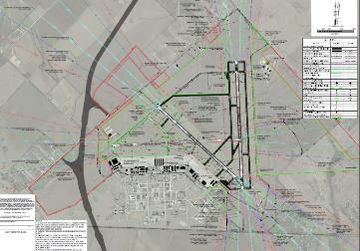In general, a large aerial photo of the airport should be utilized in conjunction with the CSPP phasing drawings to improve a contractor’s familiarity with the airfield. Each of the topics described in the previous section should be discussed with contractor personnel and the aerial photo and phasing drawings should be utilized to illustrate their application. If the airport does not have a large aerial photo, online mapping programs with integrated aerial photography (e.g. Google Maps, Google Earth, etc.) or the airport’s Airport Layout Plan (ALP) drawing can be utilized as a substitute.

For some complex projects with a high number of safety elements, consideration should be given to the development of “flash cards” for each phase of the project that can be given to contractor personnel. These flash cards should provide contractor personnel with a brief overview of the particular phase of the project that they are working in that day and specific safety considerations (e.g. protected surfaces, NAVAIDs, haul routes, etc.).

**A good practice to further improve a contractor’s familiarization with airfield facilities and operational patterns is to take contractor staff onto the airfield to see the topics identified in the previous section. Providing contractor personnel with this “hands-on” experience improves their ability to apply the airfield and operational patterns information provided during the training. Hands-on training like this is especially important if the contractor will be completing work at night when it is easier to lose situational awareness when operating on the airfield.**

Airport and Project Applications:

*(This space should be utilized to document any specific airfield familiarization or operational patterns that need to be covered for a specific project.)*

# Protected Airport Surfaces

Airports have a plethora of protected surfaces that contractors need to be aware of to operate safely on the airfield. This section specifically discusses the following protected surfaces that need to be considered during airfield construction:

* Runway Safety Areas (RSA)
* Taxiway Safety Areas (TSA)
* Object Free Areas (OFA)
* Obstacle Free Zones (OFZ)
* FAR Part 77 – Civil Imaginary Surfaces

Depending on the location of the construction project and the phase of the project, one or more of these surfaces may be an important safety consideration.

## Runway Safety Areas

Runway Safety Areas (RSA) are a defined surface surrounding a runway that is prepared or suitable for reducing the risk of damage to airplanes in the event of an undershoot, overshoot, or excursion from the runway. RSAs are rectangular in shape and extend beyond the edges and ends of a runway. According to AC 150/5300-13A, *Airport Design*, the RSA must be:

1. Cleared and graded and have no potentially hazardous ruts, humps, depressions, or other surface variations;
2. Drained by grading or storm sewers to prevent water accumulation;
3. Capable, under dry conditions, of supporting snow removal equipment, Aircraft Rescue and Fire Fighting (ARFF) equipment, and the occasional passage of aircraft without causing damage to the aircraft; and
4. Free of objects, except for objects that need to be located in the RSA because of their function. Objects higher than 3 inches (76 mm) above grade must be constructed, to the extent practical, on frangibly mounted structures of the lowest practical height with the frangible point no higher than 3 inches (76 mm) above grade. Other objects, such as manholes, should be constructed at grade and capable of supporting the loads noted above. In no case should their height exceed 3 inches (76 mm) above grade.

The dimensions of the RSA vary based on the designated critical aircraft for the runway. In general, the larger and faster the aircraft using the runway, the larger the RSA will be. Airport staff or the consulting engineer/designer for the project should clearly identify the limits of the RSA to contractor personnel when construction will be taking place near an active runway.

**For a runway to remain open during construction, the RSA must remain clear of construction activity and be maintained in the previously stated condition.**

Many times, construction activity on an airfield is completed up to the edge of the RSA to allow aircraft operations on the runway to continue. When this occurs, construction personnel operating along the edge of the RSA must maintain situational awareness to ensure the RSA remains clear. **Figure 5** provides a visual depiction of an RSA. Paragraph 2.22.1 of AC 150/5370-2G provides other specific considerations related to RSA protection during construction.

Figure 5 – RSA Example

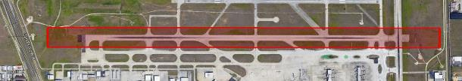

**Runway Safety Area**

Source/Map Data: Google Earth Pro, 2020.

## Taxiway Safety Areas

Similar to the RSA, the Taxiway Safety Area (TSA) is a defined surface alongside a taxiway that is prepared or suitable for reducing the risk of damage to an aircraft deviating from the taxiway. According to AC 150/5300-13A, *Airport Design*, the TSA must be:

1. Cleared and graded and have no potentially hazardous ruts, humps, depressions, or other surface variations;
2. Drained by grading or storm sewers to prevent water accumulation;
3. Capable, under dry conditions, of supporting snow removal equipment, Aircraft Rescue and Fire Fighting (ARFF) equipment, and the occasional passage of aircraft without causing structural damage to the aircraft; and
4. Free of objects, except for objects that need to be located in the TSA because of their function. Objects higher than 3 inches (76 mm) above grade must be constructed on Low Impact Resistant (LIR) supports (frangible mounted structures) of the lowest practical height with the frangible point no higher than 3 inches (76 mm) above the grade adjacent to any foundation. Other objects, such as manholes, should be constructed at grade. In no case may their height exceed 3 inches (76 mm) above grade.

The width of the TSA varies based on the designated critical aircraft for the taxiway. In general, the larger the aircraft using the taxiway, the wider the TSA will be. Airport staff or the consulting engineer/designer for the project should clearly identify the limits of the TSA to contractor personnel when construction will be taking place near an active taxiway.

**For a taxiway to remain open during construction, the TSA must remain clear of construction activity and be maintained in the previously stated condition.**

**Figure 6** provides a visual depiction of a TSA.

Figure 6 – TSA Example

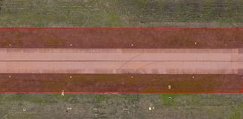

**Taxiway Safety Area**

Source/Map Data: Google Earth Pro, 2020.

## Object Free Areas

An Object Free Area (OFA) is an area centered on the ground on a runway, taxiway, or taxilane centerline provided to enhance the safety of aircraft operations by remaining clear of objects, except for objects that need to be located in the OFA for air navigation or aircraft ground maneuvering purposes.

Runway Object Free Areas (ROFA) are to be clear of above-ground objects protruding above the nearest point of the RSA. ROFAs are wider than RSAs but extend the same length beyond the runway ends.

**Construction activity may take place within the ROFA for an active runway but may not take place within the RSA or Obstacle Free Zone (OFZ) associated with the runway. Additionally, vehicles and equipment must be removed from the ROFA when not in use and materials should not be stockpiled in the ROFA if not necessary. Stockpiled materials within the ROFA requires the submittal of a 7460-1 form.**

The Taxiway/Taxilane Object Free Area (TOFA) clearing standard prohibits service vehicle roads, parked aircraft, and other objects except for objects that need to be located in the TOFA for air navigation or aircraft ground maneuvering purposes.

**In general, no construction activity may occur within the TOFA while a taxiway is open for aircraft operations unless the conditions identified in AC 150/5370-2G** **Paragraph 2.22.4.1-2.22.4.3.6 are met. Additionally, vehicles and equipment must be removed from the TOFA when not in use and materials should not be stockpiled in the TOFA if not necessary.**

Airport staff or the consulting engineer/designer for the project should clearly identify the limits of the ROFA and TOFA to contractor personnel when construction will be taking place near an active runway or taxiway. Any barricades placed within an active OFA must be low mass and low profile.

## Obstacle Free Zones

The Obstacle Free Zone (OFZ) is a three-dimensional volume of airspace along the runway and the extended runway centerline that is required to be clear of obstacles for the protection of aircraft landing or taking off from the runway and for missed approaches.

**In general, personnel, material, and/or equipment may not penetrate the OFZ while the runway is open for aircraft operations. As a result, no construction activity may take place within the OFZ while a runway is open.**

It should be noted that sometimes the RSA will be wider than OFZ and other times the OFZ will be wider than the RSA. As a result, airport staff or the consulting engineer/designer for the project should clearly identify whether the RSA or the OFZ is the controlling protected surface when conducting construction work near an active runway.

## 14 CFR Part 77 – Civil Imaginary Surfaces

14 CFR Part 77 defines the civil imaginary surfaces at an airport. The primary purpose of the civil imaginary surfaces is to protect aircraft arriving and departing on a runway. The Part 77 imaginary surfaces are typically more extensive than the ROFA, RSA, and OFZ.

In general, construction activity may take place within the civil imaginary surfaces as long as it does not create an airspace hazard. An FAA Form 7460-1 should be filed identifying the stockpile, equipment, and vehicle parking areas for a construction project so they can be properly reviewed to ensure no airspace hazard exists. If the location or height of any of these items deviates from what was approved as part of the original 7460-1 submittal, a new 7460-1 may be required. According to FAR Part 77, a minimum of 45 days’ notice is required, however the FAA recommends airspace cases be filed in OE/AAA 60 – 90 days before the determination is needed.

## Protected Surfaces Summary – Best Practices

The protected surfaces associated with an airport are complex and can vary significantly. As a result, contractors may find them confusing. Below are some best practices that have been identified to simplify them and ensure contractor personnel stay clear of protected surfaces:

* Continuous Visual Delineations - When working near an open runway or taxiway, identify the protected surface (typically the RSA or the OFZ for a runway and the TOFA for a taxiway) and provide a visual continuous delineation to construction personnel (e.g. low profile barricades, traffic cones, snow fence, construction fence, etc.) that identifies the boundaries of the area. Providing a continuous visual delineation will help contractor personnel understand and identify areas they should not access.
* Continuously Reinforce the Location of Protected Surfaces in Safety Briefings – Reinforcing the location of protected surfaces during daily safety briefings with construction personnel can improve awareness of the location of various protected surfaces and why they must be kept clear.

## Airport Protected Surfaces – External Resources

The following documents provide additional information regarding airport protected surfaces:

* [FAA AC 150/5370-2G – Operational Safety on Airports During Construction](https://www.faa.gov/documentLibrary/media/Advisory_Circular/150-5370-2G.pdf) – Provides a detailed review of the FAA’s standards and recommended practices related to airfield construction.
* [FAA AC 150/5300-13A – Airport Design](https://www.faa.gov/documentLibrary/media/Advisory_Circular/150-5300-13A-chg1-interactive-201907.pdf) – Provides a detailed overview of airport design standards and protect surfaces.
* [14 CFR Part 77 – Safe, Efficient Use, and Preservation of the Navigable Airspace](https://www.ecfr.gov/cgi-bin/text-idx?rgn=div5&node=14:2.0.1.2.9) – Provides an overview of the 5 civil airport imaginary surfaces.

Airport and Project Applications:

*(This space should be utilized to document the protected surfaces applicable to a project/airport. The size and dimensions of each protected surface should be noted.)*

# Airfield Marking, Signage, and Lighting

Airfields have a complex array of airfield markings, signs, and lights that provide personnel, vehicles, and aircraft operating on the airfield with redundant visual indications of their location on the airfield. This section of the training provides an overview of some basic airfield marking, signage, and lighting elements. Since airfield markings, signs, and lights vary from airport to airport, it is critical that the airport sponsor or consulting engineer/designer familiarize contractor personnel with the markings, signs, and lights at the airport they will be working at.

It should be notated that this module does not provided an extensive list of different airfield markings, signs, and lights. A simplified list has been provided that focuses on the airfield marking, signage, and lighting elements that are most likely to be a consideration for contractors.

## Airfield Markings

In general, runway markings are white and taxiway/apron markings are yellow. Some common airfield markings and their meaning are discussed below in **Table 2**:

Table 2 – Important Airfield Markings

Source/Aerial Photo: Google Earth Pro, 2020.

## Airfield Signage

Some common airfield signs and their meaning are discussed below in **Table 3**:

Table 3– Important Airfield Signage



## Airfield Lighting

Some common airfield lights and their meaning are discussed below in **Table 4**.

Table 4 – Important Airfield Lighting



## Airfield Marking, Signage, and Lighting – Best Practices

A key safety element of any airfield construction project is identifying the airfield marking, signage, and lighting changes that should be made during each phase of the project. Below are some best practices related to this topic:

* Detailed Airfield Marking, Signage, and Lighting Plans for Each Project Phase – Each phase of the project should have a detailed plan identifying:
  + The airfield markings that will be removed and any new markings (temporary or permanent) that should be painted.
  + The airfield signage and lights that should be covered. For signs, the plan should show the specific sign elements in each sign array that should be covered.
* Identify How Signs and Lights will be Covered – The contractor should be provided with clear expectations regarding how airfield signs and lights should be covered during each phase of the project. Below are some typical practices for covering airfield signs and lights:
  + For covering airfield signs:
    - Utilize thick black plastic to cover sign elements that need to be hidden during a particular phase.
    - Remove sign panels that need to be hidden during a particular phase and replacing them with blank sign panels.
  + For covering airfield lights:
    - For elevated lights – remove the light fixture, remove the light bulb within the fixture, cover the light with aluminum foil, cover the light with a PVC pipe, or deactivate the lighting circuit.
    - For in-pavement lights – remove the light bulb within the fixture, cover tape or deactivate the lighting circuit.

## Airfield Marking, Signage, and Lighting – External Resources

The following documents provide additional information regarding airfield markings, signage, and lighting:

* [FAA Airport Marking and Signage – Quick Reference Guide](https://www.faa.gov/airports/runway_safety/publications/media/QuickReferenceGuideProof8.pdf) – This is a quick reference guide that provides an overview of common airfield markings and signage.
* [FAA Guide to Ground Vehicle Operation](https://www.faa.gov/airports/runway_safety/media/ground_vehicle_guide_proof_final.pdf) – This document provides an overview of airport signs and markings related to operating a vehicle on the airfield.
* [FAA AC 150/5340-1M – Standards for Airport Markings](https://www.faa.gov/documentLibrary/media/Advisory_Circular/150-5340-1M.pdf) – This document provides a detailed review of airfield markings including their layout and specifications.
* [FAA AC 150/5340-18G – Standards for Airport Sign System](https://www.faa.gov/documentLibrary/media/Advisory_Circular/150-5340-18G.pdf) – This document provides a detailed review of airfield signage layout.
* [FAA AC 150/5340-30J – Design and Installation Details for Airport Visual Aids](https://www.faa.gov/documentLibrary/media/Advisory_Circular/150-5340-30J.pdf) – This document provides a detailed review of airfield lighting.
* [FAA AC 150/5345-44K – Specification for Runway and Taxiway Signs](https://www.faa.gov/documentLibrary/media/Advisory_Circular/150-5345-44K.pdfhttps:/www.faa.gov/documentLibrary/media/Advisory_Circular/150-5345-44K.pdf) – This document provides a detailed review of the technical specifications for airfield signs.

Airport and Project Applications:

*(This space should be utilized to document the types of airfield markings, signage, and lighting at the airport that a contractor should be familiar with.)*

# Operating a Vehicle on the Airfield

The safe operation of vehicles on the airfield is a critical consideration for any airport construction project. The risk of an incident involving significant property damage, injury, and/or death can be high when vehicles are not operated safely on the airfield. Vehicle/Pedestrian Deviations, commonly referred to as V/PDs, are serious incidents that are recorded by the FAA and can result in serious consequences for all involved parties. This section outlines specific requirements for safely operating a vehicle on the airfield.

## Training

All airfield drivers must receive sufficient training before operating a vehicle on the airfield. In most cases, this training will be facilitated by the airport operator and will include guidance specific to the airport and the project. Even drivers who have driven at other airports will need to complete this training. The scope and frequency of this training will vary by airport and the requirements of the project. Some of the information critical to sufficient driver training is covered in this manual in sections 9 and 15.

**It is critical that vehicle operators who have not completed driver training not be allowed to drive unescorted on an airfield.**

## Vehicle Requirements

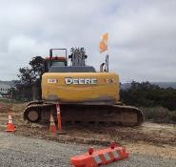

Construction vehicle with flag.

All vehicles operating on the airfield must have a rotating or flashing yellow beacon mounted on the roof or an orange and white checkered flag visible at the top of the vehicle. At some airports, vehicles may be required to be equipped with radios capable of communication with air traffic control and other aircraft, and placards or other signage on the exterior of the vehicle identifying the entity to whom the vehicle belongs. Radio communications will be discussed in more depth in Section 15 of this manual.

## Escorting

In some circumstances, vehicle operators who have not received driver’s training may drive on an airfield under escort from another vehicle. The operator of the vehicle escorting another vehicle must provide clear and specific direction to the operator of the vehicle to be escorted. Generally, the escorted vehicle must directly follow the path of the escorting vehicle and be prepared to stop any time the escorting vehicle stops. Vehicle-to-vehicle communication should also be established in advance via hand signals, radios, cell phones, or a combination thereof. Contractors should check with the airport sponsor to determine specific escorting procedures and processes related to the airport.

## Situational Awareness

Proper situational awareness can be the difference between safe operations and a catastrophic accident. Vehicle operators must ensure they understand their environment at all times, including where they are located and what is happening around them. They must communicate clearly and ensure they understand instructions given to them by air traffic control, airport operations personnel, or others. Distractions must also be minimized. The use of cell phones, vehicle radios (other than when required for communication), and unnecessary conversations with vehicle occupants should all be minimized or avoided. When weather allows, keeping a window open in the vehicle increases situational awareness by allowing the operator to better hear what is going on around them.

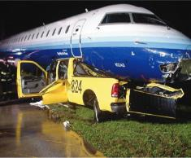

Source: FAA.

At busy airports, the environment is highly dynamic and can change quickly. Equally dangerous however, is complacency that can result from less busy environments where a driver or aircraft operator fails to maintain proper situational awareness.

**Any accidents or incidents must always be immediately reported to the airport operator.**

**Drivers must always expect the unexpected and be prepared to react quickly to maintain a safe environment.**

### Aircraft Recognition

An important component of situational awareness is being able to recognize aircraft movements at night and during periods of low visibility. Most aircraft have lights which can help the observer determine whether an aircraft is moving or about to move, and in which direction it is moving. Most aircraft will have one or two flashing red lights, commonly referred to as anti-collision lights. If these lights are illuminated it means the aircraft is either in motion or will soon be in motion, and it should always be assumed that the engines are running. Aircraft will also have a red light on the front of the left wingtip and a green light on the front of the right wingtip. These are referred to as position or navigation lights. When observing an aircraft in your vicinity at night or in low-visibility conditions, vehicle operators should always remember the phrase “red-right-wrong”. In other words, if a red light is visible on the right side of the aircraft, it means the aircraft is moving in the direction of the observer, and the vehicle should safely clear the area and give way to the aircraft. **Figure 7** depicts the standard position light configuration seen on most aircraft.

**Figure 7 – Aircraft Position Lights**

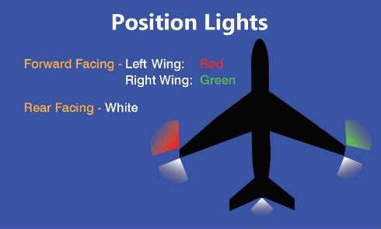

## Other Best Practices

The following is a list of best practices that should be considered when operating a vehicle on an airfield. Specific airport requirements may differ from the list of best practices provided below. In these instances, the airport specific requirements should take precedent.

**Aircraft always have the right of way over vehicles. Emergency vehicles (ARFF, Police, etc.) have the right of way over all other vehicles.**

* Never drive behind or in front of an aircraft when the engines are running.
* Never drive within 100 feet of the sides of a moving aircraft.
* Never drive under the wing of an aircraft. In general, a distance of at least 20 feet from an aircraft should be maintained when operating a vehicle around a parked aircraft.
* Never drive under passenger boarding bridges.
* Even if properly trained to do so, avoid runway crossings unless absolutely necessary. Use vehicle service roads whenever possible.
* Vehicles should operate in the Non-Movement Area whenever possible and only enter the Movement Area when operationally necessary and if trained to do so.
* When communicating with air traffic control, always clarify any direction that is unclear or seems unsafe based on the operator’s situational awareness.
* Always ensure vehicles are parked in such a way that they will not impact airport operations or encroach on protected surfaces as identified in the CSPP or SPCD.
* Never drive fast on the airfield. Maintain a speed less than 25 MPH.
* Ride-alongs are encouraged as a component of familiarization and training for new employees.

## Operating a Vehicle on the Airfield – External Resources

The following documents provide additional information regarding operating a vehicle on the airfield:

* [FAA AC 150/5210-20A - Ground Vehicle Operations to include Taxiing or Towing an Aircraft on Airports](https://www.faa.gov/airports/resources/advisory_circulars/index.cfm/go/document.current/documentnumber/150_5210-20) – This advisory circular provides guidance on training for drivers operating vehicles on an airfield.
* [FAA Guide to Ground Vehicle Operation](https://www.faa.gov/airports/runway_safety/media/ground_vehicle_guide_proof_final.pdf) – This document provides an overview of airport signs and markings related to operating a vehicle on the airfield.

Airport and Project Applications:

*(This space should be utilized to document specific information related to operating a vehicle on the airfield that will be applicable to the project.)*

# Security

Airport and project security requirements will vary based on the type of airport and the scope of the project. Most airports with commercial air service in the United States are regulated by the Transportation Security Administration. These airports will have significantly more stringent security requirements than other airports. This section outlines high-level best practices that can be applied to most environments and is not meant to replace or amend any regulatory security requirements.

## Badging

For projects at airports with commercial air service, contractors should expect to be required to complete a badging process which includes fingerprinting and several background checks.

**The airport badging process may take several weeks for each individual to complete, and project schedules should be designed accordingly.**

Some general aviation airports may also require contractors to complete a badging process. Part of these badging processes will include security training specific to the airport.

## Escorting

In some circumstances, contractors who have completed the badging process may need to escort others who have a temporary need for access to the airfield. Escorting personnel must be authorized to conduct escorts and must follow strict guidance while escorting, including maintain continuous positive control of the escorted individual(s). Contractors should check with the airport sponsor to identify specific escorting requirements and processes.

## Gate and Perimeter Control

Controlling access to the airfield is a critical component of construction security. Provisions must be made for verifying that only authorized personnel are able to gain entry (either by vehicle or on foot) and that the integrity of the airport perimeter is maintained, especially if the project involves work along the perimeter fence. Physical security of any perimeter gates being utilized for the project will also be an important consideration and will likely require issuance of keys to designated personnel, which must be closely controlled.

## Gate Guards

The use of gate guards is a common practice for controlling access during airport construction projects. Gate guards must be fully trained in airport and project security rules and must also be badged at airports where badging is required. Common gate guard responsibilities include verifying the identity and authority of drivers and vehicles requesting access through the gate, inspecting vehicles, logging and tracking gate activity, reporting any suspicious activity, and ensuring the gate is operated and secured in accordance with security protocols.

## Security Awareness

Personnel that are authorized to work in the airfield environment must maintain a high level of security awareness. At airports where badges are required, personnel should be cognizant of anyone not under escort or displaying a badge and take action as outlined in the airport’s security training. Similarly, personnel should be aware of unauthorized individuals attempting to gain access to the airfield through a gate or elsewhere along the airport perimeter.

**Contractors should adopt a “see something, say something” mentality, where any suspicious activity is immediately reported through the proper channels.**

At some airports, different areas of the airport have different security designations. A contractor’s access will usually be limited to the areas specifically required for the project, and personnel must be aware of these other areas and remain clear of them at all times. Finally, many airports require authorized construction vehicles to be adequately identifiable by decals that identify the entity to which the vehicle belongs.

## Security – External Resources

The following document provides additional information regarding security:

[49 CFR 1542 – Airport Security](https://www.ecfr.gov/cgi-bin/text-idx?SID=d9bd9626b5be189b84ec90135e7b33a4&mc=true&node=pt49.9.1542&rgn=div5) – This is the federal regulation by which most airports with commercial air service must comply.

Airport and Project Applications:

*(This space should be utilized to document specific security regulations and procedures applicable to the airport and project that contractors should be aware of.)*

# Wildlife Management

Airports frequently attract wildlife to their grounds.

**Wildlife can be a serious hazard to aircraft operations, and wildlife strikes by aircraft result in millions of dollars in damage and have also resulted in very serious aircraft incidents.**

Wildlife can also cause damage to the airport itself. As part of the CSPP process, projects are required to address several items that are known to exacerbate wildlife issues at airports.

Many airports have a wildlife hazard management plan in place, which dictates mitigative measures airports must take based on the wildlife issues that have been identified at that airport. Contractors are required to abide by this plan and take any other steps stated in the CSPP to mitigate the presence of wildlife during the project. Below is a list of best practices to which a contractor may be expected to adhere, in addition to any required practices specific to the airport.

* All trash must be properly disposed of, and trash cans and dumpsters must be covered.
* Food must not be left out and feeding of any wildlife must be strictly prohibited.
* Standing water must be drained.
* Grass should not be allowed to grow tall in any areas within the purview of the project and any grass seeding must be done with consideration for the potential to attract wildlife.
* Fencing and gates must be properly maintained. Gaps under fences should be closely monitored and promptly repaired.
* Disruption of existing wildlife habitat must be mitigated to the extent possible. Wildlife sightings must be reported to the airport operator.
* Care must be taken to ensure any material stockpiles do not become wildlife attractants.

**Any significant wildlife sightings should be immediately reported to the airport operator through the established channels.**



**Coyote hole under fence**

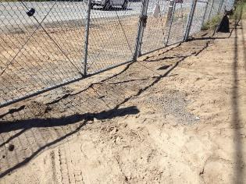

**Gap under fence**

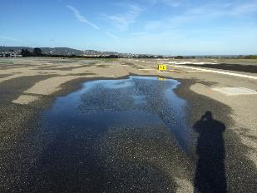

**Standing water**

## Wildlife Management – External Resources

The following website provides additional information regarding wildlife management:

[Wildlife Regulations, Guidance, and Resources (FAA website)](https://www.faa.gov/airports/airport_safety/wildlife/resources/) – This page contains a wide range of resources relating to wildlife at airports.

Airport and Project Applications:

*(This space should be utilized to document specific wildlife hazards and control measures applicable to the project.)*

# Foreign Object Debris (FOD) Prevention

Foreign object debris, commonly referred to as FOD, is any object on an airfield that should not be there. Common FOD items include trash, loose vegetation, tools or other hardware that fall off of vehicles or aircraft or are mistakenly left behind. Rocks, dirt, and mud from construction vehicles are also common sources of FOD during construction projects. FOD can become an especially significant issue on windy days when loose materials are more likely to be blown into aircraft operating areas or when haul routes cross active airfield surfaces (e.g. taxiways, aprons, etc.).

**FOD poses a serious threat to safety of aircraft operations and many serious aircraft incidents have been caused by FOD.**

Some airports have specific FOD management plans, and contractors should expect to be required to comply with these plans. Contractors must be cognizant of FOD risks associated with a project and make concerted efforts to mitigate these risks. Below is a list of FOD prevention best practices to which a contractor may be expected to adhere, in addition to any required practices specific to the airport:

* Frequent inspections of the project site should be undertaken to identify any existing or potential FOD sources. Any issues identified must be immediately corrected and should also be logged for recordkeeping.

**Any FOD issues that cannot be immediately corrected by the contractor must be immediately reported to the airport operator.**

* Construction vehicles should be checked for the presence of loose dirt, mud, or other debris in tire treads and elsewhere on the vehicle before entering areas in which aircraft operate. Haul routes that pass through these areas must also be frequently inspected and swept, when needed.
* Barricades must be securely placed to avoid become FOD during windy conditions or as a result of jet blast. Barricade lights must also be securely attached, and barricade placements must be inspected frequently to identify and correct any issues.
* Provisions must be taken to ensure stockpiled materials do not become FOD.

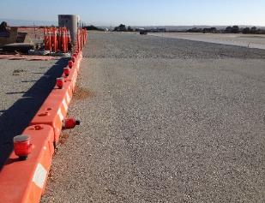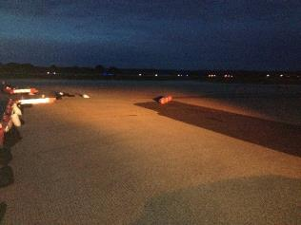

Unsecured barricades and lights.

## Foreign Object Debris Prevention – External Resources

The following document provides additional information regarding foreign object debris prevention:

[FAA AC 150/5210-24 - Airport Foreign Object Debris (FOD) Management](https://www.faa.gov/airports/resources/advisory_circulars/index.cfm/go/document.current/documentNumber/150_5210-24) – This advisory circular provides guidance for developing and managing a FOD program and includes many best practices for FOD prevention and mitigation.

Airport and Project Applications:

*(This space should be utilized to document specific FOD hazards and FOD control measures that should be taken applicable to the project.)*

# NAVAID Protection

Navigational aids, commonly referred to as NAVAIDs, are facilities that provide navigational assistance to aircraft arriving or departing from an airport. These facilities include a variety of electronic signal-broadcasting facilities and lighting components and may be owned and maintained by the FAA or the airport operator. As part of a construction project, the ownership of any impacted NAVAIDs should be identified and a plan should be developed for working with the owner of the NAVAID during the project.

Not all airports have the same NAVAIDs. Some NAVAIDs have “critical areas” associated with them. The FAA defines these critical areas as “an area of defined shape and size associated with a NAVAID that must remain clear and graded to avoid interference with the electronic signal.”

Often, construction projects require work near or within these critical areas, even if the NAVAIDs themselves are not impacted. In cases where NAVAIDs will remain operational during the project, careful considerations must be made for protection of these critical areas. These considerations will be stated in the CSPP and should be noted in the phase drawings.

**Personnel working in the field must have a good understanding of NAVAID critical areas and any limitations associated with them. Airport sponsors and the consulting engineer/designer should clearly identify the limits of any critical areas.**

Construction activity, as well as material and equipment storage, must remain clear of the critical areas and must not obstruct access to these facilities. Any anticipated impacts or required shutdowns of these facilities must be coordinated through a defined procedure with the airport and FAA well in advance as prescribed in the CSPP.

## Glideslope and Localizer Critical Areas

Two of the most common critical areas that can be found at many airports protect glideslope antennae and localizer arrays. These NAVAIDs are the two primary components of an Instrument Landing System (ILS). A picture of each of these facilities is depicted on the next page**.**  An example glideslope and localizer critical areas is depicted in **Figure 8 and 9.**

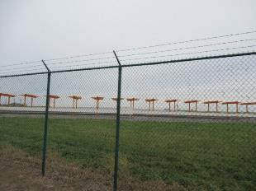 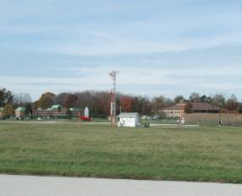

Localizer array Glideslope antenna

**Figure 8 – Glideslope Critical Area**

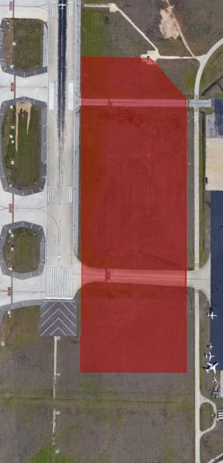

Glideslope Antenna

Source/Aerial Photo: Google Earth Pro, 2020.

**Figure 9 – Localizer Critical Area**

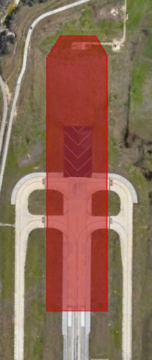

Localizer Array

Source/Aerial Photo: Google Earth Pro, 2020.

## NAVAID Protection – External Resources

The following document provides additional information regarding NAVAID protection:

[FAA Aeronautical Information Manual Section 1. Navigation Aids](https://www.faa.gov/air_traffic/publications/atpubs/aim_html/chap1_section_1.html) – This site provides technical descriptions of electronic NAVAIDs that may be found at or near an airport.

Airport and Project Applications:

*(This space should be utilized to document specific NAVAIDs and NAVAID critical areas applicable to the project that contractors should be aware of.)*

# Radio Phraseology and Procedures

Proper radio communication procedures and phraseology are critical to safe vehicle operations and preventing miscommunications which can result in catastrophic accidents. This section will outline FAA guidance on these items.

## Phraseology

Phraseology includes the terminology and organization of messages used when communicating with ATCT or aircraft.

### Phonetic Alphabet

To avoid confusion over similar sounding letters when communicating by radio, a phonetic alphabet is used in aviation radio communications. This alphabet is as follows:

**A** Alpha

**B** Bravo

**C** Charlie

**D** Delta

**E** Echo

**F** Fox-Trot

**G** Golf

**H** Hotel

**I** India

**J** Juliet

**K** Kilo

**L** Lima

**M** Mike

**N** November

**O** Oscar

**P** Papa

**Q** Quebec

**R** Romeo

**S** Sierra

**T** Tango

**U** Uniform

**V** Victor

**W** Whiskey

**X** X-Ray

**Y** Yankee

**Z** Zulu

### Common Phrases

**Table 5** is a list of commonly used phrases excerpted from FAA AC 150/5210-20A.

Table 5 – Common Air Traffic Control Phrases

|  |  |
| --- | --- |
| **What Is Said** | **What It Means** |
| Acknowledge | Let me know you have received and understand this message. |
| Advise Intentions | Let me know what you plan to do and do not do it until ATCT provides authorization. |
| Affirmative | Yes. |
| Correction | An error has been made in the transmission, and the correct version follows. |
| Go Ahead | Proceed with your message only. **(Not to be confused with a direction to move the vehicle)** |
| Hold/Hold Short | Phrase used during ground operations to keep a vehicle or aircraft within a specified area or at a specified point while awaiting further clearance from air traffic control. |
| How do you hear me? | Question relating to the quality of the transmission or to determine how well the transmission is being received. |
| Immediately or without delay | Phrase used by ATC when such action compliance is required to avoid an imminent situation. |
| Negative | "No" or "permission not granted" or "that is not correct." |
| Read Back | Repeat my message to me. |
| Roger | I have received all of your last transmission. |
| Stand By | Means the controller or pilot must pause for a few seconds, usually to attend to other duties of a higher priority. Also means to wait as in "stand by for clearance." The caller can reestablish contact if a delay is lengthy. |
| Unable | Indicates inability to comply with a specific instruction, request, or clearance. |
| Verify | Request confirmation of information. |
| Wilco | I have received your message, understand it, and will comply with it. |

## Procedures

**In all radio communications related to operating on an airfield, there are always three key items that must be clearly expressed and understood. They are:**

* **Who you are (ex. Vehicle One)**
* **Where you are (ex. Located at the FBO)**
* **What your intentions are (ex. Would like to proceed to the construction site via Taxiway V.**

### Towered Airports

At airports with an Airport Traffic Control Tower (ATCT), a specific call and response practice must be utilized to ensure proper communication. An example of this exchange is as follows:

* Driver: [AIRPORT NAME] ground control; [VEHICLE CALLSIGN] is at Taxiway Alpha. Request clearance south on Runway 19 right for a light inspection.”
* ATCT: “[VEHICLE CALLSIGN], hold short of runway 19 right.”
* Driver: “[VEHICLE CALLSIGN], holding short of runway 19 right.”

Note that the driver repeats verbatim the direction given by the ATCT. This is critical to ensuring both parties have the same understanding of the communication that has taken place. Failure to complete this step can easily result in miscommunication, leading to unsafe situations and runway incursions. The subsequent exchange in this conversation would look like this:

* ATCT: “[VEHICLE CALLSIGN], proceed on to runway 19 right.”
* Driver: “[VEHICLE CALLSIGN] proceeding on to runway 19 right.”

**It is important to remember that a vehicle operator must receive explicit permission from the ATCT to drive on or across a runway or the associated runway safety area**.

Once in the runway environment, the driver must then be ready to respond to any additional direction from the ATCT, such as to clear the runway or expedite their movement on the runway. These directions must be acknowledged using the same format. Finally, when the vehicle has cleared the runway, the operator should report that information to the ATCT and then request clearance for movement on the taxiway, if required.

### Non-Towered Airports

At airports without an ATCT, aircraft and vehicles generally communicate directly with each other on a radio frequency known as Common Traffic Advisory Frequency (CTAF). The process outlined at the beginning of this section (who, where, what) is the same, however instead of receiving permission, the driver must listen for aircraft and other vehicles to broadcast their intentions and determine when it is safe to proceed. In addition to the differences in procedure at non-towered airports, there are also some key phraseology differences that are important to understand. An example of a radio exchange on CTAF is as follows:

Driver: “[AIRPORT NAME] traffic, [VEHICLE CALLSIGN] is holding short of Runway 13 at Taxiway Bravo. Any traffic in the area please advise. [AIRPORT NAME] traffic”

The vehicle operator should wait for a response from any aircraft in the vicinity and visually observe the area. If an aircraft transmits a response, the two parties should communicate as necessary to ensure there is safe separation between the vehicle and aircraft. If an aircraft is observed but does not transmit, the vehicle should remain clear of the area until the aircraft’s intentions are clear. When safe to do so, the vehicle operator should make a second transmission.

Driver: “[AIRPORT NAME] traffic, [VEHICLE CALLSIGN] is proceeding on to Runway 13 from Taxiway Bravo. Any traffic in the area please advise. [AIRPORT NAME] traffic.”

The airport name is used at both the beginning and end of each transmission because some CTAF frequencies are used at more than one airport, so repeating the airport name helps ensure that listeners understand which airport is being referenced in the transmission. It is also helpful to understand some of the terms you may hear from aircraft when transmitting their position in the air. **Figure 10** (from the FAA Airplane Flying Handbook) depicts the traffic pattern that aircraft will usually follow, particularly in the absence of an ATCT. Pilots will often identify their position as “departing runway XX”, “on the crosswind”, “downwind for runway xx”, “turning base”, “base leg for runway XX”, or “on final for runway xx”. Understanding this graphic will help vehicle operators understand where they can expect to see aircraft and how soon they may be landing.

Figure 10 – Standard Traffic Pattern

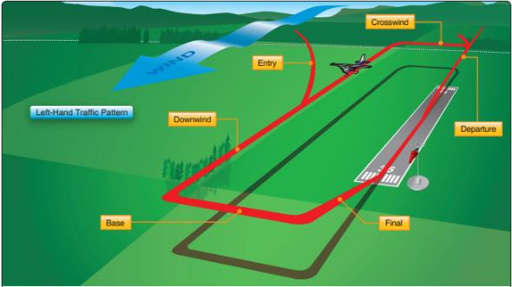

Source: FAA

**Drivers operating in a CTAF environment must understand that aircraft are not technically required to make radio transmissions while operating in this environment, and it is relatively common for aircraft operators to neglect to transmit any information at all. It is incumbent upon each vehicle operator to maintain a high level of situational awareness and be prepared to react to changing circumstances with very little notice.**

Finally, it should be noted that airports with ATCTs that do not operate 24 hours a day revert to CTAF during the hours that the ATCT is closed. Vehicle operators are responsible for understanding this distinction when it is applicable to their airport.

## Radio Phraseology and Procedures – External Resources

The following documents provide additional information regarding radio phraseology and procedures:

* [FAA AC 150/5210-20A – Ground Vehicle Operations to include Taxiing or Towing an Aircraft on Airports](https://www.faa.gov/documentLibrary/media/Advisory_Circular/150-5210-20A.pdf) – This advisory circular provides guidance on training for drivers operating vehicles on an airfield.
* [FAA Guide to Ground Vehicle Operations](https://www.faa.gov/airports/runway_safety/media/ground_vehicle_guide_proof_final.pdf) – This document provides an overview of airport signs and markings related to operating a vehicle on the airfield.

Airport and Project Applications:

*(This space should be utilized to document specific radio and phraseology procedures that contractors should be aware of. Items such as frequencies, callsigns, ATCT hours of operation, etc. should be included.)*

# Flaggers

Some airfield construction projects require contractor personnel and equipment to cross an active taxiway or ramp to access a construction site. When this occurs, the airport sponsor may request that the contractor provide “flaggers” in the CSPP to act as crossing guards.

The duties of the flagger are to:

* Visually determine whether it is safe for a vehicle operator to cross an active taxiway or ramp at an airport.
* Inspect the crossing point once the vehicle has passed to ensure the vehicle did not leave any FOD on the surface. In some instances, the flagger may also clean the surface, if necessary.
* Brief the driver of the vehicle that will be crossing to ensure they know where they are going once they enter the active taxiway/apron.

This section of the CTG provides a brief training that can be utilized to train flaggers for an airfield construction project.

## Flagger Positioning and Equipment

This section provides an overview of recommendations related to the position and equipment that should be utilized by flaggers.

**In general, at least one flagger should be located at each taxiway crossing point.**

For example, if there are two active taxiways that vehicles will need to cross to reach a construction site then two flaggers, at minimum, should be used, one for each taxiway crossing. Each flagger should be stationed immediately outside of the TOFA for the taxiway and should ideally be located on the side of the taxiway a vehicle will first approach when accessing the construction site. **Figure 11** provides a graphic depiction of where flaggers should be located for an airfield project with multiple crossings of active taxiways.

Figure 11 – Recommended Flagger Locations

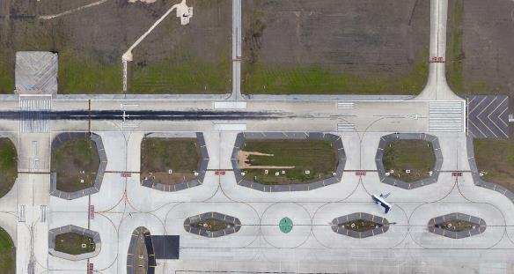

**Legend**

- Flagger Location

- Contractor Haul Route

Project Site

Source/Aerial Photo: Google Earth Pro, 2020.

If a taxiway crossing is busy and a high number of vehicles will be utilizing the haul route, consideration should be given to placing a flagger on each side of the active taxiway as shown in **Figure 12**.

Figure 12 – Recommended Flagger Locations for Busy Intersections



Project Site

**Legend**

- Flagger Location

- Contractor Haul Route

Source/Aerial Photo: Google Earth Pro, 2020.

**An important factor that needs to be considered when identifying the placement of flaggers is aircraft jet blast and propwash. If aircraft will likely be turning or holding close to the flagger’s location, the flagger may need to be positioned further away from the taxiway.**

In general, it is recommended that every flagger have the following equipment:

* Airfield Radio to Monitor the ATCT or CTAF Frequency
* Cell phone or company radio for reporting emergencies or other issues
* Reflective Safety Vest
* Stop/Slow Sign

Additional equipment may be necessary depending on the time of day the haul route will be active. For instance, area lighting and a flashlight will be needed during nighttime work. During the day, a sunshade or canopy may be needed.

Standard “Stop” and “Slow” signs should be utilized by flaggers to visually communicate with vehicle operators accessing the construction site. A flagger should ensure that the “Stop” side of the sign is shown to an approaching vehicle until the flagger can visually verify that it is safe for the vehicle to cross the taxiway. Once the flagger has determined that it is safe for the vehicle to cross the taxiway, the flagger should switch the sign to the “Slow” side to let the vehicle operator know it is safe to cross the taxiway.

**If work will be completed at night, the “Stop” and “Slow” sign should be lighted or be made of reflective material to ensure vehicle operators can see it.**

## Flagger Training

This section provides an overview of the training that should be provided to flaggers to enable them to perform their duties correctly. In general, flagger training should be provided by airport staff members with a strong knowledge of the aircraft operations the airport sees on a daily basis. The training, at minimum, should cover the following:

* Aircraft operational patterns in the area.
* Identification of the TOFA limits of the taxiway (all vehicles should be held outside the TOFA before given permission to cross the taxiway).
* Identification of any runway protected surfaces (RSA, OFZ, etc.) or NAVAID critical areas that need to be observed.
* Actions to be taken if FOD is observed on the taxiway after a vehicle crosses.

Additionally, for each vehicle crossing, it is recommended that flaggers follow the process outlined below:

* Step #1 – STOP - Have all vehicles approaching the crossing point stop before reaching the TOFA.
* Step #2 – CHECK – Visually inspect taxiway area to ensure it is safe for a vehicle to cross. If the flagger sees an aircraft that could potentially utilize the taxiway the vehicle should be held until the aircraft passes.
* Step #3 – PROCEED WHEN CLEAR – Allow the vehicle to proceed when the flagger has determined it is safe and no aircraft are in the area.
* Step #4 – INSPECT – Once the vehicle has crossed the taxiway the flagger should inspect the taxiway visually to verify no FOD was left on the taxiway. If FOD is identified, appropriate actions should be taken as defined by the airport sponsor.

**Figure 13** provides a graphic that can be provided to flaggers as a reminder of these steps:

Figure 13 – Flagger Steps

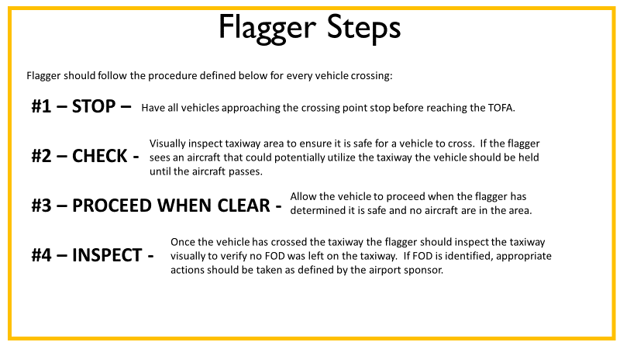

**Before a flagger begins performing his/her duties alone, it is recommended that an airport representative accompany them until they become comfortable with their duties.**

## Flaggers Training – External Resources

The American Traffic Safety Services Association (ATSSA) has an online flagger training course for roadway construction that can be found at the following link – [ATSSA Flagger Training](https://www.atssa.com/Training/Flagger-Training-Courses/Online-Training).

Airport and Project Applications:

*(This space should be utilized to document any specific flaggers training or requirements for a specific airport or project.)*