Checklist Purpose/Use:
The CSPP process has four defined phases as shown in the graphic below. Each phase has a “checkpoint” that provides a series of questions that should be reviewed and answered to help airport sponsors and/or project consulting engineers/designers determine whether they are ready to proceed to the next phase of the CSPP process.

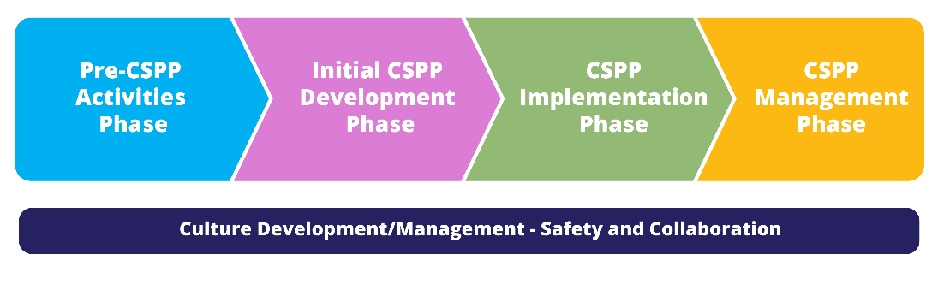
This document provides a checklist for each of the checkpoints associated with the four phases of the CSPP process.

The recommendations and guidance provided in this document are based on the current versions of FAA guidance materials in effect as of the date of this publication (November 2020). The FAA updates guidance materials from time to time. As a result, it is highly recommended that users check the FAA website to ensure they are utilizing the most current versions of published FAA guidance material.

Airport Project Manager (Name/Title):____________________________________________________

Required Action | Yes | No | N/A | Remarks
Checkpoint #1: Pre-CSPP Activities Phase
Have I determined whether a CSPP will be required? | ☐ | ☐ | ☐
Have I identified key project stakeholders? | ☐ | ☐ | ☐
Have I identified significant impacts/constraints for the project? | ☐ | ☐ | ☐
Has FAA Office of Airports determined whether an SRM panel will be required? Will FAA ATCT need to complete an SRM? If the answer is no to both questions, will the airport need to conduct any special SRA or safety assessments? | ☐ | ☐ | ☐
Have I developed/gathered key airport-specific documents and standards needed for CSPP development? | ☐ | ☐ | ☐
[insert project/airport-specific criteria] | ☐ | ☐ | ☐
Checkpoint #2: Initial CSPP Development
Does the draft CSPP meet all the requirements of FAA ARP SOP 1.0 and AC 150/5370-2G? | ☐ | ☐ | ☐
Have project stakeholders and their needs/requirements been identified? | ☐ | ☐ | ☐
Has the CSPP been reviewed by affected stakeholders? | ☐ | ☐ | ☐
Has a construction phasing feasibility review been conducted? | ☐ | ☐ | ☐
Were all required safety analysis/reviews completed? | ☐ | ☐ | ☐
Have all points of interest been identified for airspace submittal and review? | ☐ | ☐ | ☐
[insert project/airport-specific criteria] | ☐ | ☐ | ☐
Checkpoint #3: CSPP Implementation Phase
Has the contractor completed all required airport training? | ☐ | ☐ | ☐
Has the contractor provided all required training certifications and documents? | ☐ | ☐ | ☐
Does the contractor’s SPCD sufficiently describe how the contract will comply with the CSPP? | ☐ | ☐ | ☐
Has the SPCD been approved? | ☐ | ☐ | ☐
[insert project/airport-specific criteria] | ☐ | ☐ | ☐
Checkpoint #4: CSPP Management
Have lessons learned from the project been identified? | ☐ | ☐ | ☐
Have best practices/constraints identified during the project been properly documented for future improvement? | ☐ | ☐ | ☐
Have airport-specific CSPP materials and construction guidelines been updated based on lessons learned and best practices identified? | ☐ | ☐ | ☐
[insert project/airport-specific criteria] | ☐ | ☐ | ☐

