NextGen at
What is NextGen?
Next Generation Air Transportation System (NextGen) is a collection of technologies and practices that is transforming our nation’s air traffic control system. By replacing ground-based technologies and data with modernized, satellite-based systems; upgrading communications among pilots, air traffic controllers, and others; and making other NextGen-related upgrades, the Federal Aviation Administration, airports, and airlines are bringing the next generation of safer, more efficient, and faster air travel to our doorstep.

XYZ AIRPORT
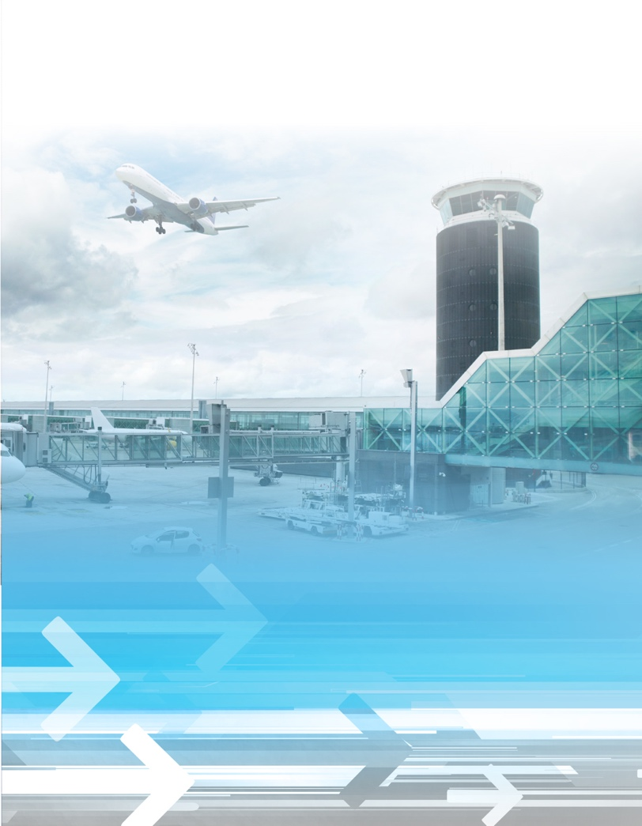
[Short paragraph here about specific NextGen procedures/technologies host airport has implemented or will implement and resulting benefits. What is the NextGen timeline for implementation of new procedures?]
For more specific information about how NextGen’s new flight procedures are affecting noise patterns around airports, contact
[AIRPORT NOISE CONTACT INFORMATION].
NextGen:

WE’RE GOING

PLACES

Safer, Greener, More Efficient Airports and Aircraft
Approximately 7,000 aircraft depart, fly, and land all over the United States at any given time. Yet the demand for more flights is growing. NextGen is helping commercial airports, as well as general aviation airports, meet this demand while improving safety, efficiency and environmental performance:
Safety - NextGen’s improvements in data communications reduce the use of voice radio traffic for controlling air traffic. This helps air traffic controllers avoid mishearing flight clearances and controller-to-pilot instructions and reduces controller workload, all of which improve safety. Other NextGen improvements will improve the sequencing of aircraft so that they can safely fly in closer proximity.
Efficiency - NextGen technologies provide better and more frequent data to improve collaborative decision-making for the aviation industry. These technologies are designed to accommodate increasing air travel and will result in more on-time arrivals for passengers.
Environment - By allowing more direct routing, shortening flight segments, reducing delays and cutting aircraft exhaust emissions, NextGen is helping airlines and airports minimize local air pollution. NextGen’s navigational improvements also enable smoother ascents and descents, which save emissions and reduce carbon footprints from each flight.

What Does NextGen Mean For Our Community?
In our neck of the woods, NextGen is giving us the tools we need to reduce pollution, flight delays—and local noise. Using NextGen technologies, pilots can reduce power, nearly to a glide, from many miles away as they approach an airport to land their aircraft. This reduces airplane noise from throttling the engines that is now typical during step-down approaches to airports. Additionally, NextGen is giving pilots more opportunity to efficiently maneuver around densely populated residential areas during takeoffs and landings.
New Technologies:
Performance Based Navigation
Performance-based navigation (PBN) is an important part of NextGen. PBN helps aircraft use airspace more efficiently, reducing aircraft emissions, concentrating noise over smaller areas and increasing safety and more on-time arrivals, no matter the weather conditions. It provides real-time, precision data to pilots and air traffic controllers, which facilitates satellite-guided approaches and departures, and more direct routes at high and low altitudes. Many large, medium, and small airports throughout the country are already enjoying the benefits of PBN.
More Satisfied Customers
NextGen is affecting the everyday experience of the flying public. For example, NextGen helps controllers, pilots, and airline dispatchers keep aircraft safely separated on new precision flight paths, even when bad weather threatens scheduled arrivals and departures. Passengers are experiencing fewer delays and spending less time sitting on the ground and holding in the air. These new NextGen arrival procedures not only ease congestion, they even provide a smoother ride.

